Factors Report 20080102-20161230

**1. factor51**

**截面指标累计曲线:**

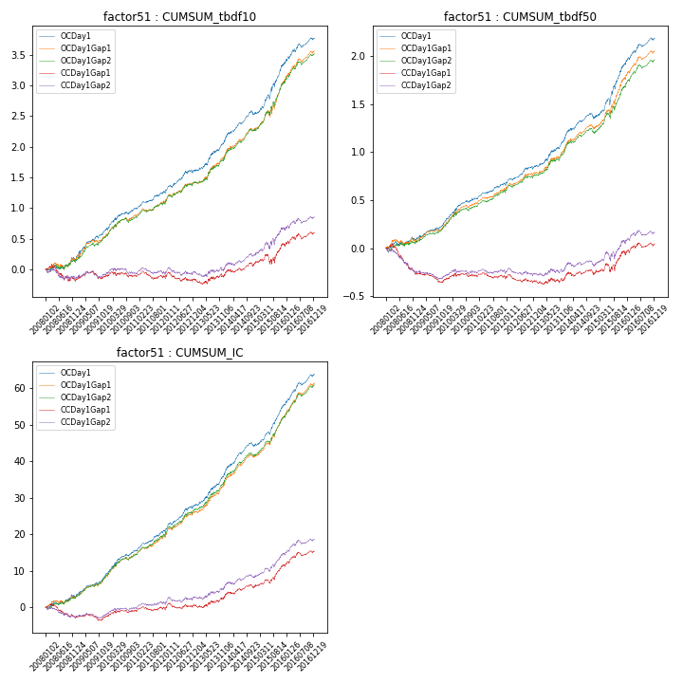

**因子换手率:** 27.02%

**截面指标_OCDay1:**

|  |  |  |  |  |  |  |  |  |
| --- | --- | --- | --- | --- | --- | --- | --- | --- |
| year | annret_tbdf10 | sharpe_tbdf10 | maxdd_tbdf10 | annret_tbdf50 | sharpe_tbdf50 | maxdd_tbdf50 | mean_IC | tstat_IC |
| 2008 | 0.16 | 1.16 | -0.07 | 0.09 | 1.11 | -0.04 | 0.01 | 1.77 |
| 2009 | 0.49 | 4.68 | -0.04 | 0.2 | 3.74 | -0.02 | 0.02 | 4.78 |
| 2010 | 0.35 | 3.41 | -0.04 | 0.23 | 3.7 | -0.02 | 0.03 | 4.47 |
| 2011 | 0.24 | 3.17 | -0.04 | 0.14 | 2.98 | -0.02 | 0.02 | 3.85 |
| 2012 | 0.37 | 3.6 | -0.05 | 0.2 | 3.55 | -0.03 | 0.03 | 4.57 |
| 2013 | 0.49 | 3.88 | -0.03 | 0.3 | 3.79 | -0.02 | 0.04 | 4.67 |
| 2014 | 0.44 | 4.43 | -0.06 | 0.21 | 3.25 | -0.06 | 0.03 | 4.92 |
| 2015 | 0.83 | 4.99 | -0.07 | 0.56 | 5.13 | -0.07 | 0.05 | 6.35 |
| 2016 | 0.42 | 3.64 | -0.06 | 0.28 | 3.98 | -0.03 | 0.03 | 5.18 |

**截面指标_CCDay1Gap1:**

|  |  |  |  |  |  |  |  |  |
| --- | --- | --- | --- | --- | --- | --- | --- | --- |
| year | annret_tbdf10 | sharpe_tbdf10 | maxdd_tbdf10 | annret_tbdf50 | sharpe_tbdf50 | maxdd_tbdf50 | mean_IC | tstat_IC |
| 2008 | -0.18 | -1.22 | -0.25 | -0.27 | -3.25 | -0.28 | -0.01 | -1.79 |
| 2009 | 0.07 | 0.65 | -0.13 | -0.05 | -1.02 | -0.1 | 0.0 | 0.24 |
| 2010 | 0.02 | 0.17 | -0.09 | 0.04 | 0.68 | -0.04 | 0.01 | 1.31 |
| 2011 | -0.06 | -0.68 | -0.13 | -0.04 | -0.85 | -0.07 | 0.0 | 0.03 |
| 2012 | -0.02 | -0.16 | -0.14 | -0.02 | -0.45 | -0.09 | 0.0 | 0.81 |
| 2013 | 0.08 | 0.58 | -0.08 | 0.03 | 0.42 | -0.05 | 0.01 | 1.33 |
| 2014 | 0.18 | 1.82 | -0.06 | 0.05 | 0.77 | -0.05 | 0.01 | 1.86 |
| 2015 | 0.3 | 1.71 | -0.15 | 0.21 | 1.83 | -0.09 | 0.02 | 3.29 |
| 2016 | 0.2 | 1.73 | -0.08 | 0.09 | 1.26 | -0.05 | 0.02 | 2.64 |

**风格暴露:**

|  |  |  |  |  |
| --- | --- | --- | --- | --- |
|  | long | short | corr_OCDay1 | corr_CCDay1Gap1 |
| liquidity10 | -1.24 | 1.25 | 0.8 | 0.81 |
| liquidity20 | -1.24 | 1.24 | 0.8 | 0.81 |
| liquidity5 | -1.25 | 1.26 | 0.8 | 0.81 |
| logmktcap | 1.04 | -1.03 | -0.62 | -0.65 |
| momentum15 | -0.32 | 0.33 | 0.17 | 0.19 |
| momentum30 | -0.4 | 0.41 | 0.23 | 0.23 |
| momentum5 | -0.22 | 0.22 | 0.05 | 0.09 |
| retvolatility30 | -1.22 | 1.23 | 0.8 | 0.8 |