Factors Report 20080102-20161230

**1. factor37**

**截面指标累计曲线:**

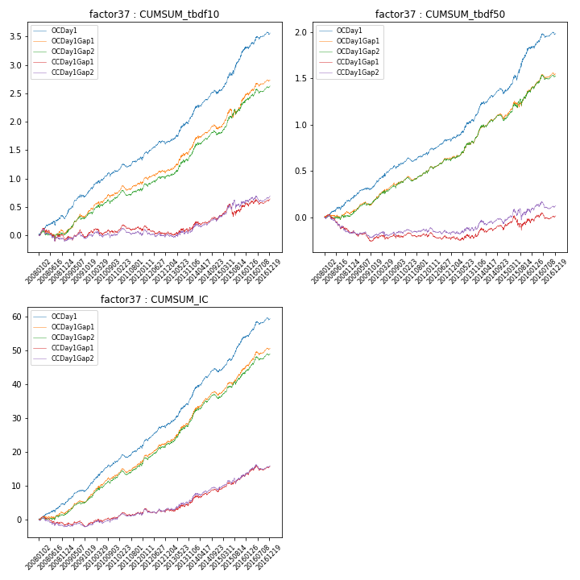

**因子换手率:** 26.58%

**截面指标_OCDay1:**

|  |  |  |  |  |  |  |  |  |
| --- | --- | --- | --- | --- | --- | --- | --- | --- |
| year | annret_tbdf10 | sharpe_tbdf10 | maxdd_tbdf10 | annret_tbdf50 | sharpe_tbdf50 | maxdd_tbdf50 | mean_IC | tstat_IC |
| 2008 | 0.29 | 2.39 | -0.08 | 0.18 | 2.73 | -0.03 | 0.02 | 3.26 |
| 2009 | 0.52 | 4.71 | -0.05 | 0.19 | 3.34 | -0.02 | 0.02 | 4.58 |
| 2010 | 0.32 | 2.89 | -0.07 | 0.21 | 3.13 | -0.04 | 0.03 | 4.16 |
| 2011 | 0.2 | 2.57 | -0.05 | 0.1 | 2.22 | -0.04 | 0.02 | 3.22 |
| 2012 | 0.31 | 3.19 | -0.07 | 0.17 | 3.26 | -0.03 | 0.03 | 4.52 |
| 2013 | 0.5 | 3.74 | -0.04 | 0.3 | 3.57 | -0.02 | 0.04 | 4.52 |
| 2014 | 0.39 | 3.38 | -0.07 | 0.19 | 2.73 | -0.06 | 0.03 | 3.94 |
| 2015 | 0.75 | 4.35 | -0.07 | 0.49 | 4.13 | -0.05 | 0.04 | 5.17 |
| 2016 | 0.3 | 2.61 | -0.05 | 0.16 | 2.28 | -0.04 | 0.02 | 3.36 |

**截面指标_CCDay1Gap1:**

|  |  |  |  |  |  |  |  |  |
| --- | --- | --- | --- | --- | --- | --- | --- | --- |
| year | annret_tbdf10 | sharpe_tbdf10 | maxdd_tbdf10 | annret_tbdf50 | sharpe_tbdf50 | maxdd_tbdf50 | mean_IC | tstat_IC |
| 2008 | -0.08 | -0.63 | -0.21 | -0.17 | -2.4 | -0.19 | -0.01 | -1.22 |
| 2009 | 0.14 | 1.17 | -0.13 | -0.05 | -0.77 | -0.11 | 0.0 | 0.58 |
| 2010 | 0.01 | 0.12 | -0.11 | 0.01 | 0.22 | -0.05 | 0.01 | 1.13 |
| 2011 | 0.0 | 0.04 | -0.11 | -0.01 | -0.27 | -0.05 | 0.0 | 0.62 |
| 2012 | -0.03 | -0.29 | -0.16 | -0.01 | -0.11 | -0.08 | 0.01 | 1.03 |
| 2013 | 0.11 | 0.76 | -0.06 | 0.05 | 0.51 | -0.05 | 0.01 | 1.47 |
| 2014 | 0.17 | 1.49 | -0.06 | 0.06 | 0.86 | -0.05 | 0.01 | 1.73 |
| 2015 | 0.18 | 0.97 | -0.21 | 0.06 | 0.48 | -0.15 | 0.02 | 2.29 |
| 2016 | 0.14 | 1.23 | -0.09 | 0.07 | 0.95 | -0.07 | 0.01 | 1.91 |

**风格暴露:**

|  |  |  |  |  |
| --- | --- | --- | --- | --- |
|  | long | short | corr_OCDay1 | corr_CCDay1Gap1 |
| liquidity10 | -0.99 | 0.99 | 0.73 | 0.75 |
| liquidity20 | -1.02 | 1.02 | 0.73 | 0.75 |
| liquidity5 | -0.95 | 0.96 | 0.72 | 0.75 |
| logmktcap | 0.89 | -0.89 | -0.55 | -0.58 |
| momentum15 | -0.28 | 0.28 | 0.21 | 0.2 |
| momentum30 | -0.39 | 0.4 | 0.27 | 0.25 |
| momentum5 | -0.15 | 0.16 | 0.07 | 0.11 |
| retvolatility30 | -1.18 | 1.19 | 0.78 | 0.78 |