Factors Report 20080102-20161230

**1. factor1**

**截面指标累计曲线:**

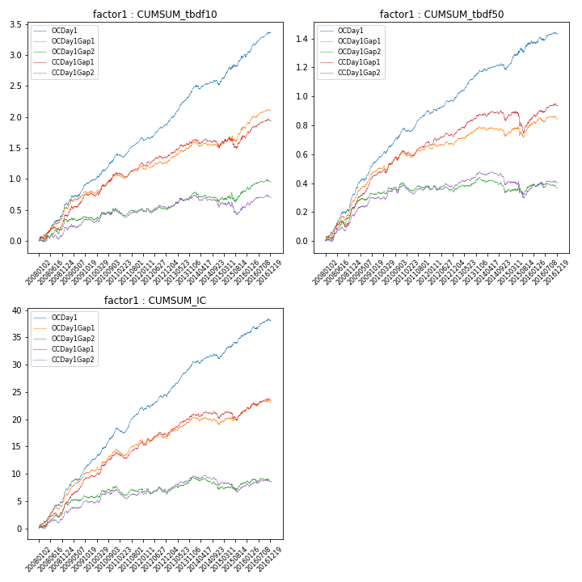

**因子换手率:** 55.63%

**截面指标_OCDay1:**

|  |  |  |  |  |  |  |  |  |
| --- | --- | --- | --- | --- | --- | --- | --- | --- |
| year | annret_tbdf10 | sharpe_tbdf10 | maxdd_tbdf10 | annret_tbdf50 | sharpe_tbdf50 | maxdd_tbdf50 | mean_IC | tstat_IC |
| 2008 | 0.58 | 5.44 | -0.03 | 0.29 | 6.28 | -0.02 | 0.03 | 6.79 |
| 2009 | 0.38 | 4.35 | -0.03 | 0.27 | 7.26 | -0.02 | 0.02 | 6.39 |
| 2010 | 0.44 | 4.98 | -0.03 | 0.22 | 6.21 | -0.01 | 0.03 | 6.67 |
| 2011 | 0.27 | 4.38 | -0.05 | 0.12 | 4.13 | -0.03 | 0.02 | 4.66 |
| 2012 | 0.26 | 3.98 | -0.04 | 0.08 | 2.89 | -0.02 | 0.01 | 3.0 |
| 2013 | 0.57 | 7.04 | -0.02 | 0.2 | 6.45 | -0.01 | 0.02 | 6.91 |
| 2014 | 0.06 | 0.72 | -0.08 | 0.01 | 0.27 | -0.04 | 0.0 | 0.76 |
| 2015 | 0.48 | 4.05 | -0.04 | 0.2 | 3.79 | -0.03 | 0.02 | 4.96 |
| 2016 | 0.37 | 4.89 | -0.03 | 0.05 | 1.25 | -0.02 | 0.01 | 2.71 |

**截面指标_CCDay1Gap1:**

|  |  |  |  |  |  |  |  |  |
| --- | --- | --- | --- | --- | --- | --- | --- | --- |
| year | annret_tbdf10 | sharpe_tbdf10 | maxdd_tbdf10 | annret_tbdf50 | sharpe_tbdf50 | maxdd_tbdf50 | mean_IC | tstat_IC |
| 2008 | 0.4 | 3.8 | -0.05 | 0.21 | 4.07 | -0.05 | 0.02 | 4.74 |
| 2009 | 0.36 | 3.9 | -0.05 | 0.25 | 6.89 | -0.01 | 0.02 | 6.42 |
| 2010 | 0.34 | 3.46 | -0.05 | 0.16 | 3.86 | -0.03 | 0.02 | 4.6 |
| 2011 | 0.16 | 2.65 | -0.07 | 0.05 | 1.81 | -0.04 | 0.01 | 2.41 |
| 2012 | 0.12 | 1.78 | -0.04 | 0.06 | 1.96 | -0.03 | 0.01 | 1.99 |
| 2013 | 0.25 | 3.1 | -0.03 | 0.14 | 4.63 | -0.01 | 0.01 | 4.51 |
| 2014 | -0.11 | -1.27 | -0.14 | -0.04 | -1.17 | -0.07 | -0.0 | -0.88 |
| 2015 | 0.16 | 1.14 | -0.18 | 0.02 | 0.24 | -0.14 | 0.01 | 1.36 |
| 2016 | 0.27 | 3.72 | -0.03 | 0.08 | 2.23 | -0.02 | 0.01 | 2.41 |

**风格暴露:**

|  |  |  |  |  |
| --- | --- | --- | --- | --- |
|  | long | short | corr_OCDay1 | corr_CCDay1Gap1 |
| liquidity10 | 0.21 | -0.21 | -0.15 | 0.03 |
| liquidity20 | 0.17 | -0.16 | -0.13 | 0.04 |
| liquidity5 | 0.26 | -0.26 | -0.15 | 0.03 |
| logmktcap | 0.33 | -0.33 | -0.06 | -0.26 |
| momentum15 | 0.21 | -0.2 | -0.17 | -0.09 |
| momentum30 | 0.25 | -0.24 | -0.13 | -0.11 |
| momentum5 | 0.13 | -0.12 | -0.12 | -0.06 |
| retvolatility30 | 0.34 | -0.34 | -0.08 | 0.11 |