Factors Report 20080102-20161230

**1. factor3**

**截面指标累计曲线:**

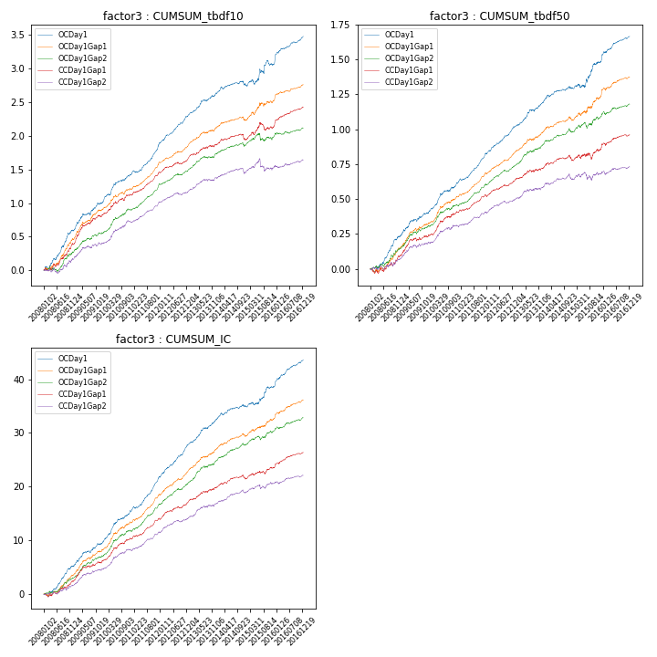

**因子换手率:** 41.74%

**截面指标_OCDay1:**

|  |  |  |  |  |  |  |  |  |
| --- | --- | --- | --- | --- | --- | --- | --- | --- |
| year | annret_tbdf10 | sharpe_tbdf10 | maxdd_tbdf10 | annret_tbdf50 | sharpe_tbdf50 | maxdd_tbdf50 | mean_IC | tstat_IC |
| 2008 | 0.59 | 5.74 | -0.04 | 0.23 | 4.89 | -0.03 | 0.02 | 5.53 |
| 2009 | 0.41 | 4.79 | -0.03 | 0.17 | 4.21 | -0.02 | 0.02 | 4.67 |
| 2010 | 0.42 | 5.1 | -0.02 | 0.21 | 5.26 | -0.01 | 0.02 | 6.24 |
| 2011 | 0.47 | 6.98 | -0.03 | 0.21 | 7.44 | -0.01 | 0.03 | 8.02 |
| 2012 | 0.42 | 7.06 | -0.01 | 0.19 | 6.41 | -0.01 | 0.02 | 7.43 |
| 2013 | 0.34 | 5.29 | -0.02 | 0.18 | 5.12 | -0.01 | 0.02 | 5.82 |
| 2014 | 0.13 | 2.01 | -0.06 | 0.1 | 2.88 | -0.01 | 0.01 | 2.98 |
| 2015 | 0.3 | 2.2 | -0.07 | 0.19 | 2.89 | -0.03 | 0.01 | 3.02 |
| 2016 | 0.41 | 5.96 | -0.02 | 0.18 | 5.26 | -0.01 | 0.02 | 6.53 |

**截面指标_CCDay1Gap1:**

|  |  |  |  |  |  |  |  |  |
| --- | --- | --- | --- | --- | --- | --- | --- | --- |
| year | annret_tbdf10 | sharpe_tbdf10 | maxdd_tbdf10 | annret_tbdf50 | sharpe_tbdf50 | maxdd_tbdf50 | mean_IC | tstat_IC |
| 2008 | 0.38 | 3.94 | -0.05 | 0.08 | 1.84 | -0.04 | 0.01 | 2.76 |
| 2009 | 0.43 | 4.88 | -0.03 | 0.16 | 3.76 | -0.02 | 0.02 | 4.51 |
| 2010 | 0.3 | 3.76 | -0.04 | 0.17 | 4.19 | -0.01 | 0.02 | 4.99 |
| 2011 | 0.35 | 6.22 | -0.01 | 0.12 | 4.73 | -0.01 | 0.02 | 5.62 |
| 2012 | 0.2 | 3.67 | -0.03 | 0.11 | 4.0 | -0.01 | 0.01 | 4.26 |
| 2013 | 0.22 | 3.24 | -0.02 | 0.09 | 2.58 | -0.01 | 0.01 | 3.48 |
| 2014 | 0.06 | 0.99 | -0.09 | 0.05 | 1.57 | -0.04 | 0.01 | 2.18 |
| 2015 | 0.22 | 1.97 | -0.11 | 0.08 | 1.41 | -0.05 | 0.01 | 2.52 |
| 2016 | 0.28 | 4.78 | -0.01 | 0.1 | 3.12 | -0.02 | 0.01 | 4.41 |

**风格暴露:**

|  |  |  |  |  |
| --- | --- | --- | --- | --- |
|  | long | short | corr_OCDay1 | corr_CCDay1Gap1 |
| liquidity10 | -0.14 | 0.14 | 0.38 | 0.36 |
| liquidity20 | -0.13 | 0.14 | 0.36 | 0.35 |
| liquidity5 | -0.14 | 0.15 | 0.4 | 0.36 |
| logmktcap | 0.04 | -0.03 | -0.05 | -0.13 |
| momentum15 | -0.03 | 0.04 | 0.17 | 0.1 |
| momentum30 | -0.04 | 0.05 | 0.2 | 0.14 |
| momentum5 | 0.0 | 0.01 | 0.14 | 0.05 |
| retvolatility30 | -0.17 | 0.17 | 0.45 | 0.43 |