Factors Report 20080102-20161230

**1. factor10**

**截面指标累计曲线:**

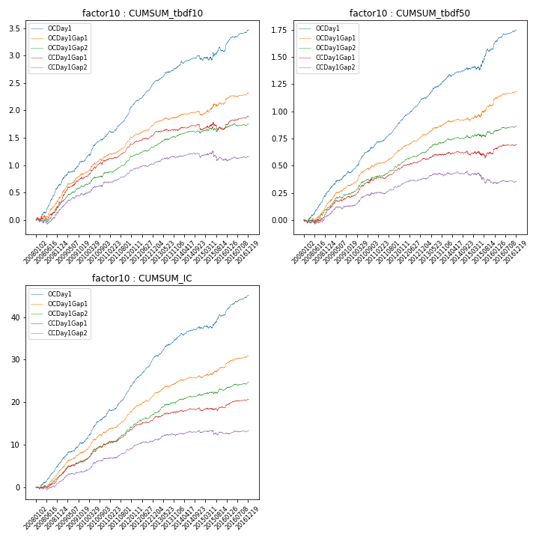

**因子换手率:** 43.74%

**截面指标_OCDay1:**

|  |  |  |  |  |  |  |  |  |
| --- | --- | --- | --- | --- | --- | --- | --- | --- |
| year | annret_tbdf10 | sharpe_tbdf10 | maxdd_tbdf10 | annret_tbdf50 | sharpe_tbdf50 | maxdd_tbdf50 | mean_IC | tstat_IC |
| 2008 | 0.64 | 6.14 | -0.05 | 0.26 | 5.37 | -0.03 | 0.02 | 6.09 |
| 2009 | 0.43 | 5.04 | -0.02 | 0.18 | 4.27 | -0.01 | 0.02 | 5.04 |
| 2010 | 0.48 | 6.06 | -0.02 | 0.25 | 6.4 | -0.01 | 0.03 | 7.13 |
| 2011 | 0.5 | 7.56 | -0.03 | 0.2 | 6.75 | -0.01 | 0.03 | 7.82 |
| 2012 | 0.47 | 8.1 | -0.01 | 0.23 | 7.91 | -0.01 | 0.03 | 8.52 |
| 2013 | 0.29 | 4.51 | -0.02 | 0.18 | 5.07 | -0.01 | 0.02 | 5.38 |
| 2014 | 0.16 | 2.23 | -0.07 | 0.09 | 2.66 | -0.02 | 0.01 | 2.77 |
| 2015 | 0.14 | 1.08 | -0.08 | 0.18 | 2.6 | -0.04 | 0.01 | 2.6 |
| 2016 | 0.38 | 5.72 | -0.02 | 0.18 | 5.38 | -0.01 | 0.02 | 6.22 |

**截面指标_CCDay1Gap1:**

|  |  |  |  |  |  |  |  |  |
| --- | --- | --- | --- | --- | --- | --- | --- | --- |
| year | annret_tbdf10 | sharpe_tbdf10 | maxdd_tbdf10 | annret_tbdf50 | sharpe_tbdf50 | maxdd_tbdf50 | mean_IC | tstat_IC |
| 2008 | 0.31 | 3.19 | -0.07 | 0.09 | 1.97 | -0.03 | 0.01 | 3.21 |
| 2009 | 0.47 | 5.29 | -0.03 | 0.13 | 3.24 | -0.02 | 0.02 | 4.43 |
| 2010 | 0.32 | 3.85 | -0.04 | 0.16 | 4.04 | -0.02 | 0.02 | 4.71 |
| 2011 | 0.3 | 5.03 | -0.02 | 0.09 | 3.34 | -0.02 | 0.01 | 4.65 |
| 2012 | 0.2 | 3.7 | -0.02 | 0.09 | 3.31 | -0.01 | 0.01 | 3.88 |
| 2013 | 0.05 | 0.84 | -0.04 | 0.05 | 1.34 | -0.02 | 0.01 | 1.83 |
| 2014 | 0.0 | 0.07 | -0.1 | -0.01 | -0.19 | -0.04 | 0.0 | 0.36 |
| 2015 | 0.04 | 0.37 | -0.13 | 0.01 | 0.19 | -0.06 | 0.0 | 0.78 |
| 2016 | 0.2 | 3.3 | -0.02 | 0.08 | 2.47 | -0.01 | 0.01 | 2.95 |

**风格暴露:**

|  |  |  |  |  |
| --- | --- | --- | --- | --- |
|  | long | short | corr_OCDay1 | corr_CCDay1Gap1 |
| liquidity10 | -0.13 | 0.14 | 0.36 | 0.31 |
| liquidity20 | -0.12 | 0.13 | 0.34 | 0.29 |
| liquidity5 | -0.14 | 0.15 | 0.39 | 0.31 |
| logmktcap | 0.04 | -0.03 | -0.08 | -0.1 |
| momentum15 | -0.03 | 0.04 | 0.2 | 0.11 |
| momentum30 | -0.04 | 0.05 | 0.22 | 0.13 |
| momentum5 | -0.01 | 0.02 | 0.16 | 0.07 |
| retvolatility30 | -0.15 | 0.16 | 0.42 | 0.36 |