Factors Report 20080102-20161230

**1. factor13**

**截面指标累计曲线:**

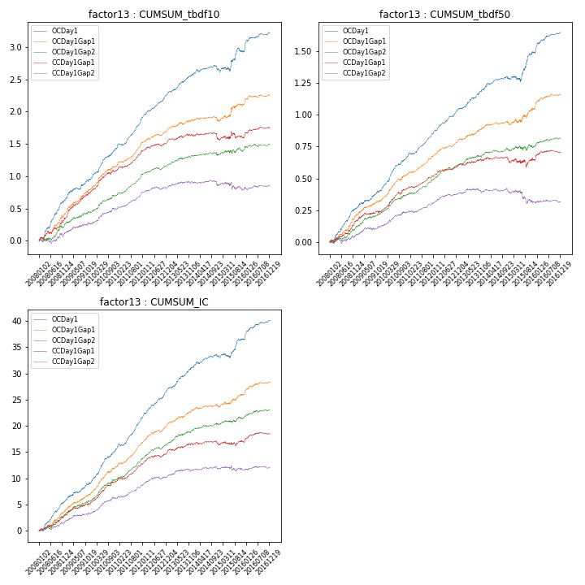

**因子换手率:** 45.17%

**截面指标_OCDay1:**

|  |  |  |  |  |  |  |  |  |
| --- | --- | --- | --- | --- | --- | --- | --- | --- |
| year | annret_tbdf10 | sharpe_tbdf10 | maxdd_tbdf10 | annret_tbdf50 | sharpe_tbdf50 | maxdd_tbdf50 | mean_IC | tstat_IC |
| 2008 | 0.63 | 6.55 | -0.02 | 0.26 | 5.77 | -0.01 | 0.02 | 6.45 |
| 2009 | 0.33 | 3.91 | -0.03 | 0.15 | 3.78 | -0.01 | 0.01 | 3.86 |
| 2010 | 0.47 | 5.93 | -0.02 | 0.26 | 6.92 | -0.01 | 0.03 | 7.09 |
| 2011 | 0.49 | 7.86 | -0.02 | 0.18 | 6.67 | -0.01 | 0.02 | 7.76 |
| 2012 | 0.38 | 6.68 | -0.01 | 0.2 | 6.66 | -0.01 | 0.02 | 6.76 |
| 2013 | 0.3 | 4.77 | -0.02 | 0.16 | 4.65 | -0.01 | 0.02 | 5.07 |
| 2014 | 0.08 | 1.3 | -0.07 | 0.08 | 2.31 | -0.02 | 0.01 | 2.55 |
| 2015 | 0.27 | 2.01 | -0.07 | 0.21 | 2.95 | -0.05 | 0.01 | 2.8 |
| 2016 | 0.29 | 4.32 | -0.02 | 0.16 | 4.62 | -0.01 | 0.01 | 4.84 |

**截面指标_CCDay1Gap1:**

|  |  |  |  |  |  |  |  |  |
| --- | --- | --- | --- | --- | --- | --- | --- | --- |
| year | annret_tbdf10 | sharpe_tbdf10 | maxdd_tbdf10 | annret_tbdf50 | sharpe_tbdf50 | maxdd_tbdf50 | mean_IC | tstat_IC |
| 2008 | 0.33 | 3.7 | -0.04 | 0.16 | 3.44 | -0.02 | 0.01 | 3.63 |
| 2009 | 0.43 | 4.85 | -0.03 | 0.09 | 2.2 | -0.01 | 0.01 | 3.01 |
| 2010 | 0.32 | 4.03 | -0.04 | 0.17 | 4.68 | -0.02 | 0.02 | 5.12 |
| 2011 | 0.33 | 5.54 | -0.02 | 0.1 | 3.9 | -0.01 | 0.01 | 5.04 |
| 2012 | 0.14 | 2.51 | -0.04 | 0.09 | 3.2 | -0.01 | 0.01 | 3.2 |
| 2013 | 0.09 | 1.43 | -0.03 | 0.04 | 1.17 | -0.02 | 0.01 | 1.75 |
| 2014 | -0.06 | -1.0 | -0.11 | -0.02 | -0.49 | -0.04 | -0.0 | -0.2 |
| 2015 | 0.04 | 0.38 | -0.1 | 0.02 | 0.25 | -0.07 | 0.0 | 0.59 |
| 2016 | 0.14 | 2.47 | -0.03 | 0.06 | 1.9 | -0.02 | 0.01 | 2.36 |

**风格暴露:**

|  |  |  |  |  |
| --- | --- | --- | --- | --- |
|  | long | short | corr_OCDay1 | corr_CCDay1Gap1 |
| liquidity10 | -0.13 | 0.13 | 0.36 | 0.29 |
| liquidity20 | -0.12 | 0.13 | 0.34 | 0.28 |
| liquidity5 | -0.13 | 0.14 | 0.39 | 0.3 |
| logmktcap | 0.04 | -0.04 | -0.1 | -0.11 |
| momentum15 | -0.03 | 0.04 | 0.21 | 0.16 |
| momentum30 | -0.04 | 0.05 | 0.23 | 0.17 |
| momentum5 | -0.02 | 0.02 | 0.18 | 0.11 |
| retvolatility30 | -0.15 | 0.16 | 0.42 | 0.35 |