Factors Report 20080102-20161230

**1. factor6**

**截面指标累计曲线:**

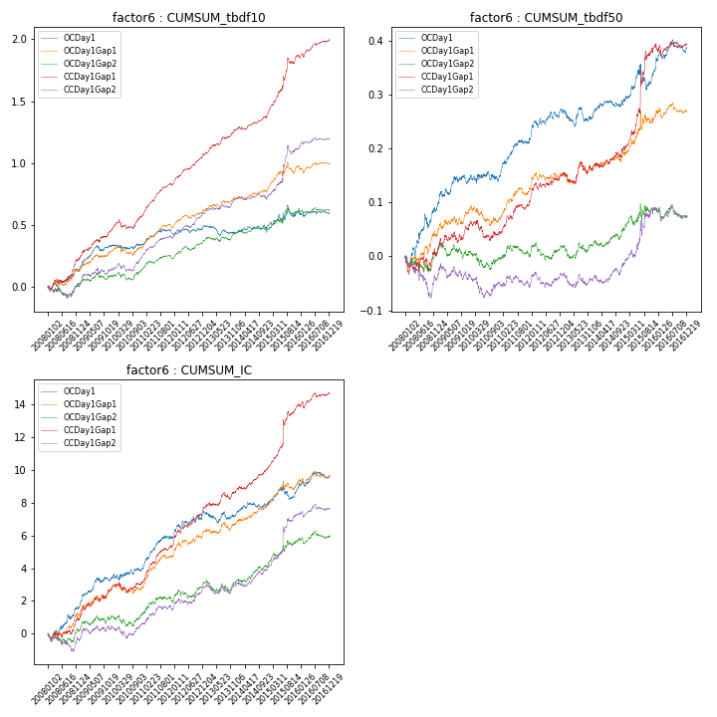

**因子换手率:** 54.67%

**截面指标_OCDay1:**

|  |  |  |  |  |  |  |  |  |
| --- | --- | --- | --- | --- | --- | --- | --- | --- |
| year | annret_tbdf10 | sharpe_tbdf10 | maxdd_tbdf10 | annret_tbdf50 | sharpe_tbdf50 | maxdd_tbdf50 | mean_IC | tstat_IC |
| 2008 | 0.14 | 1.76 | -0.05 | 0.09 | 2.02 | -0.03 | 0.01 | 2.07 |
| 2009 | 0.19 | 3.02 | -0.04 | 0.05 | 1.82 | -0.02 | 0.01 | 2.79 |
| 2010 | 0.02 | 0.27 | -0.04 | 0.01 | 0.37 | -0.02 | 0.0 | 0.92 |
| 2011 | 0.08 | 1.65 | -0.05 | 0.07 | 3.0 | -0.01 | 0.01 | 2.92 |
| 2012 | 0.07 | 1.38 | -0.03 | 0.05 | 2.17 | -0.01 | 0.01 | 2.36 |
| 2013 | -0.05 | -1.03 | -0.08 | -0.01 | -0.33 | -0.03 | -0.0 | -0.22 |
| 2014 | 0.03 | 0.58 | -0.04 | 0.03 | 1.37 | -0.01 | 0.0 | 1.28 |
| 2015 | 0.15 | 1.61 | -0.07 | 0.06 | 1.22 | -0.05 | 0.0 | 1.34 |
| 2016 | -0.02 | -0.44 | -0.06 | 0.04 | 1.4 | -0.02 | 0.0 | 1.32 |

**截面指标_CCDay1Gap1:**

|  |  |  |  |  |  |  |  |  |
| --- | --- | --- | --- | --- | --- | --- | --- | --- |
| year | annret_tbdf10 | sharpe_tbdf10 | maxdd_tbdf10 | annret_tbdf50 | sharpe_tbdf50 | maxdd_tbdf50 | mean_IC | tstat_IC |
| 2008 | 0.22 | 2.77 | -0.03 | 0.0 | 0.08 | -0.03 | 0.0 | 1.28 |
| 2009 | 0.23 | 3.37 | -0.03 | 0.05 | 1.69 | -0.02 | 0.01 | 3.0 |
| 2010 | 0.12 | 1.93 | -0.07 | -0.01 | -0.19 | -0.04 | 0.0 | 0.78 |
| 2011 | 0.26 | 5.8 | -0.02 | 0.06 | 2.73 | -0.01 | 0.01 | 4.45 |
| 2012 | 0.24 | 5.22 | -0.01 | 0.04 | 1.95 | -0.01 | 0.01 | 3.86 |
| 2013 | 0.21 | 4.15 | -0.02 | 0.01 | 0.5 | -0.02 | 0.0 | 1.71 |
| 2014 | 0.11 | 2.48 | -0.02 | 0.04 | 1.55 | -0.01 | 0.01 | 3.0 |
| 2015 | 0.48 | 4.27 | -0.05 | 0.19 | 3.29 | -0.02 | 0.02 | 3.77 |
| 2016 | 0.14 | 2.94 | -0.03 | 0.01 | 0.3 | -0.02 | 0.0 | 1.74 |

**风格暴露:**

|  |  |  |  |  |
| --- | --- | --- | --- | --- |
|  | long | short | corr_OCDay1 | corr_CCDay1Gap1 |
| liquidity10 | -0.02 | 0.03 | 0.27 | 0.16 |
| liquidity20 | -0.02 | 0.03 | 0.25 | 0.15 |
| liquidity5 | -0.01 | 0.02 | 0.27 | 0.12 |
| logmktcap | -0.03 | 0.03 | -0.05 | -0.05 |
| momentum15 | -0.07 | 0.07 | 0.2 | 0.1 |
| momentum30 | -0.06 | 0.06 | 0.17 | 0.07 |
| momentum5 | -0.07 | 0.07 | 0.14 | 0.09 |
| retvolatility30 | 0.0 | 0.0 | 0.17 | 0.1 |