Factors Report 20080102-20161230

**1. factor11**

**截面指标累计曲线:**

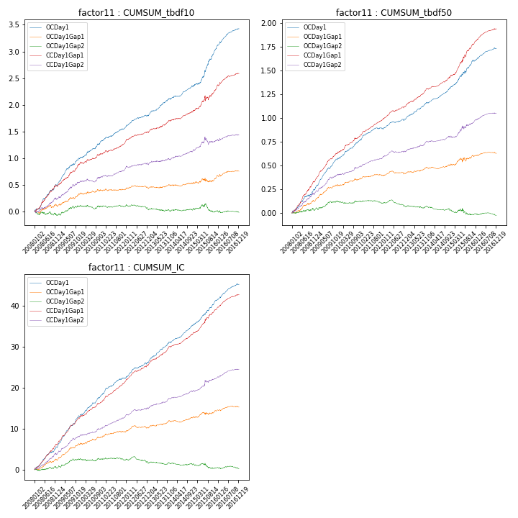

**因子换手率:** 36.03%

**截面指标_OCDay1:**

|  |  |  |  |  |  |  |  |  |
| --- | --- | --- | --- | --- | --- | --- | --- | --- |
| year | annret_tbdf10 | sharpe_tbdf10 | maxdd_tbdf10 | annret_tbdf50 | sharpe_tbdf50 | maxdd_tbdf50 | mean_IC | tstat_IC |
| 2008 | 0.49 | 6.46 | -0.02 | 0.25 | 6.4 | -0.01 | 0.02 | 7.53 |
| 2009 | 0.53 | 7.66 | -0.02 | 0.33 | 10.74 | -0.01 | 0.03 | 11.18 |
| 2010 | 0.32 | 4.77 | -0.03 | 0.2 | 6.64 | -0.01 | 0.02 | 7.17 |
| 2011 | 0.25 | 5.08 | -0.02 | 0.12 | 4.48 | -0.02 | 0.02 | 5.62 |
| 2012 | 0.23 | 4.68 | -0.02 | 0.11 | 4.55 | -0.02 | 0.02 | 6.08 |
| 2013 | 0.32 | 5.96 | -0.02 | 0.18 | 6.24 | -0.01 | 0.02 | 7.41 |
| 2014 | 0.25 | 4.84 | -0.03 | 0.16 | 7.08 | -0.01 | 0.02 | 7.86 |
| 2015 | 0.68 | 6.3 | -0.02 | 0.28 | 5.28 | -0.03 | 0.02 | 7.16 |
| 2016 | 0.38 | 7.18 | -0.03 | 0.13 | 5.37 | -0.01 | 0.02 | 7.05 |

**截面指标_CCDay1Gap1:**

|  |  |  |  |  |  |  |  |  |
| --- | --- | --- | --- | --- | --- | --- | --- | --- |
| year | annret_tbdf10 | sharpe_tbdf10 | maxdd_tbdf10 | annret_tbdf50 | sharpe_tbdf50 | maxdd_tbdf50 | mean_IC | tstat_IC |
| 2008 | 0.47 | 5.64 | -0.03 | 0.34 | 8.36 | -0.01 | 0.03 | 8.69 |
| 2009 | 0.44 | 6.35 | -0.02 | 0.31 | 10.12 | -0.01 | 0.03 | 10.44 |
| 2010 | 0.18 | 2.7 | -0.03 | 0.18 | 5.64 | -0.01 | 0.02 | 5.75 |
| 2011 | 0.22 | 4.62 | -0.03 | 0.17 | 7.27 | -0.01 | 0.02 | 7.87 |
| 2012 | 0.18 | 3.87 | -0.02 | 0.15 | 5.89 | -0.01 | 0.02 | 6.72 |
| 2013 | 0.23 | 4.3 | -0.02 | 0.19 | 6.73 | -0.01 | 0.02 | 7.17 |
| 2014 | 0.18 | 3.67 | -0.01 | 0.14 | 5.64 | -0.01 | 0.01 | 6.49 |
| 2015 | 0.41 | 3.44 | -0.09 | 0.33 | 5.55 | -0.02 | 0.02 | 5.34 |
| 2016 | 0.29 | 5.28 | -0.02 | 0.16 | 7.04 | -0.01 | 0.02 | 7.62 |

**风格暴露:**

|  |  |  |  |  |
| --- | --- | --- | --- | --- |
|  | long | short | corr_OCDay1 | corr_CCDay1Gap1 |
| liquidity10 | 0.02 | -0.01 | 0.09 | 0.1 |
| liquidity20 | -0.0 | 0.01 | 0.11 | 0.11 |
| liquidity5 | 0.05 | -0.04 | 0.07 | 0.06 |
| logmktcap | -0.03 | 0.04 | -0.11 | -0.06 |
| momentum15 | 0.12 | -0.12 | -0.17 | -0.14 |
| momentum30 | 0.08 | -0.07 | -0.19 | -0.13 |
| momentum5 | 0.23 | -0.23 | -0.26 | -0.26 |
| retvolatility30 | -0.0 | 0.01 | 0.11 | 0.13 |