Factors Report 20080102-20161230

**1. factor12**

**截面指标累计曲线:**

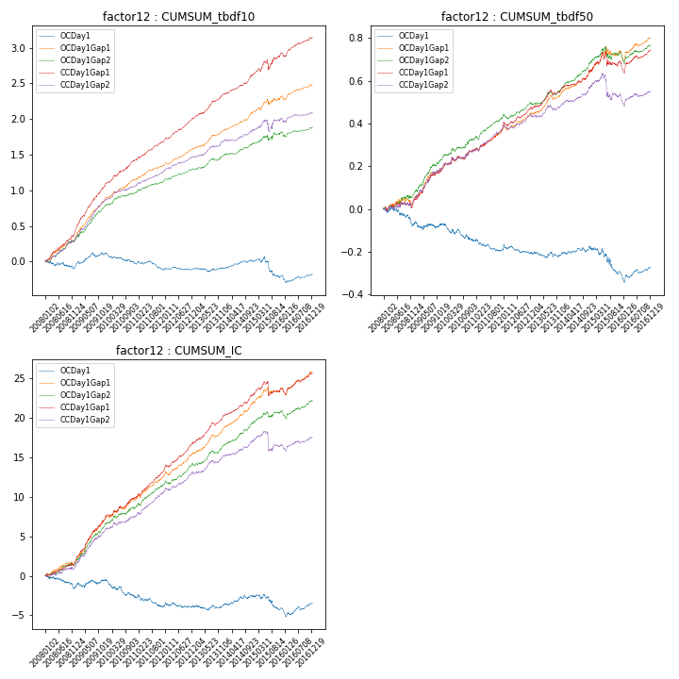

**因子换手率:** 43.82%

**截面指标_OCDay1:**

|  |  |  |  |  |  |  |  |  |
| --- | --- | --- | --- | --- | --- | --- | --- | --- |
| year | annret_tbdf10 | sharpe_tbdf10 | maxdd_tbdf10 | annret_tbdf50 | sharpe_tbdf50 | maxdd_tbdf50 | mean_IC | tstat_IC |
| 2008 | -0.06 | -0.77 | -0.11 | -0.07 | -1.66 | -0.09 | -0.01 | -1.82 |
| 2009 | 0.18 | 2.55 | -0.05 | -0.0 | -0.01 | -0.04 | 0.0 | 1.04 |
| 2010 | -0.14 | -2.29 | -0.14 | -0.08 | -2.09 | -0.08 | -0.01 | -2.68 |
| 2011 | -0.09 | -1.77 | -0.12 | -0.05 | -1.73 | -0.06 | -0.0 | -1.67 |
| 2012 | 0.01 | 0.29 | -0.05 | -0.02 | -0.65 | -0.04 | -0.0 | -0.05 |
| 2013 | 0.01 | 0.25 | -0.06 | -0.0 | -0.14 | -0.03 | 0.0 | 0.23 |
| 2014 | 0.09 | 1.94 | -0.03 | 0.03 | 1.12 | -0.02 | 0.0 | 1.91 |
| 2015 | -0.2 | -2.04 | -0.26 | -0.12 | -2.29 | -0.12 | -0.01 | -1.99 |
| 2016 | 0.02 | 0.43 | -0.09 | 0.03 | 1.1 | -0.04 | 0.0 | 1.29 |

**截面指标_CCDay1Gap1:**

|  |  |  |  |  |  |  |  |  |
| --- | --- | --- | --- | --- | --- | --- | --- | --- |
| year | annret_tbdf10 | sharpe_tbdf10 | maxdd_tbdf10 | annret_tbdf50 | sharpe_tbdf50 | maxdd_tbdf50 | mean_IC | tstat_IC |
| 2008 | 0.43 | 5.73 | -0.03 | 0.03 | 0.74 | -0.03 | 0.01 | 2.74 |
| 2009 | 0.64 | 8.98 | -0.02 | 0.16 | 4.26 | -0.01 | 0.02 | 7.12 |
| 2010 | 0.36 | 5.77 | -0.01 | 0.09 | 2.3 | -0.02 | 0.01 | 3.66 |
| 2011 | 0.26 | 5.76 | -0.02 | 0.1 | 4.17 | -0.01 | 0.01 | 5.81 |
| 2012 | 0.33 | 7.48 | -0.01 | 0.09 | 3.51 | -0.02 | 0.01 | 5.29 |
| 2013 | 0.35 | 6.56 | -0.02 | 0.09 | 3.5 | -0.03 | 0.01 | 5.95 |
| 2014 | 0.28 | 5.85 | -0.01 | 0.09 | 3.31 | -0.01 | 0.01 | 5.19 |
| 2015 | 0.29 | 2.47 | -0.13 | 0.03 | 0.46 | -0.07 | 0.0 | 0.51 |
| 2016 | 0.23 | 4.3 | -0.04 | 0.06 | 1.78 | -0.05 | 0.01 | 3.38 |

**风格暴露:**

|  |  |  |  |  |
| --- | --- | --- | --- | --- |
|  | long | short | corr_OCDay1 | corr_CCDay1Gap1 |
| liquidity10 | -0.05 | 0.06 | 0.24 | 0.18 |
| liquidity20 | -0.04 | 0.04 | 0.2 | 0.15 |
| liquidity5 | -0.08 | 0.09 | 0.28 | 0.25 |
| logmktcap | 0.02 | -0.01 | -0.05 | -0.06 |
| momentum15 | -0.17 | 0.18 | 0.37 | 0.35 |
| momentum30 | -0.12 | 0.12 | 0.27 | 0.22 |
| momentum5 | -0.26 | 0.27 | 0.35 | 0.37 |
| retvolatility30 | -0.02 | 0.02 | 0.18 | 0.14 |