Factors Report 20080102-20161230

**1. factor19**

**截面指标累计曲线:**

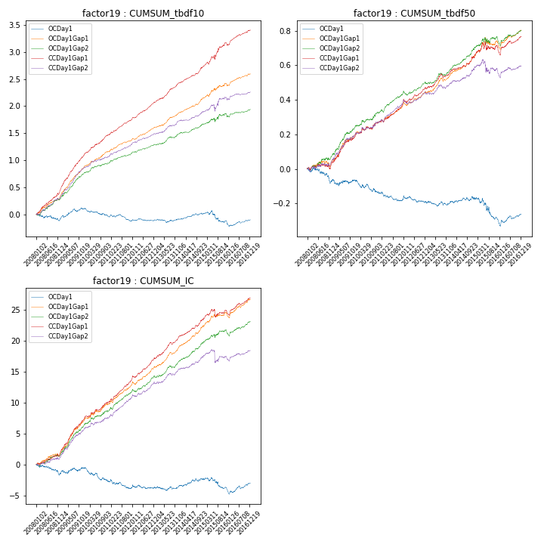

**因子换手率:** 43.83%

**截面指标_OCDay1:**

|  |  |  |  |  |  |  |  |  |
| --- | --- | --- | --- | --- | --- | --- | --- | --- |
| year | annret_tbdf10 | sharpe_tbdf10 | maxdd_tbdf10 | annret_tbdf50 | sharpe_tbdf50 | maxdd_tbdf50 | mean_IC | tstat_IC |
| 2008 | -0.08 | -0.91 | -0.12 | -0.07 | -1.67 | -0.09 | -0.01 | -1.79 |
| 2009 | 0.19 | 2.68 | -0.05 | 0.0 | 0.12 | -0.04 | 0.0 | 1.08 |
| 2010 | -0.14 | -2.31 | -0.14 | -0.07 | -2.02 | -0.07 | -0.01 | -2.71 |
| 2011 | -0.09 | -1.72 | -0.12 | -0.04 | -1.58 | -0.05 | -0.0 | -1.54 |
| 2012 | 0.02 | 0.39 | -0.05 | -0.01 | -0.55 | -0.04 | 0.0 | 0.08 |
| 2013 | 0.02 | 0.36 | -0.06 | -0.0 | -0.1 | -0.03 | 0.0 | 0.33 |
| 2014 | 0.09 | 1.91 | -0.03 | 0.03 | 1.12 | -0.02 | 0.0 | 1.89 |
| 2015 | -0.13 | -1.44 | -0.2 | -0.13 | -2.2 | -0.12 | -0.01 | -1.73 |
| 2016 | 0.03 | 0.51 | -0.09 | 0.03 | 1.03 | -0.04 | 0.0 | 1.34 |

**截面指标_CCDay1Gap1:**

|  |  |  |  |  |  |  |  |  |
| --- | --- | --- | --- | --- | --- | --- | --- | --- |
| year | annret_tbdf10 | sharpe_tbdf10 | maxdd_tbdf10 | annret_tbdf50 | sharpe_tbdf50 | maxdd_tbdf50 | mean_IC | tstat_IC |
| 2008 | 0.45 | 5.95 | -0.03 | 0.02 | 0.58 | -0.03 | 0.01 | 2.82 |
| 2009 | 0.65 | 9.07 | -0.01 | 0.17 | 4.32 | -0.01 | 0.02 | 7.1 |
| 2010 | 0.37 | 6.02 | -0.01 | 0.09 | 2.25 | -0.02 | 0.01 | 3.7 |
| 2011 | 0.27 | 6.0 | -0.02 | 0.1 | 4.1 | -0.01 | 0.01 | 5.93 |
| 2012 | 0.33 | 7.47 | -0.01 | 0.09 | 3.52 | -0.02 | 0.01 | 5.36 |
| 2013 | 0.36 | 6.85 | -0.02 | 0.1 | 3.55 | -0.03 | 0.01 | 6.04 |
| 2014 | 0.3 | 6.12 | -0.01 | 0.09 | 3.36 | -0.01 | 0.01 | 5.22 |
| 2015 | 0.44 | 4.02 | -0.07 | 0.06 | 0.9 | -0.05 | 0.01 | 1.2 |
| 2016 | 0.24 | 4.63 | -0.04 | 0.06 | 1.84 | -0.05 | 0.01 | 3.5 |

**风格暴露:**

|  |  |  |  |  |
| --- | --- | --- | --- | --- |
|  | long | short | corr_OCDay1 | corr_CCDay1Gap1 |
| liquidity10 | -0.06 | 0.07 | 0.24 | 0.2 |
| liquidity20 | -0.04 | 0.05 | 0.19 | 0.17 |
| liquidity5 | -0.09 | 0.1 | 0.28 | 0.26 |
| logmktcap | 0.02 | -0.01 | -0.03 | -0.08 |
| momentum15 | -0.17 | 0.18 | 0.38 | 0.36 |
| momentum30 | -0.12 | 0.13 | 0.28 | 0.23 |
| momentum5 | -0.27 | 0.27 | 0.38 | 0.37 |
| retvolatility30 | -0.02 | 0.03 | 0.18 | 0.15 |