Factors Report 20080102-20161230

**1. factor8**

**截面指标累计曲线:**

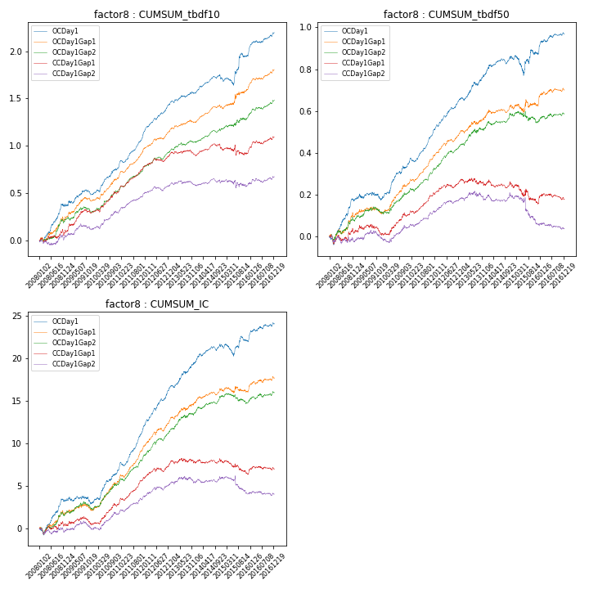

**因子换手率:** 35.52%

**截面指标_OCDay1:**

|  |  |  |  |  |  |  |  |  |
| --- | --- | --- | --- | --- | --- | --- | --- | --- |
| year | annret_tbdf10 | sharpe_tbdf10 | maxdd_tbdf10 | annret_tbdf50 | sharpe_tbdf50 | maxdd_tbdf50 | mean_IC | tstat_IC |
| 2008 | 0.38 | 4.47 | -0.03 | 0.18 | 3.71 | -0.04 | 0.01 | 3.53 |
| 2009 | 0.11 | 1.66 | -0.05 | 0.0 | 0.09 | -0.04 | -0.0 | -0.3 |
| 2010 | 0.27 | 4.49 | -0.03 | 0.17 | 4.24 | -0.01 | 0.02 | 4.47 |
| 2011 | 0.39 | 7.45 | -0.02 | 0.17 | 6.11 | -0.02 | 0.02 | 7.24 |
| 2012 | 0.31 | 6.08 | -0.01 | 0.15 | 5.15 | -0.01 | 0.02 | 5.98 |
| 2013 | 0.11 | 2.37 | -0.02 | 0.13 | 3.19 | -0.02 | 0.01 | 3.63 |
| 2014 | 0.16 | 3.29 | -0.05 | 0.07 | 2.32 | -0.03 | 0.01 | 2.8 |
| 2015 | 0.23 | 1.94 | -0.08 | 0.01 | 0.23 | -0.09 | 0.0 | 0.42 |
| 2016 | 0.25 | 4.33 | -0.02 | 0.1 | 3.0 | -0.01 | 0.01 | 3.05 |

**截面指标_CCDay1Gap1:**

|  |  |  |  |  |  |  |  |  |
| --- | --- | --- | --- | --- | --- | --- | --- | --- |
| year | annret_tbdf10 | sharpe_tbdf10 | maxdd_tbdf10 | annret_tbdf50 | sharpe_tbdf50 | maxdd_tbdf50 | mean_IC | tstat_IC |
| 2008 | 0.09 | 1.12 | -0.07 | 0.02 | 0.49 | -0.04 | 0.0 | 0.42 |
| 2009 | 0.21 | 2.93 | -0.04 | -0.01 | -0.2 | -0.05 | 0.0 | 0.31 |
| 2010 | 0.21 | 3.32 | -0.03 | 0.09 | 2.38 | -0.02 | 0.01 | 2.99 |
| 2011 | 0.28 | 5.78 | -0.01 | 0.1 | 4.17 | -0.01 | 0.01 | 5.13 |
| 2012 | 0.13 | 2.64 | -0.03 | 0.06 | 2.36 | -0.02 | 0.01 | 2.51 |
| 2013 | -0.02 | -0.35 | -0.06 | -0.02 | -0.41 | -0.04 | 0.0 | 0.04 |
| 2014 | 0.07 | 1.43 | -0.06 | -0.01 | -0.35 | -0.04 | 0.0 | 0.06 |
| 2015 | -0.02 | -0.24 | -0.11 | -0.08 | -1.29 | -0.09 | -0.01 | -1.7 |
| 2016 | 0.16 | 2.92 | -0.04 | 0.02 | 0.54 | -0.03 | 0.0 | 0.93 |

**风格暴露:**

|  |  |  |  |  |
| --- | --- | --- | --- | --- |
|  | long | short | corr_OCDay1 | corr_CCDay1Gap1 |
| liquidity10 | -0.13 | 0.13 | 0.25 | 0.17 |
| liquidity20 | -0.09 | 0.1 | 0.2 | 0.14 |
| liquidity5 | -0.15 | 0.15 | 0.28 | 0.17 |
| logmktcap | -0.27 | 0.27 | 0.22 | 0.21 |
| momentum15 | -0.08 | 0.08 | 0.25 | 0.18 |
| momentum30 | -0.08 | 0.09 | 0.26 | 0.21 |
| momentum5 | -0.04 | 0.05 | 0.24 | 0.13 |
| retvolatility30 | -0.12 | 0.13 | 0.27 | 0.2 |