Factors Report 20080102-20161230

**1. factor11**

**截面指标累计曲线:**

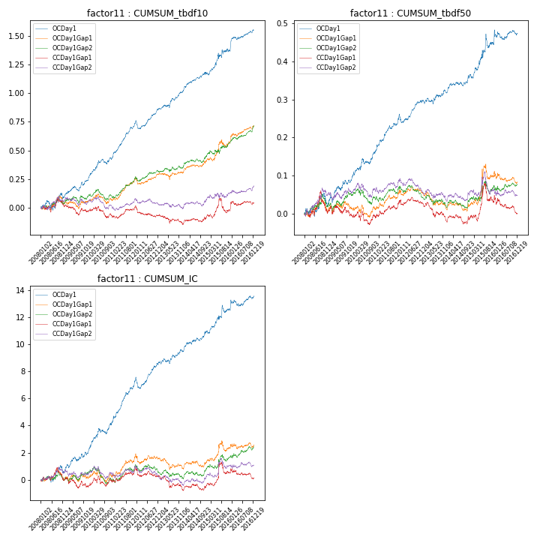

**因子换手率:** 45.31%

**截面指标_OCDay1:**

|  |  |  |  |  |  |  |  |  |
| --- | --- | --- | --- | --- | --- | --- | --- | --- |
| year | annret_tbdf10 | sharpe_tbdf10 | maxdd_tbdf10 | annret_tbdf50 | sharpe_tbdf50 | maxdd_tbdf50 | mean_IC | tstat_IC |
| 2008 | 0.1 | 1.22 | -0.08 | 0.02 | 0.66 | -0.04 | 0.0 | 0.87 |
| 2009 | 0.15 | 2.87 | -0.04 | 0.07 | 2.55 | -0.02 | 0.01 | 2.61 |
| 2010 | 0.18 | 3.02 | -0.04 | 0.07 | 2.7 | -0.01 | 0.01 | 3.32 |
| 2011 | 0.33 | 6.9 | -0.02 | 0.1 | 4.56 | -0.01 | 0.01 | 6.08 |
| 2012 | 0.11 | 2.28 | -0.07 | 0.04 | 1.88 | -0.02 | 0.0 | 2.01 |
| 2013 | 0.15 | 2.81 | -0.03 | 0.02 | 1.13 | -0.02 | 0.0 | 1.68 |
| 2014 | 0.16 | 3.23 | -0.02 | 0.05 | 2.52 | -0.01 | 0.01 | 3.05 |
| 2015 | 0.2 | 2.02 | -0.05 | 0.08 | 1.73 | -0.04 | 0.01 | 1.93 |
| 2016 | 0.18 | 3.19 | -0.03 | 0.03 | 1.05 | -0.03 | 0.0 | 1.78 |

**截面指标_CCDay1Gap1:**

|  |  |  |  |  |  |  |  |  |
| --- | --- | --- | --- | --- | --- | --- | --- | --- |
| year | annret_tbdf10 | sharpe_tbdf10 | maxdd_tbdf10 | annret_tbdf50 | sharpe_tbdf50 | maxdd_tbdf50 | mean_IC | tstat_IC |
| 2008 | 0.02 | 0.21 | -0.08 | 0.0 | 0.09 | -0.06 | -0.0 | -0.01 |
| 2009 | -0.04 | -0.79 | -0.09 | -0.01 | -0.34 | -0.03 | -0.0 | -0.82 |
| 2010 | -0.05 | -0.91 | -0.1 | -0.01 | -0.19 | -0.04 | 0.0 | 0.55 |
| 2011 | 0.1 | 2.14 | -0.02 | 0.05 | 2.31 | -0.01 | 0.0 | 2.21 |
| 2012 | -0.08 | -1.7 | -0.1 | -0.01 | -0.44 | -0.02 | -0.0 | -1.27 |
| 2013 | -0.08 | -1.48 | -0.09 | -0.05 | -2.04 | -0.05 | -0.0 | -1.95 |
| 2014 | 0.06 | 1.19 | -0.03 | 0.01 | 0.35 | -0.03 | 0.0 | 0.72 |
| 2015 | 0.07 | 0.77 | -0.13 | 0.04 | 0.88 | -0.05 | 0.0 | 1.09 |
| 2016 | 0.05 | 0.98 | -0.04 | -0.03 | -1.23 | -0.05 | -0.0 | -0.84 |

**风格暴露:**

|  |  |  |  |  |
| --- | --- | --- | --- | --- |
|  | long | short | corr_OCDay1 | corr_CCDay1Gap1 |
| liquidity10 | 0.01 | -0.01 | -0.02 | -0.02 |
| liquidity20 | 0.02 | -0.02 | -0.03 | -0.04 |
| liquidity5 | 0.0 | -0.0 | -0.01 | -0.06 |
| logmktcap | -0.03 | 0.03 | 0.12 | 0.11 |
| momentum15 | -0.07 | 0.07 | 0.18 | 0.12 |
| momentum30 | -0.05 | 0.06 | 0.19 | 0.12 |
| momentum5 | -0.03 | 0.03 | 0.15 | 0.17 |
| retvolatility30 | 0.05 | -0.05 | -0.08 | -0.05 |