Factors Report 20080102-20161230

**1. factor36**

**截面指标累计曲线:**

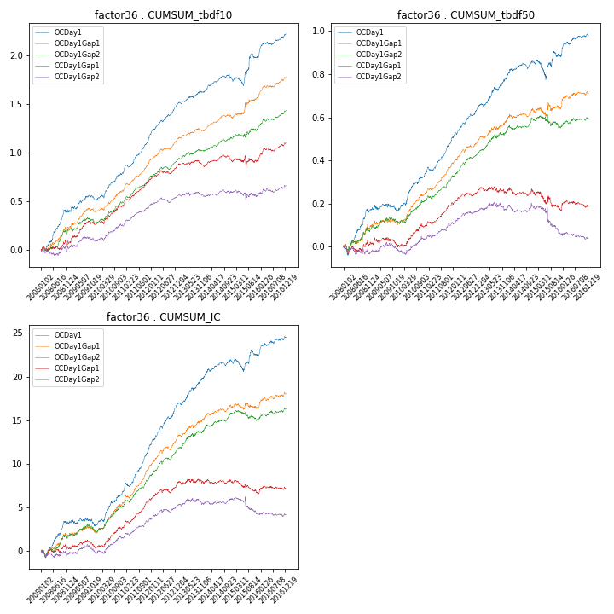

**因子换手率:** 35.42%

**截面指标_OCDay1:**

|  |  |  |  |  |  |  |  |  |
| --- | --- | --- | --- | --- | --- | --- | --- | --- |
| year | annret_tbdf10 | sharpe_tbdf10 | maxdd_tbdf10 | annret_tbdf50 | sharpe_tbdf50 | maxdd_tbdf50 | mean_IC | tstat_IC |
| 2008 | 0.4 | 4.72 | -0.03 | 0.17 | 3.51 | -0.04 | 0.01 | 3.5 |
| 2009 | 0.12 | 1.67 | -0.05 | -0.0 | -0.02 | -0.04 | -0.0 | -0.27 |
| 2010 | 0.27 | 4.5 | -0.03 | 0.17 | 4.42 | -0.01 | 0.02 | 4.49 |
| 2011 | 0.4 | 7.73 | -0.02 | 0.17 | 6.24 | -0.02 | 0.02 | 7.46 |
| 2012 | 0.31 | 6.2 | -0.02 | 0.15 | 5.27 | -0.01 | 0.02 | 6.07 |
| 2013 | 0.13 | 2.86 | -0.02 | 0.13 | 3.26 | -0.01 | 0.01 | 3.77 |
| 2014 | 0.15 | 3.12 | -0.05 | 0.07 | 2.3 | -0.03 | 0.01 | 2.75 |
| 2015 | 0.21 | 1.73 | -0.08 | 0.02 | 0.37 | -0.09 | 0.0 | 0.49 |
| 2016 | 0.24 | 4.28 | -0.02 | 0.1 | 3.03 | -0.01 | 0.01 | 3.1 |

**截面指标_CCDay1Gap1:**

|  |  |  |  |  |  |  |  |  |
| --- | --- | --- | --- | --- | --- | --- | --- | --- |
| year | annret_tbdf10 | sharpe_tbdf10 | maxdd_tbdf10 | annret_tbdf50 | sharpe_tbdf50 | maxdd_tbdf50 | mean_IC | tstat_IC |
| 2008 | 0.07 | 0.87 | -0.07 | 0.01 | 0.27 | -0.04 | 0.0 | 0.34 |
| 2009 | 0.2 | 2.86 | -0.04 | -0.0 | -0.11 | -0.04 | 0.0 | 0.31 |
| 2010 | 0.18 | 2.95 | -0.03 | 0.09 | 2.4 | -0.02 | 0.01 | 2.96 |
| 2011 | 0.29 | 5.99 | -0.01 | 0.11 | 4.26 | -0.01 | 0.01 | 5.32 |
| 2012 | 0.14 | 2.83 | -0.04 | 0.07 | 2.54 | -0.02 | 0.01 | 2.57 |
| 2013 | -0.01 | -0.19 | -0.06 | -0.01 | -0.34 | -0.03 | 0.0 | 0.14 |
| 2014 | 0.06 | 1.25 | -0.06 | -0.01 | -0.3 | -0.04 | 0.0 | 0.04 |
| 2015 | 0.02 | 0.19 | -0.1 | -0.07 | -1.18 | -0.09 | -0.01 | -1.58 |
| 2016 | 0.17 | 3.12 | -0.04 | 0.01 | 0.38 | -0.03 | 0.0 | 0.89 |

**风格暴露:**

|  |  |  |  |  |
| --- | --- | --- | --- | --- |
|  | long | short | corr_OCDay1 | corr_CCDay1Gap1 |
| liquidity10 | -0.13 | 0.13 | 0.26 | 0.17 |
| liquidity20 | -0.1 | 0.1 | 0.22 | 0.15 |
| liquidity5 | -0.15 | 0.15 | 0.29 | 0.18 |
| logmktcap | -0.26 | 0.27 | 0.2 | 0.19 |
| momentum15 | -0.08 | 0.09 | 0.25 | 0.18 |
| momentum30 | -0.09 | 0.09 | 0.26 | 0.21 |
| momentum5 | -0.04 | 0.05 | 0.23 | 0.13 |
| retvolatility30 | -0.12 | 0.13 | 0.29 | 0.21 |