Factors Report 20080102-20161230

**1. factor3**

**截面指标累计曲线:**

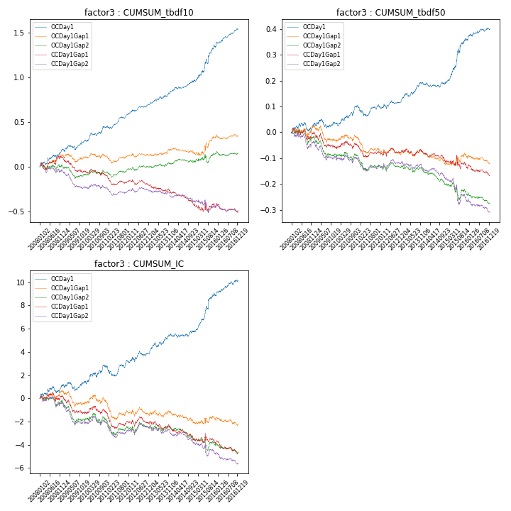

**因子换手率:** 42.5%

**截面指标_OCDay1:**

|  |  |  |  |  |  |  |  |  |
| --- | --- | --- | --- | --- | --- | --- | --- | --- |
| year | annret_tbdf10 | sharpe_tbdf10 | maxdd_tbdf10 | annret_tbdf50 | sharpe_tbdf50 | maxdd_tbdf50 | mean_IC | tstat_IC |
| 2008 | 0.19 | 2.8 | -0.03 | 0.03 | 1.0 | -0.03 | 0.0 | 1.8 |
| 2009 | 0.09 | 1.56 | -0.05 | 0.0 | 0.15 | -0.04 | 0.0 | 0.5 |
| 2010 | 0.16 | 2.76 | -0.03 | 0.07 | 2.59 | -0.01 | 0.01 | 2.13 |
| 2011 | 0.15 | 3.26 | -0.03 | -0.01 | -0.22 | -0.04 | 0.0 | 0.57 |
| 2012 | 0.12 | 3.15 | -0.02 | 0.03 | 1.6 | -0.02 | 0.0 | 1.95 |
| 2013 | 0.14 | 2.69 | -0.02 | 0.06 | 2.76 | -0.01 | 0.01 | 2.27 |
| 2014 | 0.13 | 2.81 | -0.02 | 0.0 | 0.17 | -0.02 | 0.0 | 0.81 |
| 2015 | 0.38 | 3.18 | -0.05 | 0.17 | 3.5 | -0.02 | 0.01 | 3.04 |
| 2016 | 0.19 | 3.96 | -0.01 | 0.04 | 2.05 | -0.01 | 0.01 | 2.72 |

**截面指标_CCDay1Gap1:**

|  |  |  |  |  |  |  |  |  |
| --- | --- | --- | --- | --- | --- | --- | --- | --- |
| year | annret_tbdf10 | sharpe_tbdf10 | maxdd_tbdf10 | annret_tbdf50 | sharpe_tbdf50 | maxdd_tbdf50 | mean_IC | tstat_IC |
| 2008 | 0.1 | 1.23 | -0.07 | -0.0 | -0.04 | -0.05 | 0.0 | 0.32 |
| 2009 | -0.16 | -2.7 | -0.17 | -0.06 | -2.05 | -0.06 | -0.01 | -2.66 |
| 2010 | -0.05 | -0.83 | -0.07 | 0.01 | 0.37 | -0.03 | 0.0 | 0.13 |
| 2011 | -0.06 | -1.4 | -0.1 | -0.03 | -1.28 | -0.05 | -0.0 | -1.57 |
| 2012 | -0.05 | -1.1 | -0.07 | 0.01 | 0.47 | -0.02 | 0.0 | 0.08 |
| 2013 | -0.09 | -1.69 | -0.09 | -0.01 | -0.5 | -0.03 | -0.0 | -1.37 |
| 2014 | -0.14 | -3.09 | -0.14 | -0.03 | -1.75 | -0.04 | -0.0 | -2.07 |
| 2015 | -0.01 | -0.09 | -0.09 | -0.03 | -0.5 | -0.05 | -0.0 | -0.45 |
| 2016 | -0.07 | -1.49 | -0.1 | -0.03 | -1.32 | -0.04 | -0.0 | -1.85 |

**风格暴露:**

|  |  |  |  |  |
| --- | --- | --- | --- | --- |
|  | long | short | corr_OCDay1 | corr_CCDay1Gap1 |
| liquidity10 | 0.01 | -0.0 | -0.04 | -0.06 |
| liquidity20 | -0.0 | 0.01 | -0.03 | -0.05 |
| liquidity5 | 0.02 | -0.01 | -0.03 | -0.05 |
| logmktcap | 0.04 | -0.03 | -0.06 | 0.02 |
| momentum15 | 0.08 | -0.08 | -0.03 | -0.05 |
| momentum30 | 0.06 | -0.06 | -0.01 | -0.05 |
| momentum5 | 0.07 | -0.06 | -0.0 | -0.01 |
| retvolatility30 | 0.0 | 0.0 | -0.0 | -0.0 |