Factors Report 20080102-20161230

**1. factor12**

**截面指标累计曲线:**

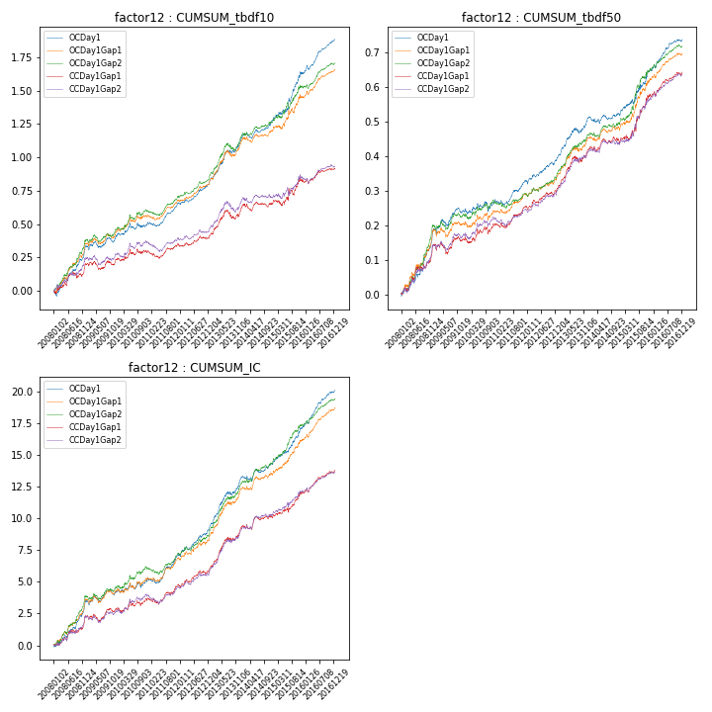

**因子换手率:** 30.0%

**截面指标_OCDay1:**

|  |  |  |  |  |  |  |  |  |
| --- | --- | --- | --- | --- | --- | --- | --- | --- |
| year | annret_tbdf10 | sharpe_tbdf10 | maxdd_tbdf10 | annret_tbdf50 | sharpe_tbdf50 | maxdd_tbdf50 | mean_IC | tstat_IC |
| 2008 | 0.33 | 5.1 | -0.04 | 0.18 | 5.21 | -0.01 | 0.01 | 5.37 |
| 2009 | 0.08 | 1.5 | -0.05 | 0.06 | 2.02 | -0.02 | 0.0 | 1.25 |
| 2010 | 0.11 | 1.8 | -0.05 | 0.04 | 1.29 | -0.03 | 0.0 | 1.75 |
| 2011 | 0.14 | 3.81 | -0.03 | 0.06 | 2.97 | -0.02 | 0.01 | 3.66 |
| 2012 | 0.17 | 4.28 | -0.02 | 0.07 | 3.22 | -0.01 | 0.01 | 4.14 |
| 2013 | 0.31 | 4.66 | -0.02 | 0.12 | 4.45 | -0.02 | 0.02 | 5.54 |
| 2014 | 0.15 | 3.23 | -0.04 | 0.01 | 0.4 | -0.02 | 0.0 | 2.25 |
| 2015 | 0.35 | 3.88 | -0.03 | 0.13 | 3.56 | -0.01 | 0.01 | 4.56 |
| 2016 | 0.26 | 6.38 | -0.03 | 0.09 | 4.52 | -0.01 | 0.01 | 6.59 |

**截面指标_CCDay1Gap1:**

|  |  |  |  |  |  |  |  |  |
| --- | --- | --- | --- | --- | --- | --- | --- | --- |
| year | annret_tbdf10 | sharpe_tbdf10 | maxdd_tbdf10 | annret_tbdf50 | sharpe_tbdf50 | maxdd_tbdf50 | mean_IC | tstat_IC |
| 2008 | 0.19 | 2.49 | -0.05 | 0.14 | 3.79 | -0.01 | 0.01 | 3.39 |
| 2009 | 0.04 | 0.77 | -0.06 | 0.02 | 0.76 | -0.03 | 0.0 | 1.17 |
| 2010 | 0.06 | 1.01 | -0.04 | 0.05 | 1.59 | -0.02 | 0.0 | 1.45 |
| 2011 | 0.04 | 0.92 | -0.06 | 0.05 | 2.58 | -0.01 | 0.0 | 2.08 |
| 2012 | 0.08 | 2.03 | -0.02 | 0.05 | 2.32 | -0.01 | 0.01 | 2.56 |
| 2013 | 0.19 | 2.78 | -0.07 | 0.12 | 4.16 | -0.02 | 0.01 | 4.79 |
| 2014 | 0.05 | 0.97 | -0.05 | 0.02 | 0.95 | -0.02 | 0.0 | 1.69 |
| 2015 | 0.16 | 1.51 | -0.05 | 0.14 | 3.05 | -0.02 | 0.01 | 3.03 |
| 2016 | 0.1 | 2.6 | -0.03 | 0.07 | 3.74 | -0.01 | 0.01 | 4.64 |

**风格暴露:**

|  |  |  |  |  |
| --- | --- | --- | --- | --- |
|  | long | short | corr_OCDay1 | corr_CCDay1Gap1 |
| liquidity10 | 0.04 | -0.04 | 0.05 | 0.03 |
| liquidity20 | 0.03 | -0.02 | 0.05 | 0.03 |
| liquidity5 | 0.05 | -0.04 | 0.04 | 0.04 |
| logmktcap | -0.04 | 0.04 | 0.04 | 0.1 |
| momentum15 | 0.02 | -0.01 | 0.08 | 0.09 |
| momentum30 | -0.0 | 0.01 | 0.15 | 0.14 |
| momentum5 | 0.01 | -0.0 | 0.08 | 0.04 |
| retvolatility30 | 0.02 | -0.01 | 0.12 | 0.08 |