Factors Report 20080102-20161230

**1. factor13**

**截面指标累计曲线:**

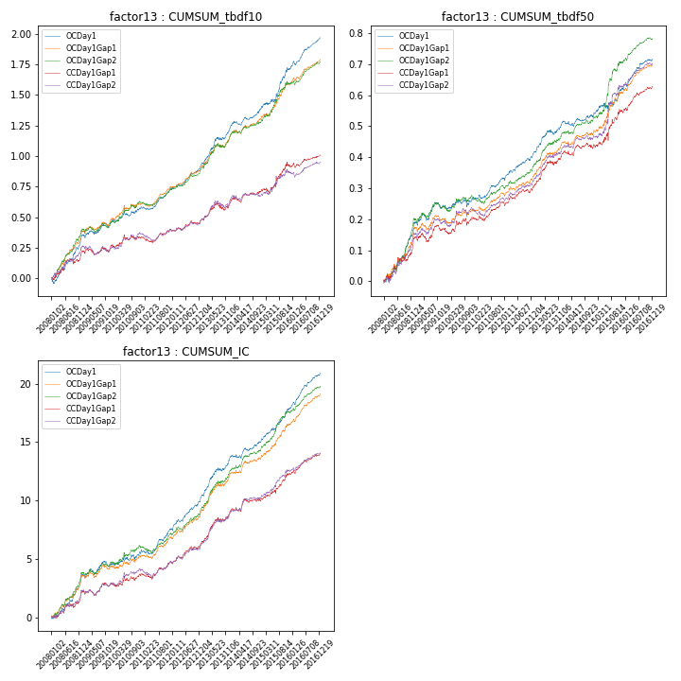

**因子换手率:** 30.13%

**截面指标_OCDay1:**

|  |  |  |  |  |  |  |  |  |
| --- | --- | --- | --- | --- | --- | --- | --- | --- |
| year | annret_tbdf10 | sharpe_tbdf10 | maxdd_tbdf10 | annret_tbdf50 | sharpe_tbdf50 | maxdd_tbdf50 | mean_IC | tstat_IC |
| 2008 | 0.34 | 5.37 | -0.04 | 0.19 | 5.32 | -0.01 | 0.01 | 5.54 |
| 2009 | 0.12 | 2.21 | -0.04 | 0.05 | 1.88 | -0.02 | 0.0 | 1.58 |
| 2010 | 0.13 | 2.29 | -0.04 | 0.03 | 1.17 | -0.03 | 0.01 | 2.0 |
| 2011 | 0.15 | 4.23 | -0.03 | 0.06 | 3.34 | -0.01 | 0.01 | 3.65 |
| 2012 | 0.19 | 5.04 | -0.01 | 0.08 | 3.86 | -0.01 | 0.01 | 5.02 |
| 2013 | 0.31 | 4.81 | -0.02 | 0.1 | 4.16 | -0.02 | 0.01 | 5.35 |
| 2014 | 0.15 | 3.31 | -0.03 | 0.02 | 0.86 | -0.02 | 0.01 | 2.59 |
| 2015 | 0.33 | 3.79 | -0.03 | 0.09 | 2.37 | -0.03 | 0.01 | 4.51 |
| 2016 | 0.26 | 6.49 | -0.03 | 0.1 | 4.99 | -0.01 | 0.01 | 6.81 |

**截面指标_CCDay1Gap1:**

|  |  |  |  |  |  |  |  |  |
| --- | --- | --- | --- | --- | --- | --- | --- | --- |
| year | annret_tbdf10 | sharpe_tbdf10 | maxdd_tbdf10 | annret_tbdf50 | sharpe_tbdf50 | maxdd_tbdf50 | mean_IC | tstat_IC |
| 2008 | 0.21 | 2.77 | -0.04 | 0.14 | 3.52 | -0.02 | 0.01 | 3.1 |
| 2009 | 0.06 | 1.11 | -0.05 | 0.03 | 1.08 | -0.03 | 0.0 | 1.39 |
| 2010 | 0.07 | 1.14 | -0.04 | 0.04 | 1.32 | -0.02 | 0.0 | 1.5 |
| 2011 | 0.05 | 1.35 | -0.05 | 0.05 | 2.56 | -0.02 | 0.0 | 2.04 |
| 2012 | 0.09 | 2.21 | -0.03 | 0.05 | 2.21 | -0.01 | 0.01 | 3.07 |
| 2013 | 0.15 | 2.13 | -0.06 | 0.11 | 4.22 | -0.01 | 0.01 | 4.42 |
| 2014 | 0.09 | 1.87 | -0.05 | 0.02 | 0.83 | -0.02 | 0.0 | 1.79 |
| 2015 | 0.2 | 2.12 | -0.04 | 0.12 | 2.46 | -0.03 | 0.01 | 3.56 |
| 2016 | 0.1 | 2.6 | -0.04 | 0.08 | 4.32 | -0.01 | 0.01 | 4.68 |

**风格暴露:**

|  |  |  |  |  |
| --- | --- | --- | --- | --- |
|  | long | short | corr_OCDay1 | corr_CCDay1Gap1 |
| liquidity10 | 0.05 | -0.04 | 0.0 | 0.01 |
| liquidity20 | 0.03 | -0.03 | -0.0 | 0.01 |
| liquidity5 | 0.06 | -0.05 | 0.0 | 0.03 |
| logmktcap | -0.03 | 0.04 | 0.12 | 0.1 |
| momentum15 | 0.02 | -0.01 | 0.08 | 0.07 |
| momentum30 | 0.0 | 0.0 | 0.13 | 0.14 |
| momentum5 | 0.01 | -0.01 | 0.08 | 0.03 |
| retvolatility30 | 0.02 | -0.02 | 0.1 | 0.07 |