Factors Report 20080102-20161230

**1. factor20**

**截面指标累计曲线:**

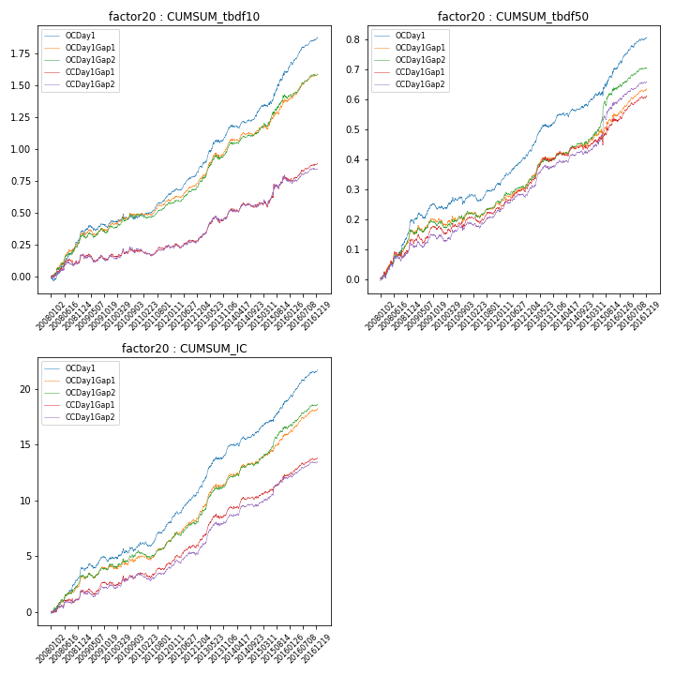

**因子换手率:** 30.35%

**截面指标_OCDay1:**

|  |  |  |  |  |  |  |  |  |
| --- | --- | --- | --- | --- | --- | --- | --- | --- |
| year | annret_tbdf10 | sharpe_tbdf10 | maxdd_tbdf10 | annret_tbdf50 | sharpe_tbdf50 | maxdd_tbdf50 | mean_IC | tstat_IC |
| 2008 | 0.35 | 5.36 | -0.03 | 0.19 | 5.31 | -0.01 | 0.02 | 5.89 |
| 2009 | 0.07 | 1.4 | -0.05 | 0.05 | 1.7 | -0.02 | 0.0 | 1.59 |
| 2010 | 0.07 | 1.18 | -0.04 | 0.05 | 1.72 | -0.03 | 0.01 | 2.39 |
| 2011 | 0.16 | 4.63 | -0.01 | 0.04 | 1.92 | -0.02 | 0.01 | 3.9 |
| 2012 | 0.2 | 5.31 | -0.02 | 0.1 | 4.84 | -0.01 | 0.01 | 5.52 |
| 2013 | 0.31 | 5.03 | -0.02 | 0.12 | 4.86 | -0.01 | 0.02 | 5.88 |
| 2014 | 0.14 | 3.14 | -0.03 | 0.03 | 1.68 | -0.01 | 0.01 | 2.77 |
| 2015 | 0.31 | 3.82 | -0.02 | 0.13 | 3.19 | -0.01 | 0.01 | 4.45 |
| 2016 | 0.27 | 6.72 | -0.02 | 0.1 | 5.21 | -0.01 | 0.01 | 6.11 |

**截面指标_CCDay1Gap1:**

|  |  |  |  |  |  |  |  |  |
| --- | --- | --- | --- | --- | --- | --- | --- | --- |
| year | annret_tbdf10 | sharpe_tbdf10 | maxdd_tbdf10 | annret_tbdf50 | sharpe_tbdf50 | maxdd_tbdf50 | mean_IC | tstat_IC |
| 2008 | 0.16 | 2.1 | -0.06 | 0.13 | 3.07 | -0.02 | 0.01 | 2.55 |
| 2009 | 0.01 | 0.12 | -0.06 | 0.04 | 1.63 | -0.03 | 0.0 | 1.49 |
| 2010 | 0.04 | 0.64 | -0.04 | 0.04 | 1.31 | -0.02 | 0.0 | 1.59 |
| 2011 | 0.02 | 0.63 | -0.04 | 0.03 | 1.57 | -0.02 | 0.0 | 1.89 |
| 2012 | 0.07 | 2.06 | -0.03 | 0.07 | 3.4 | -0.01 | 0.01 | 3.52 |
| 2013 | 0.2 | 3.14 | -0.05 | 0.1 | 3.83 | -0.02 | 0.01 | 4.72 |
| 2014 | 0.07 | 1.4 | -0.04 | 0.02 | 1.02 | -0.02 | 0.0 | 2.21 |
| 2015 | 0.2 | 2.01 | -0.05 | 0.09 | 1.86 | -0.03 | 0.01 | 3.44 |
| 2016 | 0.13 | 3.28 | -0.02 | 0.08 | 4.41 | -0.01 | 0.01 | 4.01 |

**风格暴露:**

|  |  |  |  |  |
| --- | --- | --- | --- | --- |
|  | long | short | corr_OCDay1 | corr_CCDay1Gap1 |
| liquidity10 | 0.05 | -0.05 | -0.01 | -0.01 |
| liquidity20 | 0.03 | -0.03 | -0.0 | -0.0 |
| liquidity5 | 0.06 | -0.06 | -0.01 | 0.0 |
| logmktcap | -0.04 | 0.05 | 0.09 | 0.11 |
| momentum15 | 0.03 | -0.02 | 0.06 | 0.03 |
| momentum30 | 0.01 | -0.0 | 0.13 | 0.11 |
| momentum5 | 0.02 | -0.01 | 0.08 | 0.02 |
| retvolatility30 | 0.02 | -0.02 | 0.08 | 0.04 |