Factors Report 20080102-20161230

**1. factor27**

**截面指标累计曲线:**

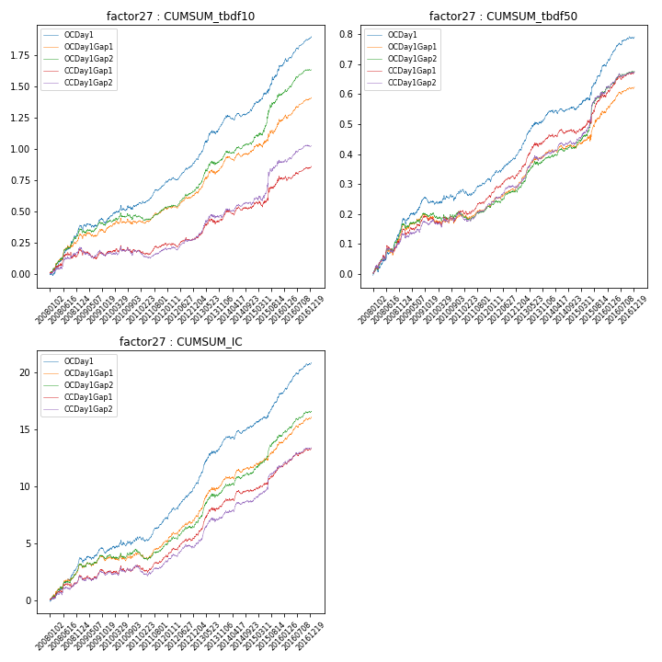

**因子换手率:** 30.56%

**截面指标_OCDay1:**

|  |  |  |  |  |  |  |  |  |
| --- | --- | --- | --- | --- | --- | --- | --- | --- |
| year | annret_tbdf10 | sharpe_tbdf10 | maxdd_tbdf10 | annret_tbdf50 | sharpe_tbdf50 | maxdd_tbdf50 | mean_IC | tstat_IC |
| 2008 | 0.38 | 5.65 | -0.03 | 0.18 | 5.22 | -0.01 | 0.01 | 6.03 |
| 2009 | 0.06 | 1.11 | -0.04 | 0.06 | 2.27 | -0.02 | 0.0 | 1.29 |
| 2010 | 0.12 | 2.06 | -0.04 | 0.04 | 1.56 | -0.02 | 0.01 | 1.88 |
| 2011 | 0.18 | 5.22 | -0.02 | 0.04 | 1.95 | -0.02 | 0.01 | 3.63 |
| 2012 | 0.16 | 4.39 | -0.02 | 0.09 | 4.31 | -0.01 | 0.01 | 5.52 |
| 2013 | 0.33 | 5.36 | -0.03 | 0.13 | 5.01 | -0.01 | 0.02 | 5.93 |
| 2014 | 0.11 | 2.44 | -0.04 | 0.02 | 0.91 | -0.01 | 0.01 | 2.56 |
| 2015 | 0.33 | 3.86 | -0.03 | 0.15 | 3.84 | -0.01 | 0.01 | 4.42 |
| 2016 | 0.24 | 5.79 | -0.02 | 0.1 | 4.98 | -0.01 | 0.01 | 6.04 |

**截面指标_CCDay1Gap1:**

|  |  |  |  |  |  |  |  |  |
| --- | --- | --- | --- | --- | --- | --- | --- | --- |
| year | annret_tbdf10 | sharpe_tbdf10 | maxdd_tbdf10 | annret_tbdf50 | sharpe_tbdf50 | maxdd_tbdf50 | mean_IC | tstat_IC |
| 2008 | 0.18 | 2.27 | -0.05 | 0.14 | 3.8 | -0.02 | 0.01 | 3.11 |
| 2009 | -0.01 | -0.14 | -0.08 | 0.04 | 1.58 | -0.02 | 0.0 | 0.81 |
| 2010 | 0.01 | 0.12 | -0.06 | 0.03 | 0.96 | -0.03 | 0.0 | 1.0 |
| 2011 | 0.04 | 1.09 | -0.04 | 0.05 | 2.7 | -0.01 | 0.0 | 1.77 |
| 2012 | 0.05 | 1.4 | -0.03 | 0.07 | 3.58 | -0.01 | 0.01 | 3.34 |
| 2013 | 0.18 | 2.8 | -0.04 | 0.12 | 4.35 | -0.01 | 0.01 | 4.69 |
| 2014 | 0.09 | 1.79 | -0.04 | 0.02 | 0.96 | -0.01 | 0.0 | 2.18 |
| 2015 | 0.22 | 2.37 | -0.05 | 0.13 | 2.83 | -0.02 | 0.01 | 3.13 |
| 2016 | 0.1 | 2.42 | -0.03 | 0.08 | 3.97 | -0.01 | 0.01 | 3.88 |

**风格暴露:**

|  |  |  |  |  |
| --- | --- | --- | --- | --- |
|  | long | short | corr_OCDay1 | corr_CCDay1Gap1 |
| liquidity10 | 0.05 | -0.04 | 0.03 | 0.04 |
| liquidity20 | 0.03 | -0.02 | 0.03 | 0.04 |
| liquidity5 | 0.06 | -0.06 | 0.02 | 0.06 |
| logmktcap | -0.03 | 0.04 | 0.09 | 0.11 |
| momentum15 | 0.03 | -0.02 | 0.05 | 0.09 |
| momentum30 | 0.01 | -0.0 | 0.09 | 0.13 |
| momentum5 | 0.03 | -0.02 | 0.07 | 0.03 |
| retvolatility30 | 0.02 | -0.01 | 0.1 | 0.07 |