Factors Report 20080102-20161230

**1. factor41**

**截面指标累计曲线:**

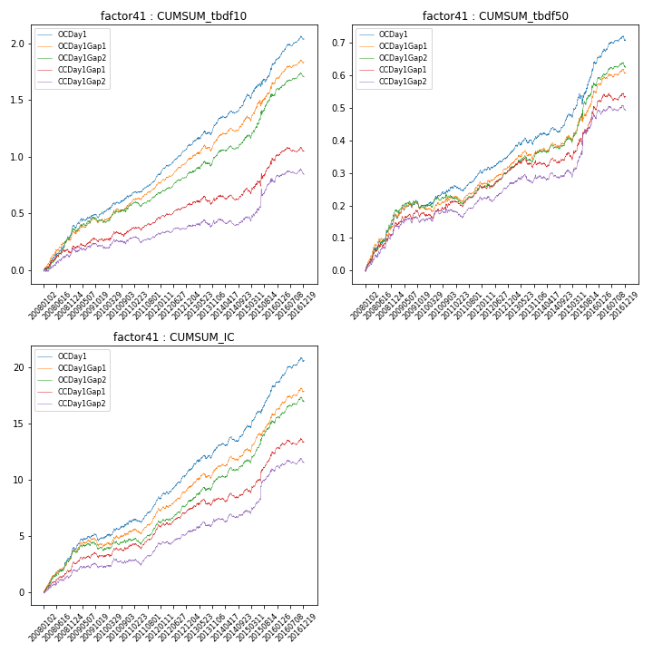

**因子换手率:** 27.1%

**截面指标_OCDay1:**

|  |  |  |  |  |  |  |  |  |
| --- | --- | --- | --- | --- | --- | --- | --- | --- |
| year | annret_tbdf10 | sharpe_tbdf10 | maxdd_tbdf10 | annret_tbdf50 | sharpe_tbdf50 | maxdd_tbdf50 | mean_IC | tstat_IC |
| 2008 | 0.39 | 5.91 | -0.02 | 0.17 | 5.76 | -0.01 | 0.02 | 6.41 |
| 2009 | 0.11 | 2.11 | -0.03 | 0.03 | 1.25 | -0.03 | 0.0 | 1.7 |
| 2010 | 0.16 | 2.81 | -0.02 | 0.06 | 2.7 | -0.01 | 0.01 | 2.82 |
| 2011 | 0.18 | 4.34 | -0.02 | 0.04 | 2.38 | -0.02 | 0.01 | 3.78 |
| 2012 | 0.26 | 7.16 | -0.01 | 0.06 | 3.33 | -0.01 | 0.01 | 5.27 |
| 2013 | 0.2 | 3.37 | -0.03 | 0.05 | 2.11 | -0.02 | 0.01 | 3.18 |
| 2014 | 0.23 | 4.53 | -0.02 | 0.06 | 3.02 | -0.02 | 0.01 | 3.41 |
| 2015 | 0.3 | 3.26 | -0.04 | 0.16 | 3.6 | -0.03 | 0.02 | 4.72 |
| 2016 | 0.21 | 4.49 | -0.03 | 0.07 | 3.36 | -0.01 | 0.01 | 4.12 |

**截面指标_CCDay1Gap1:**

|  |  |  |  |  |  |  |  |  |
| --- | --- | --- | --- | --- | --- | --- | --- | --- |
| year | annret_tbdf10 | sharpe_tbdf10 | maxdd_tbdf10 | annret_tbdf50 | sharpe_tbdf50 | maxdd_tbdf50 | mean_IC | tstat_IC |
| 2008 | 0.21 | 2.87 | -0.04 | 0.14 | 4.54 | -0.01 | 0.01 | 4.7 |
| 2009 | 0.07 | 1.19 | -0.04 | 0.04 | 1.66 | -0.02 | 0.0 | 1.42 |
| 2010 | 0.08 | 1.36 | -0.04 | 0.04 | 1.41 | -0.02 | 0.0 | 1.69 |
| 2011 | 0.09 | 2.14 | -0.03 | 0.04 | 2.5 | -0.02 | 0.01 | 3.55 |
| 2012 | 0.13 | 3.75 | -0.01 | 0.06 | 2.99 | -0.01 | 0.01 | 3.52 |
| 2013 | 0.05 | 0.73 | -0.07 | 0.02 | 0.67 | -0.03 | 0.0 | 1.43 |
| 2014 | 0.09 | 1.73 | -0.05 | 0.03 | 1.69 | -0.02 | 0.0 | 1.95 |
| 2015 | 0.25 | 2.35 | -0.05 | 0.14 | 2.88 | -0.02 | 0.01 | 4.0 |
| 2016 | 0.08 | 1.53 | -0.04 | 0.04 | 1.52 | -0.02 | 0.0 | 1.92 |

**风格暴露:**

|  |  |  |  |  |
| --- | --- | --- | --- | --- |
|  | long | short | corr_OCDay1 | corr_CCDay1Gap1 |
| liquidity10 | 0.02 | -0.01 | 0.19 | 0.2 |
| liquidity20 | 0.01 | -0.0 | 0.2 | 0.2 |
| liquidity5 | 0.02 | -0.02 | 0.19 | 0.17 |
| logmktcap | 0.03 | -0.02 | -0.11 | -0.13 |
| momentum15 | 0.02 | -0.02 | 0.04 | 0.01 |
| momentum30 | 0.01 | -0.01 | 0.1 | 0.07 |
| momentum5 | 0.01 | -0.01 | 0.04 | 0.0 |
| retvolatility30 | -0.01 | 0.01 | 0.28 | 0.26 |