Factors Report 20080102-20161230

**1. factor43**

**截面指标累计曲线:**

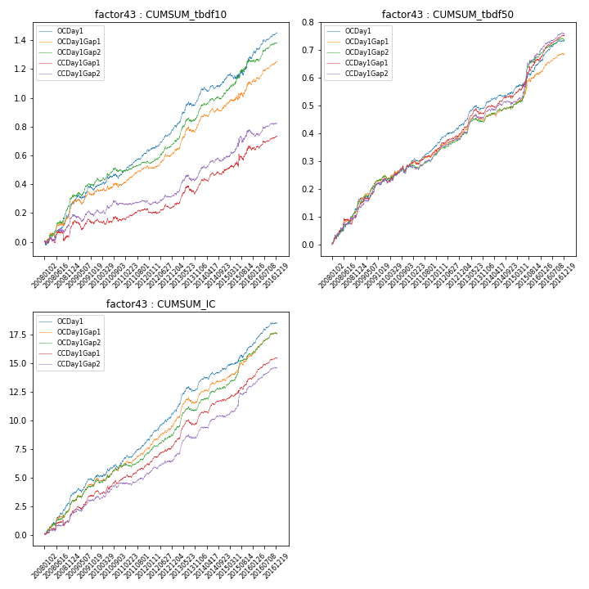

**因子换手率:** 30.68%

**截面指标_OCDay1:**

|  |  |  |  |  |  |  |  |  |
| --- | --- | --- | --- | --- | --- | --- | --- | --- |
| year | annret_tbdf10 | sharpe_tbdf10 | maxdd_tbdf10 | annret_tbdf50 | sharpe_tbdf50 | maxdd_tbdf50 | mean_IC | tstat_IC |
| 2008 | 0.26 | 4.2 | -0.04 | 0.15 | 4.99 | -0.01 | 0.01 | 5.87 |
| 2009 | 0.13 | 2.53 | -0.03 | 0.07 | 3.03 | -0.01 | 0.01 | 3.47 |
| 2010 | 0.1 | 2.22 | -0.03 | 0.07 | 2.85 | -0.02 | 0.01 | 2.79 |
| 2011 | 0.16 | 4.87 | -0.01 | 0.07 | 4.21 | -0.01 | 0.01 | 4.88 |
| 2012 | 0.15 | 4.24 | -0.01 | 0.08 | 4.12 | -0.01 | 0.01 | 4.96 |
| 2013 | 0.23 | 4.65 | -0.03 | 0.08 | 4.03 | -0.02 | 0.01 | 5.07 |
| 2014 | 0.11 | 2.82 | -0.03 | 0.03 | 1.92 | -0.01 | 0.0 | 2.8 |
| 2015 | 0.14 | 1.79 | -0.04 | 0.11 | 2.94 | -0.02 | 0.01 | 3.39 |
| 2016 | 0.18 | 4.78 | -0.02 | 0.08 | 4.92 | -0.01 | 0.01 | 5.25 |

**截面指标_CCDay1Gap1:**

|  |  |  |  |  |  |  |  |  |
| --- | --- | --- | --- | --- | --- | --- | --- | --- |
| year | annret_tbdf10 | sharpe_tbdf10 | maxdd_tbdf10 | annret_tbdf50 | sharpe_tbdf50 | maxdd_tbdf50 | mean_IC | tstat_IC |
| 2008 | 0.09 | 1.04 | -0.07 | 0.13 | 3.16 | -0.02 | 0.01 | 2.34 |
| 2009 | 0.06 | 1.1 | -0.06 | 0.11 | 4.66 | -0.01 | 0.01 | 4.55 |
| 2010 | 0.01 | 0.19 | -0.04 | 0.05 | 2.19 | -0.02 | 0.0 | 2.39 |
| 2011 | 0.06 | 1.71 | -0.02 | 0.05 | 3.23 | -0.01 | 0.01 | 3.36 |
| 2012 | 0.03 | 0.85 | -0.03 | 0.06 | 3.37 | -0.01 | 0.01 | 3.69 |
| 2013 | 0.15 | 2.84 | -0.06 | 0.09 | 4.29 | -0.02 | 0.01 | 5.0 |
| 2014 | 0.1 | 2.5 | -0.02 | 0.04 | 2.16 | -0.01 | 0.01 | 3.33 |
| 2015 | 0.14 | 1.61 | -0.05 | 0.13 | 3.21 | -0.02 | 0.01 | 3.44 |
| 2016 | 0.09 | 2.52 | -0.02 | 0.09 | 4.64 | -0.01 | 0.01 | 4.97 |

**风格暴露:**

|  |  |  |  |  |
| --- | --- | --- | --- | --- |
|  | long | short | corr_OCDay1 | corr_CCDay1Gap1 |
| liquidity10 | 0.04 | -0.04 | -0.04 | -0.04 |
| liquidity20 | 0.03 | -0.03 | -0.03 | -0.02 |
| liquidity5 | 0.04 | -0.03 | -0.04 | -0.01 |
| logmktcap | -0.03 | 0.03 | 0.08 | 0.1 |
| momentum15 | 0.02 | -0.01 | 0.02 | 0.04 |
| momentum30 | 0.01 | -0.0 | 0.06 | 0.09 |
| momentum5 | 0.0 | 0.0 | 0.08 | 0.04 |
| retvolatility30 | 0.01 | -0.01 | 0.02 | -0.01 |