Factors Report 20080102-20161230

**1. factor2**

**截面指标累计曲线:**

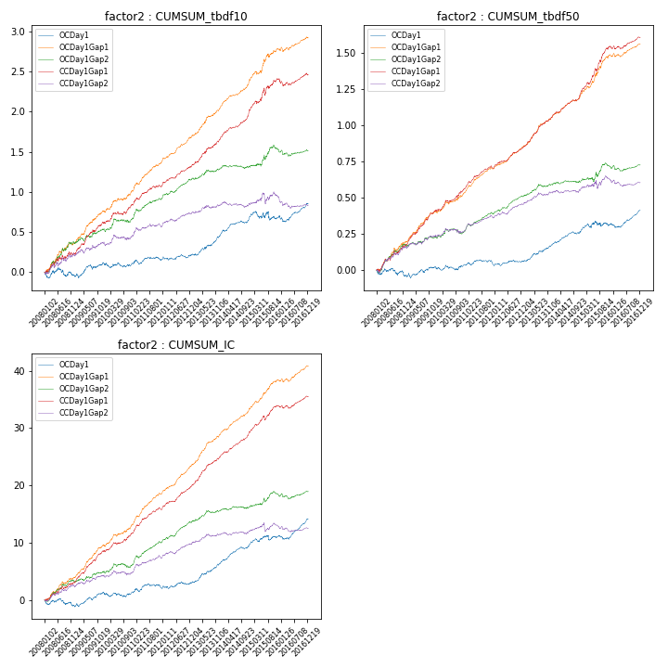

**因子换手率:** 54.28%

**截面指标_OCDay1:**

|  |  |  |  |  |  |  |  |  |
| --- | --- | --- | --- | --- | --- | --- | --- | --- |
| year | annret_tbdf10 | sharpe_tbdf10 | maxdd_tbdf10 | annret_tbdf50 | sharpe_tbdf50 | maxdd_tbdf50 | mean_IC | tstat_IC |
| 2008 | -0.03 | -0.35 | -0.1 | -0.04 | -0.81 | -0.06 | -0.0 | -0.99 |
| 2009 | 0.15 | 1.98 | -0.05 | 0.06 | 1.6 | -0.03 | 0.01 | 2.82 |
| 2010 | -0.01 | -0.08 | -0.06 | 0.01 | 0.42 | -0.03 | -0.0 | -0.01 |
| 2011 | 0.05 | 0.75 | -0.06 | -0.0 | -0.18 | -0.04 | 0.0 | 0.81 |
| 2012 | 0.05 | 0.97 | -0.04 | 0.03 | 1.09 | -0.02 | 0.0 | 1.28 |
| 2013 | 0.25 | 3.96 | -0.02 | 0.12 | 3.87 | -0.01 | 0.01 | 4.61 |
| 2014 | 0.23 | 4.6 | -0.03 | 0.1 | 4.0 | -0.02 | 0.01 | 5.3 |
| 2015 | 0.0 | 0.02 | -0.11 | 0.04 | 0.73 | -0.04 | 0.01 | 1.3 |
| 2016 | 0.16 | 2.59 | -0.08 | 0.1 | 3.56 | -0.03 | 0.01 | 4.35 |

**截面指标_CCDay1Gap1:**

|  |  |  |  |  |  |  |  |  |
| --- | --- | --- | --- | --- | --- | --- | --- | --- |
| year | annret_tbdf10 | sharpe_tbdf10 | maxdd_tbdf10 | annret_tbdf50 | sharpe_tbdf50 | maxdd_tbdf50 | mean_IC | tstat_IC |
| 2008 | 0.23 | 2.11 | -0.05 | 0.17 | 3.39 | -0.03 | 0.01 | 3.45 |
| 2009 | 0.39 | 5.31 | -0.03 | 0.24 | 7.26 | -0.01 | 0.02 | 7.47 |
| 2010 | 0.22 | 3.03 | -0.03 | 0.15 | 4.03 | -0.02 | 0.01 | 3.86 |
| 2011 | 0.24 | 3.89 | -0.02 | 0.14 | 5.89 | -0.02 | 0.02 | 5.86 |
| 2012 | 0.23 | 4.92 | -0.01 | 0.14 | 6.02 | -0.01 | 0.02 | 6.05 |
| 2013 | 0.35 | 5.1 | -0.02 | 0.22 | 7.17 | -0.01 | 0.02 | 7.11 |
| 2014 | 0.38 | 6.82 | -0.01 | 0.18 | 6.66 | -0.01 | 0.02 | 7.39 |
| 2015 | 0.38 | 3.37 | -0.09 | 0.3 | 5.55 | -0.03 | 0.02 | 4.9 |
| 2016 | 0.05 | 0.83 | -0.08 | 0.07 | 2.27 | -0.02 | 0.01 | 2.54 |

**风格暴露:**

|  |  |  |  |  |
| --- | --- | --- | --- | --- |
|  | long | short | corr_OCDay1 | corr_CCDay1Gap1 |
| liquidity10 | -0.01 | 0.01 | 0.1 | 0.09 |
| liquidity20 | 0.0 | 0.0 | 0.09 | 0.07 |
| liquidity5 | -0.01 | 0.02 | 0.11 | 0.11 |
| logmktcap | -0.03 | 0.04 | -0.01 | -0.02 |
| momentum15 | 0.08 | -0.07 | 0.08 | 0.12 |
| momentum30 | 0.05 | -0.04 | 0.03 | 0.11 |
| momentum5 | 0.11 | -0.1 | 0.01 | 0.03 |
| retvolatility30 | -0.0 | 0.01 | 0.1 | 0.06 |