Factors Report 20080102-20161230

**1. factor4**

**截面指标累计曲线:**

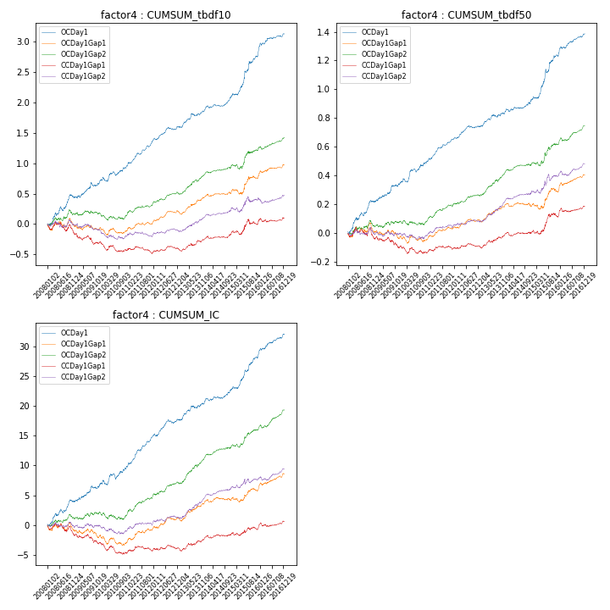

**因子换手率:** 64.03%

**截面指标_OCDay1:**

|  |  |  |  |  |  |  |  |  |
| --- | --- | --- | --- | --- | --- | --- | --- | --- |
| year | annret_tbdf10 | sharpe_tbdf10 | maxdd_tbdf10 | annret_tbdf50 | sharpe_tbdf50 | maxdd_tbdf50 | mean_IC | tstat_IC |
| 2008 | 0.43 | 3.71 | -0.07 | 0.22 | 4.54 | -0.02 | 0.02 | 3.86 |
| 2009 | 0.28 | 2.95 | -0.06 | 0.13 | 3.22 | -0.01 | 0.01 | 3.03 |
| 2010 | 0.24 | 2.63 | -0.07 | 0.15 | 3.62 | -0.03 | 0.01 | 2.82 |
| 2011 | 0.42 | 6.25 | -0.02 | 0.16 | 5.84 | -0.01 | 0.02 | 6.61 |
| 2012 | 0.22 | 3.49 | -0.04 | 0.09 | 3.38 | -0.02 | 0.01 | 3.53 |
| 2013 | 0.3 | 4.05 | -0.04 | 0.11 | 3.35 | -0.02 | 0.01 | 3.72 |
| 2014 | 0.22 | 3.7 | -0.04 | 0.09 | 2.7 | -0.02 | 0.01 | 2.81 |
| 2015 | 0.67 | 4.94 | -0.04 | 0.3 | 5.17 | -0.03 | 0.02 | 5.16 |
| 2016 | 0.36 | 4.19 | -0.04 | 0.15 | 4.74 | -0.01 | 0.02 | 4.86 |

**截面指标_CCDay1Gap1:**

|  |  |  |  |  |  |  |  |  |
| --- | --- | --- | --- | --- | --- | --- | --- | --- |
| year | annret_tbdf10 | sharpe_tbdf10 | maxdd_tbdf10 | annret_tbdf50 | sharpe_tbdf50 | maxdd_tbdf50 | mean_IC | tstat_IC |
| 2008 | -0.15 | -1.33 | -0.18 | -0.04 | -0.78 | -0.08 | -0.01 | -1.68 |
| 2009 | -0.14 | -1.62 | -0.17 | -0.05 | -1.23 | -0.08 | -0.01 | -1.51 |
| 2010 | -0.14 | -1.87 | -0.15 | -0.05 | -1.29 | -0.05 | -0.01 | -2.19 |
| 2011 | -0.02 | -0.38 | -0.12 | 0.03 | 1.12 | -0.03 | 0.0 | 0.78 |
| 2012 | 0.05 | 0.84 | -0.05 | 0.02 | 0.68 | -0.02 | 0.0 | 0.41 |
| 2013 | 0.18 | 2.6 | -0.04 | 0.09 | 2.75 | -0.02 | 0.01 | 2.42 |
| 2014 | 0.1 | 1.8 | -0.04 | 0.01 | 0.52 | -0.03 | 0.0 | 1.1 |
| 2015 | 0.14 | 1.11 | -0.09 | 0.11 | 1.96 | -0.03 | 0.0 | 0.79 |
| 2016 | 0.1 | 1.29 | -0.06 | 0.07 | 2.29 | -0.03 | 0.01 | 1.94 |

**风格暴露:**

|  |  |  |  |  |
| --- | --- | --- | --- | --- |
|  | long | short | corr_OCDay1 | corr_CCDay1Gap1 |
| liquidity10 | -0.02 | 0.02 | -0.02 | 0.01 |
| liquidity20 | -0.01 | 0.01 | -0.05 | -0.01 |
| liquidity5 | -0.03 | 0.04 | 0.01 | 0.02 |
| logmktcap | -0.03 | 0.03 | 0.08 | 0.04 |
| momentum15 | 0.07 | -0.06 | 0.13 | 0.08 |
| momentum30 | 0.04 | -0.03 | 0.08 | 0.06 |
| momentum5 | 0.12 | -0.11 | 0.16 | 0.1 |
| retvolatility30 | -0.02 | 0.03 | -0.04 | 0.01 |