Factors Report 20080102-20161230

**1. factor6**

**截面指标累计曲线:**

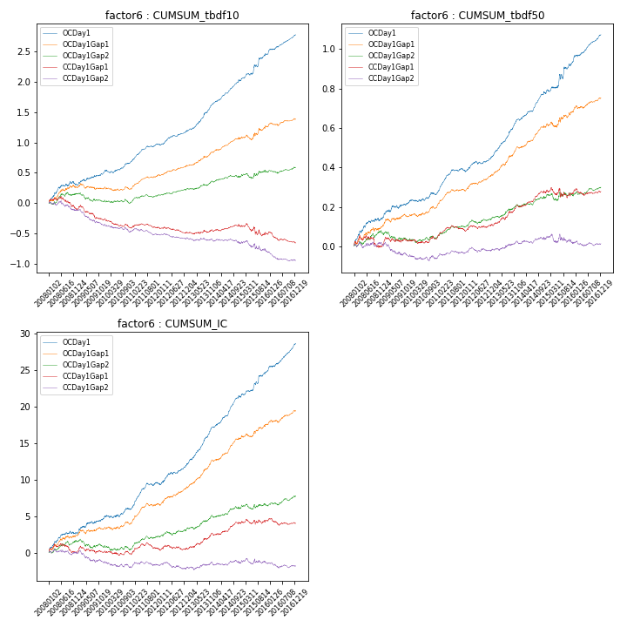

**因子换手率:** 47.68%

**截面指标_OCDay1:**

|  |  |  |  |  |  |  |  |  |
| --- | --- | --- | --- | --- | --- | --- | --- | --- |
| year | annret_tbdf10 | sharpe_tbdf10 | maxdd_tbdf10 | annret_tbdf50 | sharpe_tbdf50 | maxdd_tbdf50 | mean_IC | tstat_IC |
| 2008 | 0.31 | 3.08 | -0.06 | 0.14 | 3.76 | -0.01 | 0.01 | 3.29 |
| 2009 | 0.2 | 2.6 | -0.03 | 0.08 | 2.61 | -0.02 | 0.01 | 2.79 |
| 2010 | 0.18 | 2.74 | -0.05 | 0.04 | 1.44 | -0.01 | 0.01 | 1.69 |
| 2011 | 0.29 | 5.55 | -0.02 | 0.12 | 5.29 | -0.01 | 0.01 | 5.27 |
| 2012 | 0.21 | 3.85 | -0.02 | 0.07 | 2.8 | -0.02 | 0.01 | 3.61 |
| 2013 | 0.47 | 6.29 | -0.02 | 0.2 | 7.32 | -0.01 | 0.02 | 7.48 |
| 2014 | 0.38 | 6.36 | -0.03 | 0.13 | 5.17 | -0.01 | 0.02 | 6.44 |
| 2015 | 0.45 | 4.09 | -0.04 | 0.17 | 3.46 | -0.03 | 0.02 | 4.38 |
| 2016 | 0.31 | 5.26 | -0.01 | 0.13 | 5.29 | -0.01 | 0.01 | 5.92 |

**截面指标_CCDay1Gap1:**

|  |  |  |  |  |  |  |  |  |
| --- | --- | --- | --- | --- | --- | --- | --- | --- |
| year | annret_tbdf10 | sharpe_tbdf10 | maxdd_tbdf10 | annret_tbdf50 | sharpe_tbdf50 | maxdd_tbdf50 | mean_IC | tstat_IC |
| 2008 | -0.1 | -1.08 | -0.2 | -0.0 | -0.02 | -0.06 | 0.0 | 0.01 |
| 2009 | -0.17 | -2.19 | -0.22 | 0.03 | 0.88 | -0.03 | 0.0 | 0.07 |
| 2010 | -0.14 | -2.32 | -0.15 | 0.01 | 0.34 | -0.02 | -0.0 | -0.56 |
| 2011 | 0.01 | 0.24 | -0.07 | 0.05 | 2.21 | -0.02 | 0.0 | 1.28 |
| 2012 | -0.09 | -1.64 | -0.1 | 0.03 | 1.13 | -0.02 | 0.0 | 0.11 |
| 2013 | 0.02 | 0.35 | -0.04 | 0.1 | 3.4 | -0.01 | 0.01 | 2.85 |
| 2014 | 0.08 | 1.34 | -0.04 | 0.07 | 2.99 | -0.01 | 0.01 | 2.76 |
| 2015 | -0.11 | -0.89 | -0.2 | -0.0 | -0.05 | -0.05 | 0.0 | 0.55 |
| 2016 | -0.15 | -2.59 | -0.17 | 0.01 | 0.28 | -0.03 | -0.0 | -0.76 |

**风格暴露:**

|  |  |  |  |  |
| --- | --- | --- | --- | --- |
|  | long | short | corr_OCDay1 | corr_CCDay1Gap1 |
| liquidity10 | 0.07 | -0.06 | 0.03 | 0.06 |
| liquidity20 | 0.06 | -0.05 | 0.0 | 0.04 |
| liquidity5 | 0.05 | -0.05 | 0.07 | 0.11 |
| logmktcap | 0.01 | -0.0 | 0.04 | -0.03 |
| momentum15 | 0.09 | -0.09 | 0.15 | 0.11 |
| momentum30 | 0.07 | -0.06 | 0.08 | 0.02 |
| momentum5 | 0.04 | -0.03 | 0.22 | 0.16 |
| retvolatility30 | 0.02 | -0.01 | 0.0 | 0.08 |