Factors Report 20080102-20161230

**1. factor7**

**截面指标累计曲线:**

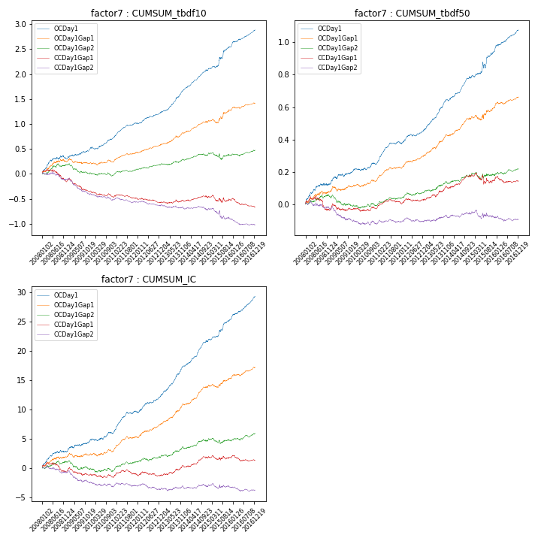

**因子换手率:** 47.77%

**截面指标_OCDay1:**

|  |  |  |  |  |  |  |  |  |
| --- | --- | --- | --- | --- | --- | --- | --- | --- |
| year | annret_tbdf10 | sharpe_tbdf10 | maxdd_tbdf10 | annret_tbdf50 | sharpe_tbdf50 | maxdd_tbdf50 | mean_IC | tstat_IC |
| 2008 | 0.31 | 3.12 | -0.05 | 0.13 | 3.26 | -0.01 | 0.01 | 3.49 |
| 2009 | 0.18 | 2.4 | -0.03 | 0.08 | 2.53 | -0.02 | 0.01 | 2.43 |
| 2010 | 0.23 | 3.54 | -0.05 | 0.05 | 1.59 | -0.01 | 0.01 | 1.91 |
| 2011 | 0.29 | 5.81 | -0.02 | 0.13 | 5.44 | -0.01 | 0.01 | 5.51 |
| 2012 | 0.22 | 3.96 | -0.02 | 0.08 | 3.5 | -0.01 | 0.01 | 3.98 |
| 2013 | 0.47 | 6.47 | -0.02 | 0.19 | 6.96 | -0.01 | 0.02 | 7.17 |
| 2014 | 0.39 | 6.47 | -0.02 | 0.13 | 5.34 | -0.01 | 0.02 | 6.58 |
| 2015 | 0.49 | 4.05 | -0.04 | 0.17 | 3.39 | -0.04 | 0.02 | 4.69 |
| 2016 | 0.33 | 5.43 | -0.02 | 0.13 | 5.22 | -0.01 | 0.02 | 6.12 |

**截面指标_CCDay1Gap1:**

|  |  |  |  |  |  |  |  |  |
| --- | --- | --- | --- | --- | --- | --- | --- | --- |
| year | annret_tbdf10 | sharpe_tbdf10 | maxdd_tbdf10 | annret_tbdf50 | sharpe_tbdf50 | maxdd_tbdf50 | mean_IC | tstat_IC |
| 2008 | -0.15 | -1.5 | -0.22 | -0.04 | -0.73 | -0.08 | -0.0 | -0.75 |
| 2009 | -0.2 | -2.74 | -0.24 | 0.01 | 0.17 | -0.05 | -0.0 | -0.83 |
| 2010 | -0.12 | -1.92 | -0.13 | 0.0 | 0.08 | -0.02 | -0.0 | -0.78 |
| 2011 | -0.02 | -0.39 | -0.08 | 0.04 | 1.8 | -0.02 | 0.0 | 0.86 |
| 2012 | -0.08 | -1.55 | -0.09 | 0.02 | 0.86 | -0.02 | -0.0 | -0.12 |
| 2013 | 0.02 | 0.35 | -0.05 | 0.08 | 2.64 | -0.02 | 0.01 | 2.12 |
| 2014 | 0.07 | 1.27 | -0.04 | 0.07 | 2.75 | -0.01 | 0.01 | 2.64 |
| 2015 | -0.04 | -0.37 | -0.14 | -0.02 | -0.41 | -0.07 | 0.0 | 0.14 |
| 2016 | -0.14 | -2.54 | -0.17 | -0.01 | -0.3 | -0.04 | -0.0 | -0.97 |

**风格暴露:**

|  |  |  |  |  |
| --- | --- | --- | --- | --- |
|  | long | short | corr_OCDay1 | corr_CCDay1Gap1 |
| liquidity10 | 0.07 | -0.06 | 0.03 | 0.05 |
| liquidity20 | 0.06 | -0.05 | -0.0 | 0.03 |
| liquidity5 | 0.05 | -0.05 | 0.07 | 0.1 |
| logmktcap | 0.01 | -0.0 | 0.05 | -0.04 |
| momentum15 | 0.09 | -0.08 | 0.13 | 0.06 |
| momentum30 | 0.05 | -0.05 | 0.07 | -0.01 |
| momentum5 | 0.03 | -0.03 | 0.19 | 0.15 |
| retvolatility30 | 0.01 | -0.01 | -0.0 | 0.08 |