Factors Report 20080102-20161230

**1. factor8**

**截面指标累计曲线:**

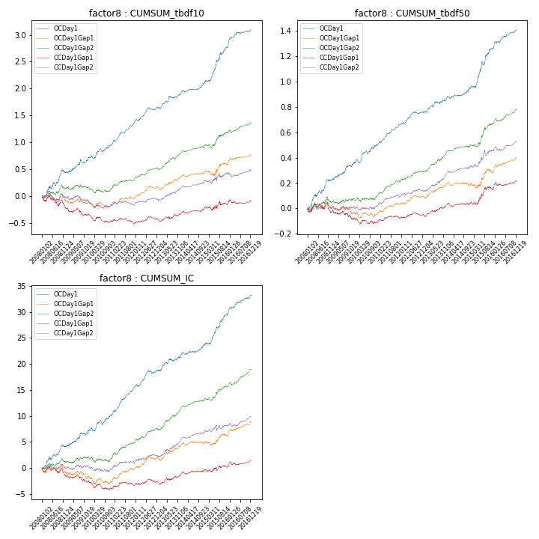

**因子换手率:** 64.21%

**截面指标_OCDay1:**

|  |  |  |  |  |  |  |  |  |
| --- | --- | --- | --- | --- | --- | --- | --- | --- |
| year | annret_tbdf10 | sharpe_tbdf10 | maxdd_tbdf10 | annret_tbdf50 | sharpe_tbdf50 | maxdd_tbdf50 | mean_IC | tstat_IC |
| 2008 | 0.43 | 3.51 | -0.06 | 0.22 | 4.55 | -0.02 | 0.02 | 3.97 |
| 2009 | 0.28 | 2.87 | -0.06 | 0.13 | 3.23 | -0.01 | 0.01 | 3.09 |
| 2010 | 0.26 | 2.86 | -0.07 | 0.15 | 3.66 | -0.03 | 0.01 | 3.22 |
| 2011 | 0.43 | 6.43 | -0.03 | 0.16 | 5.92 | -0.01 | 0.02 | 7.08 |
| 2012 | 0.24 | 3.81 | -0.05 | 0.09 | 3.62 | -0.02 | 0.01 | 3.87 |
| 2013 | 0.29 | 3.71 | -0.04 | 0.11 | 3.37 | -0.02 | 0.01 | 3.48 |
| 2014 | 0.2 | 3.57 | -0.03 | 0.08 | 2.72 | -0.02 | 0.01 | 2.81 |
| 2015 | 0.66 | 4.98 | -0.04 | 0.31 | 5.24 | -0.03 | 0.02 | 5.49 |
| 2016 | 0.32 | 3.9 | -0.04 | 0.15 | 4.68 | -0.01 | 0.01 | 4.68 |

**截面指标_CCDay1Gap1:**

|  |  |  |  |  |  |  |  |  |
| --- | --- | --- | --- | --- | --- | --- | --- | --- |
| year | annret_tbdf10 | sharpe_tbdf10 | maxdd_tbdf10 | annret_tbdf50 | sharpe_tbdf50 | maxdd_tbdf50 | mean_IC | tstat_IC |
| 2008 | -0.22 | -1.91 | -0.22 | -0.03 | -0.58 | -0.07 | -0.01 | -1.53 |
| 2009 | -0.12 | -1.3 | -0.15 | -0.04 | -1.04 | -0.07 | -0.0 | -1.19 |
| 2010 | -0.14 | -1.82 | -0.15 | -0.04 | -1.04 | -0.05 | -0.01 | -1.82 |
| 2011 | -0.02 | -0.3 | -0.11 | 0.04 | 1.4 | -0.03 | 0.0 | 1.08 |
| 2012 | 0.06 | 0.97 | -0.06 | 0.02 | 0.96 | -0.02 | 0.0 | 0.8 |
| 2013 | 0.13 | 1.83 | -0.04 | 0.08 | 2.57 | -0.02 | 0.01 | 2.11 |
| 2014 | 0.1 | 1.84 | -0.04 | 0.01 | 0.49 | -0.03 | 0.0 | 1.15 |
| 2015 | 0.06 | 0.46 | -0.07 | 0.11 | 1.95 | -0.02 | 0.0 | 0.56 |
| 2016 | 0.06 | 0.81 | -0.07 | 0.06 | 2.16 | -0.03 | 0.0 | 1.85 |

**风格暴露:**

|  |  |  |  |  |
| --- | --- | --- | --- | --- |
|  | long | short | corr_OCDay1 | corr_CCDay1Gap1 |
| liquidity10 | 0.01 | 0.0 | -0.05 | -0.01 |
| liquidity20 | 0.01 | -0.0 | -0.08 | -0.02 |
| liquidity5 | -0.0 | 0.01 | -0.02 | 0.0 |
| logmktcap | 0.0 | 0.01 | 0.1 | 0.01 |
| momentum15 | 0.12 | -0.11 | 0.1 | 0.01 |
| momentum30 | 0.08 | -0.08 | 0.04 | -0.01 |
| momentum5 | 0.15 | -0.14 | 0.13 | 0.06 |
| retvolatility30 | -0.0 | 0.01 | -0.08 | -0.02 |