Factors Report 20080102-20161230

**1. factor9**

**截面指标累计曲线:**

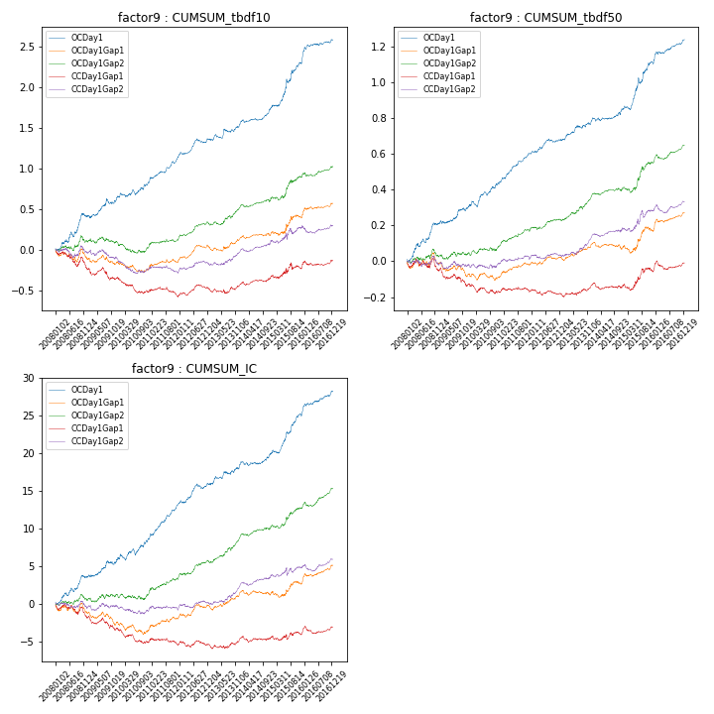

**因子换手率:** 61.05%

**截面指标_OCDay1:**

|  |  |  |  |  |  |  |  |  |
| --- | --- | --- | --- | --- | --- | --- | --- | --- |
| year | annret_tbdf10 | sharpe_tbdf10 | maxdd_tbdf10 | annret_tbdf50 | sharpe_tbdf50 | maxdd_tbdf50 | mean_IC | tstat_IC |
| 2008 | 0.4 | 3.62 | -0.06 | 0.21 | 4.32 | -0.02 | 0.01 | 3.62 |
| 2009 | 0.24 | 2.65 | -0.06 | 0.09 | 2.34 | -0.02 | 0.01 | 2.51 |
| 2010 | 0.18 | 2.17 | -0.06 | 0.14 | 3.35 | -0.03 | 0.01 | 2.79 |
| 2011 | 0.34 | 5.35 | -0.03 | 0.16 | 5.74 | -0.01 | 0.02 | 6.38 |
| 2012 | 0.19 | 3.24 | -0.05 | 0.07 | 2.77 | -0.02 | 0.01 | 3.35 |
| 2013 | 0.2 | 2.57 | -0.05 | 0.11 | 3.27 | -0.02 | 0.01 | 3.03 |
| 2014 | 0.2 | 3.76 | -0.04 | 0.07 | 2.17 | -0.02 | 0.01 | 2.23 |
| 2015 | 0.56 | 4.39 | -0.04 | 0.26 | 4.53 | -0.03 | 0.02 | 5.09 |
| 2016 | 0.28 | 3.67 | -0.02 | 0.13 | 4.22 | -0.01 | 0.01 | 4.18 |

**截面指标_CCDay1Gap1:**

|  |  |  |  |  |  |  |  |  |
| --- | --- | --- | --- | --- | --- | --- | --- | --- |
| year | annret_tbdf10 | sharpe_tbdf10 | maxdd_tbdf10 | annret_tbdf50 | sharpe_tbdf50 | maxdd_tbdf50 | mean_IC | tstat_IC |
| 2008 | -0.23 | -2.23 | -0.21 | -0.05 | -1.03 | -0.07 | -0.01 | -1.86 |
| 2009 | -0.11 | -1.34 | -0.15 | -0.08 | -1.83 | -0.1 | -0.01 | -1.8 |
| 2010 | -0.18 | -2.69 | -0.18 | -0.05 | -1.27 | -0.06 | -0.01 | -2.44 |
| 2011 | -0.03 | -0.48 | -0.12 | 0.01 | 0.29 | -0.03 | -0.0 | -0.25 |
| 2012 | 0.07 | 1.22 | -0.06 | -0.02 | -0.6 | -0.03 | -0.0 | -0.23 |
| 2013 | 0.06 | 0.9 | -0.06 | 0.05 | 1.57 | -0.02 | 0.0 | 1.17 |
| 2014 | 0.1 | 1.86 | -0.04 | -0.0 | -0.08 | -0.04 | 0.0 | 0.34 |
| 2015 | 0.11 | 0.82 | -0.08 | 0.08 | 1.48 | -0.04 | 0.0 | 0.39 |
| 2016 | 0.08 | 1.3 | -0.06 | 0.04 | 1.53 | -0.05 | 0.0 | 1.51 |

**风格暴露:**

|  |  |  |  |  |
| --- | --- | --- | --- | --- |
|  | long | short | corr_OCDay1 | corr_CCDay1Gap1 |
| liquidity10 | -0.04 | -0.01 | -0.04 | 0.01 |
| liquidity20 | -0.02 | -0.03 | -0.07 | -0.01 |
| liquidity5 | -0.05 | 0.01 | -0.0 | 0.03 |
| logmktcap | 0.05 | 0.13 | 0.11 | 0.01 |
| momentum15 | 0.03 | -0.03 | 0.15 | 0.08 |
| momentum30 | 0.01 | -0.02 | 0.08 | 0.05 |
| momentum5 | 0.08 | -0.07 | 0.18 | 0.11 |
| retvolatility30 | -0.05 | -0.03 | -0.09 | -0.02 |