Factors Report 20080102-20161230

**1. factor12**

**截面指标累计曲线:**

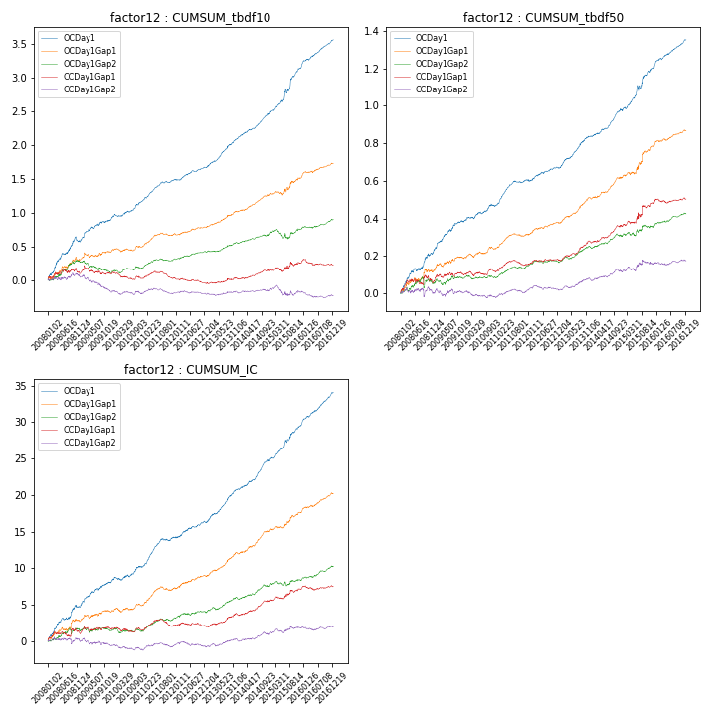

**因子换手率:** 49.33%

**截面指标_OCDay1:**

|  |  |  |  |  |  |  |  |  |
| --- | --- | --- | --- | --- | --- | --- | --- | --- |
| year | annret_tbdf10 | sharpe_tbdf10 | maxdd_tbdf10 | annret_tbdf50 | sharpe_tbdf50 | maxdd_tbdf50 | mean_IC | tstat_IC |
| 2008 | 0.57 | 4.62 | -0.08 | 0.21 | 4.44 | -0.01 | 0.02 | 4.52 |
| 2009 | 0.36 | 4.2 | -0.03 | 0.18 | 5.1 | -0.01 | 0.01 | 4.57 |
| 2010 | 0.27 | 4.22 | -0.03 | 0.08 | 2.95 | -0.01 | 0.01 | 2.82 |
| 2011 | 0.31 | 6.18 | -0.02 | 0.14 | 6.34 | -0.01 | 0.02 | 6.41 |
| 2012 | 0.18 | 3.67 | -0.02 | 0.06 | 2.7 | -0.01 | 0.01 | 3.02 |
| 2013 | 0.44 | 6.75 | -0.02 | 0.17 | 6.7 | -0.01 | 0.02 | 7.02 |
| 2014 | 0.36 | 6.44 | -0.02 | 0.14 | 5.58 | -0.01 | 0.02 | 6.34 |
| 2015 | 0.7 | 6.09 | -0.07 | 0.23 | 4.81 | -0.03 | 0.02 | 6.43 |
| 2016 | 0.4 | 7.1 | -0.01 | 0.15 | 6.85 | -0.01 | 0.02 | 7.71 |

**截面指标_CCDay1Gap1:**

|  |  |  |  |  |  |  |  |  |
| --- | --- | --- | --- | --- | --- | --- | --- | --- |
| year | annret_tbdf10 | sharpe_tbdf10 | maxdd_tbdf10 | annret_tbdf50 | sharpe_tbdf50 | maxdd_tbdf50 | mean_IC | tstat_IC |
| 2008 | 0.1 | 0.93 | -0.08 | 0.06 | 1.0 | -0.04 | 0.0 | 0.87 |
| 2009 | -0.01 | -0.07 | -0.13 | 0.04 | 1.17 | -0.02 | 0.0 | 0.82 |
| 2010 | -0.07 | -1.09 | -0.11 | 0.01 | 0.49 | -0.03 | -0.0 | -0.38 |
| 2011 | 0.01 | 0.16 | -0.11 | 0.04 | 1.99 | -0.03 | 0.0 | 1.39 |
| 2012 | -0.08 | -1.79 | -0.08 | 0.02 | 1.04 | -0.01 | -0.0 | -0.37 |
| 2013 | 0.07 | 1.08 | -0.02 | 0.1 | 3.97 | -0.01 | 0.01 | 2.69 |
| 2014 | 0.12 | 2.47 | -0.02 | 0.09 | 3.7 | -0.01 | 0.01 | 3.51 |
| 2015 | 0.13 | 1.22 | -0.07 | 0.13 | 2.15 | -0.03 | 0.01 | 2.4 |
| 2016 | -0.04 | -0.76 | -0.09 | 0.02 | 0.8 | -0.02 | 0.0 | 0.57 |

**风格暴露:**

|  |  |  |  |  |
| --- | --- | --- | --- | --- |
|  | long | short | corr_OCDay1 | corr_CCDay1Gap1 |
| liquidity10 | 0.06 | -0.04 | -0.06 | -0.03 |
| liquidity20 | 0.03 | -0.03 | -0.09 | -0.05 |
| liquidity5 | 0.05 | -0.03 | -0.03 | -0.02 |
| logmktcap | 0.18 | 0.14 | 0.14 | -0.0 |
| momentum15 | 0.09 | -0.08 | 0.08 | -0.02 |
| momentum30 | 0.05 | -0.04 | 0.03 | -0.05 |
| momentum5 | 0.04 | -0.02 | 0.16 | 0.12 |
| retvolatility30 | 0.01 | 0.0 | -0.09 | -0.02 |