Factors Report 20080102-20161230

**1. factor7**

**截面指标累计曲线:**

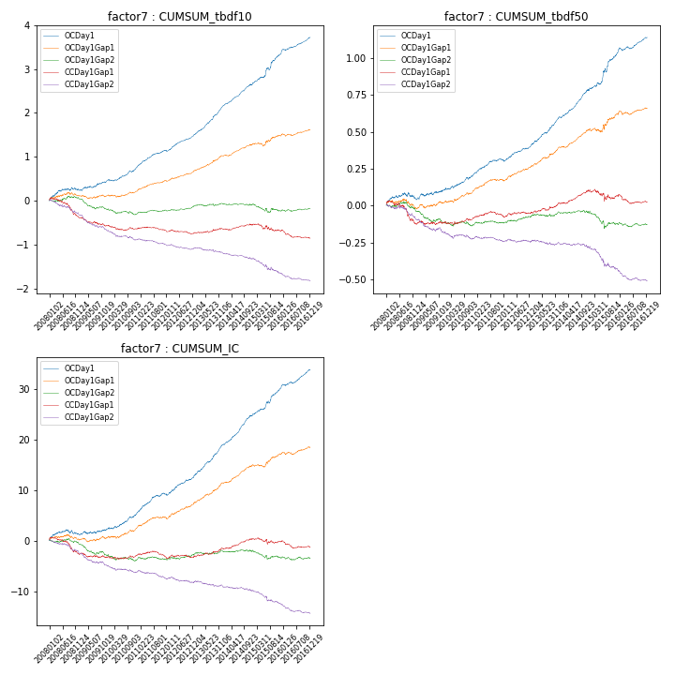

**因子换手率:** 58.0%

**截面指标_OCDay1:**

|  |  |  |  |  |  |  |  |  |
| --- | --- | --- | --- | --- | --- | --- | --- | --- |
| year | annret_tbdf10 | sharpe_tbdf10 | maxdd_tbdf10 | annret_tbdf50 | sharpe_tbdf50 | maxdd_tbdf50 | mean_IC | tstat_IC |
| 2008 | 0.26 | 2.12 | -0.06 | 0.05 | 1.03 | -0.04 | 0.01 | 1.34 |
| 2009 | 0.2 | 2.39 | -0.03 | 0.06 | 1.61 | -0.02 | 0.0 | 1.16 |
| 2010 | 0.3 | 3.81 | -0.04 | 0.1 | 3.18 | -0.01 | 0.01 | 3.51 |
| 2011 | 0.39 | 6.11 | -0.01 | 0.1 | 4.04 | -0.01 | 0.02 | 5.12 |
| 2012 | 0.37 | 5.97 | -0.03 | 0.11 | 4.05 | -0.01 | 0.02 | 4.74 |
| 2013 | 0.67 | 9.08 | -0.01 | 0.19 | 6.43 | -0.01 | 0.03 | 7.86 |
| 2014 | 0.49 | 7.46 | -0.02 | 0.18 | 6.8 | -0.01 | 0.02 | 8.19 |
| 2015 | 0.71 | 5.33 | -0.05 | 0.26 | 4.92 | -0.03 | 0.02 | 5.91 |
| 2016 | 0.37 | 5.1 | -0.03 | 0.1 | 3.94 | -0.02 | 0.01 | 5.2 |

**截面指标_CCDay1Gap1:**

|  |  |  |  |  |  |  |  |  |
| --- | --- | --- | --- | --- | --- | --- | --- | --- |
| year | annret_tbdf10 | sharpe_tbdf10 | maxdd_tbdf10 | annret_tbdf50 | sharpe_tbdf50 | maxdd_tbdf50 | mean_IC | tstat_IC |
| 2008 | -0.37 | -3.04 | -0.36 | -0.12 | -2.35 | -0.15 | -0.01 | -2.57 |
| 2009 | -0.2 | -2.5 | -0.19 | 0.0 | 0.04 | -0.03 | -0.0 | -1.07 |
| 2010 | -0.07 | -0.94 | -0.12 | 0.03 | 1.09 | -0.02 | 0.0 | 0.43 |
| 2011 | -0.03 | -0.51 | -0.08 | 0.02 | 0.89 | -0.02 | -0.0 | -0.22 |
| 2012 | -0.05 | -0.94 | -0.1 | 0.02 | 0.69 | -0.01 | 0.0 | 0.1 |
| 2013 | 0.08 | 1.13 | -0.03 | 0.06 | 2.13 | -0.01 | 0.01 | 2.08 |
| 2014 | 0.09 | 1.51 | -0.03 | 0.08 | 3.31 | -0.01 | 0.01 | 3.15 |
| 2015 | -0.12 | -1.06 | -0.17 | -0.03 | -0.57 | -0.08 | -0.0 | -0.44 |
| 2016 | -0.17 | -2.64 | -0.18 | -0.04 | -1.61 | -0.06 | -0.0 | -1.9 |

**风格暴露:**

|  |  |  |  |  |
| --- | --- | --- | --- | --- |
|  | long | short | corr_OCDay1 | corr_CCDay1Gap1 |
| liquidity10 | 0.08 | -0.07 | -0.01 | 0.03 |
| liquidity20 | 0.04 | -0.03 | -0.03 | 0.01 |
| liquidity5 | 0.13 | -0.12 | 0.03 | 0.06 |
| logmktcap | 0.02 | -0.02 | 0.09 | 0.02 |
| momentum15 | 0.11 | -0.1 | 0.07 | 0.01 |
| momentum30 | 0.06 | -0.06 | 0.04 | -0.02 |
| momentum5 | 0.13 | -0.13 | 0.15 | 0.09 |
| retvolatility30 | 0.02 | -0.02 | -0.01 | 0.07 |