Factors Report 20080102-20161230

**1. factor8**

**截面指标累计曲线:**

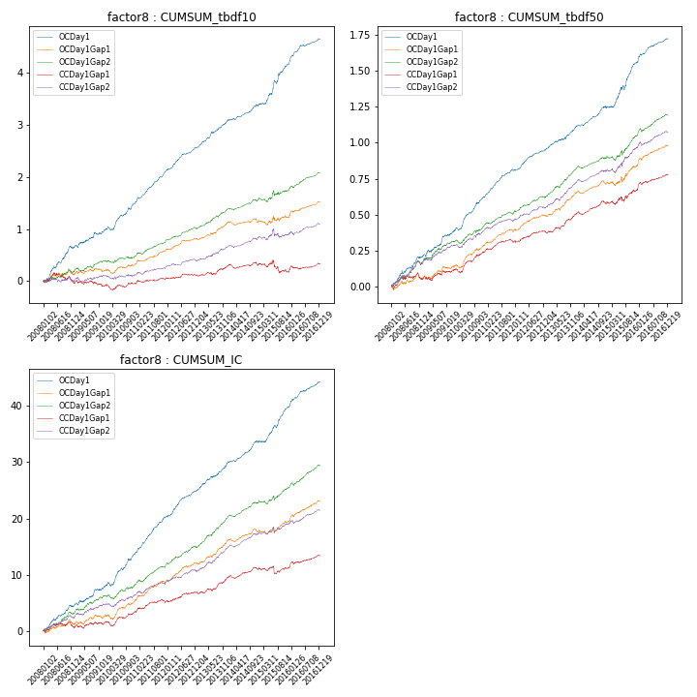

**因子换手率:** 64.89%

**截面指标_OCDay1:**

|  |  |  |  |  |  |  |  |  |
| --- | --- | --- | --- | --- | --- | --- | --- | --- |
| year | annret_tbdf10 | sharpe_tbdf10 | maxdd_tbdf10 | annret_tbdf50 | sharpe_tbdf50 | maxdd_tbdf50 | mean_IC | tstat_IC |
| 2008 | 0.65 | 4.97 | -0.05 | 0.2 | 4.17 | -0.02 | 0.02 | 4.48 |
| 2009 | 0.33 | 2.97 | -0.05 | 0.18 | 4.2 | -0.02 | 0.01 | 3.4 |
| 2010 | 0.55 | 5.2 | -0.07 | 0.24 | 6.32 | -0.02 | 0.02 | 5.81 |
| 2011 | 0.61 | 8.0 | -0.03 | 0.19 | 6.91 | -0.01 | 0.03 | 8.04 |
| 2012 | 0.44 | 6.68 | -0.02 | 0.14 | 5.68 | -0.01 | 0.02 | 6.22 |
| 2013 | 0.52 | 6.47 | -0.02 | 0.16 | 5.01 | -0.01 | 0.02 | 5.7 |
| 2014 | 0.3 | 4.18 | -0.03 | 0.14 | 5.0 | -0.01 | 0.02 | 5.15 |
| 2015 | 0.79 | 5.43 | -0.07 | 0.31 | 5.29 | -0.03 | 0.03 | 6.07 |
| 2016 | 0.49 | 5.79 | -0.02 | 0.17 | 5.52 | -0.01 | 0.02 | 5.85 |

**截面指标_CCDay1Gap1:**

|  |  |  |  |  |  |  |  |  |
| --- | --- | --- | --- | --- | --- | --- | --- | --- |
| year | annret_tbdf10 | sharpe_tbdf10 | maxdd_tbdf10 | annret_tbdf50 | sharpe_tbdf50 | maxdd_tbdf50 | mean_IC | tstat_IC |
| 2008 | -0.05 | -0.35 | -0.2 | 0.05 | 1.02 | -0.05 | 0.0 | 0.62 |
| 2009 | -0.04 | -0.37 | -0.11 | 0.07 | 1.72 | -0.03 | 0.0 | 1.1 |
| 2010 | 0.03 | 0.33 | -0.11 | 0.12 | 3.03 | -0.03 | 0.01 | 1.99 |
| 2011 | 0.12 | 1.68 | -0.04 | 0.08 | 2.96 | -0.02 | 0.01 | 2.75 |
| 2012 | 0.05 | 0.78 | -0.03 | 0.07 | 2.58 | -0.01 | 0.01 | 2.08 |
| 2013 | 0.18 | 2.16 | -0.05 | 0.12 | 3.58 | -0.02 | 0.01 | 3.15 |
| 2014 | 0.02 | 0.35 | -0.08 | 0.07 | 2.82 | -0.02 | 0.01 | 2.36 |
| 2015 | -0.13 | -0.85 | -0.23 | 0.09 | 1.73 | -0.04 | 0.0 | 0.25 |
| 2016 | 0.14 | 1.8 | -0.06 | 0.1 | 3.4 | -0.02 | 0.01 | 3.11 |

**风格暴露:**

|  |  |  |  |  |
| --- | --- | --- | --- | --- |
|  | long | short | corr_OCDay1 | corr_CCDay1Gap1 |
| liquidity10 | -0.02 | 0.02 | -0.03 | 0.06 |
| liquidity20 | -0.04 | 0.04 | -0.04 | 0.04 |
| liquidity5 | 0.02 | -0.01 | 0.0 | 0.07 |
| logmktcap | 0.06 | -0.05 | -0.06 | -0.07 |
| momentum15 | 0.19 | -0.19 | 0.01 | -0.03 |
| momentum30 | 0.14 | -0.14 | -0.04 | -0.07 |
| momentum5 | 0.27 | -0.27 | 0.07 | 0.02 |
| retvolatility30 | -0.07 | 0.07 | 0.01 | 0.08 |