Factors Report 20080102-20161230

**1. factor9**

**截面指标累计曲线:**

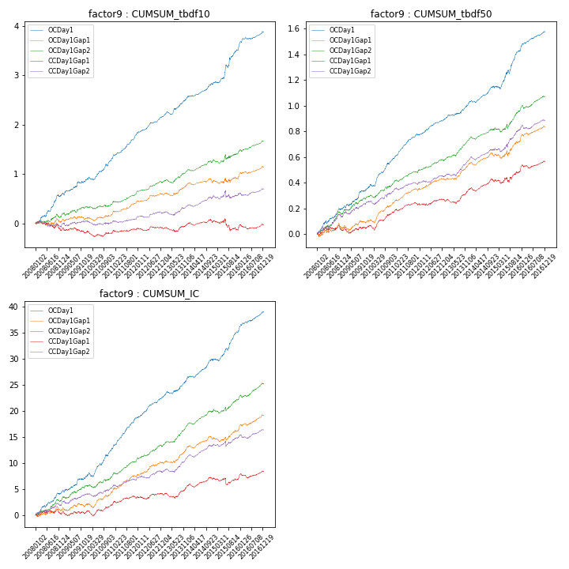

**因子换手率:** 61.44%

**截面指标_OCDay1:**

|  |  |  |  |  |  |  |  |  |
| --- | --- | --- | --- | --- | --- | --- | --- | --- |
| year | annret_tbdf10 | sharpe_tbdf10 | maxdd_tbdf10 | annret_tbdf50 | sharpe_tbdf50 | maxdd_tbdf50 | mean_IC | tstat_IC |
| 2008 | 0.56 | 4.84 | -0.05 | 0.2 | 4.02 | -0.02 | 0.02 | 4.29 |
| 2009 | 0.32 | 3.27 | -0.04 | 0.16 | 4.03 | -0.01 | 0.01 | 3.42 |
| 2010 | 0.43 | 4.48 | -0.06 | 0.23 | 5.98 | -0.02 | 0.02 | 5.29 |
| 2011 | 0.52 | 6.91 | -0.03 | 0.19 | 6.87 | -0.01 | 0.02 | 7.59 |
| 2012 | 0.33 | 5.7 | -0.02 | 0.11 | 4.83 | -0.01 | 0.02 | 5.46 |
| 2013 | 0.4 | 5.12 | -0.05 | 0.13 | 4.13 | -0.01 | 0.02 | 4.48 |
| 2014 | 0.27 | 3.99 | -0.02 | 0.12 | 4.36 | -0.02 | 0.01 | 4.78 |
| 2015 | 0.69 | 4.82 | -0.06 | 0.28 | 4.92 | -0.03 | 0.02 | 5.45 |
| 2016 | 0.37 | 4.69 | -0.03 | 0.15 | 5.03 | -0.01 | 0.02 | 5.08 |

**截面指标_CCDay1Gap1:**

|  |  |  |  |  |  |  |  |  |
| --- | --- | --- | --- | --- | --- | --- | --- | --- |
| year | annret_tbdf10 | sharpe_tbdf10 | maxdd_tbdf10 | annret_tbdf50 | sharpe_tbdf50 | maxdd_tbdf50 | mean_IC | tstat_IC |
| 2008 | -0.15 | -1.26 | -0.18 | 0.03 | 0.56 | -0.05 | 0.0 | 0.15 |
| 2009 | -0.03 | -0.3 | -0.11 | 0.04 | 0.93 | -0.05 | 0.0 | 0.64 |
| 2010 | -0.03 | -0.38 | -0.11 | 0.1 | 2.77 | -0.04 | 0.0 | 1.35 |
| 2011 | 0.11 | 1.59 | -0.04 | 0.07 | 2.55 | -0.02 | 0.01 | 2.29 |
| 2012 | 0.01 | 0.16 | -0.05 | 0.04 | 1.39 | -0.02 | 0.0 | 0.95 |
| 2013 | 0.07 | 0.92 | -0.09 | 0.08 | 2.41 | -0.03 | 0.01 | 1.85 |
| 2014 | 0.05 | 0.69 | -0.07 | 0.06 | 2.36 | -0.03 | 0.01 | 2.05 |
| 2015 | -0.15 | -1.05 | -0.23 | 0.08 | 1.39 | -0.04 | -0.0 | -0.01 |
| 2016 | 0.1 | 1.29 | -0.09 | 0.08 | 2.64 | -0.03 | 0.01 | 2.21 |

**风格暴露:**

|  |  |  |  |  |
| --- | --- | --- | --- | --- |
|  | long | short | corr_OCDay1 | corr_CCDay1Gap1 |
| liquidity10 | -0.05 | 0.01 | 0.01 | 0.1 |
| liquidity20 | -0.06 | 0.02 | -0.02 | 0.08 |
| liquidity5 | -0.02 | -0.02 | 0.04 | 0.12 |
| logmktcap | 0.11 | 0.07 | -0.04 | -0.08 |
| momentum15 | 0.12 | -0.12 | 0.07 | 0.04 |
| momentum30 | 0.09 | -0.09 | -0.0 | -0.02 |
| momentum5 | 0.2 | -0.19 | 0.12 | 0.07 |
| retvolatility30 | -0.11 | 0.03 | 0.02 | 0.11 |