Factors Report 20080102-20161230

**1. factor10**

**截面指标累计曲线:**

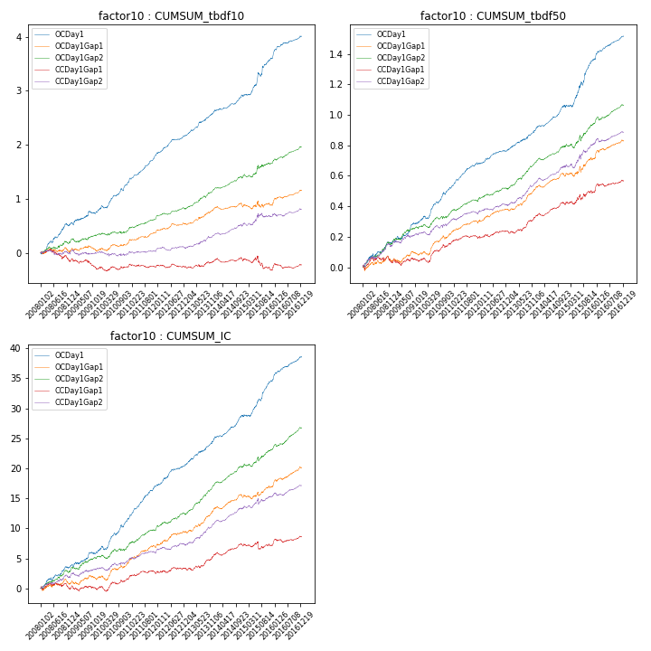

**因子换手率:** 62.49%

**截面指标_OCDay1:**

|  |  |  |  |  |  |  |  |  |
| --- | --- | --- | --- | --- | --- | --- | --- | --- |
| year | annret_tbdf10 | sharpe_tbdf10 | maxdd_tbdf10 | annret_tbdf50 | sharpe_tbdf50 | maxdd_tbdf50 | mean_IC | tstat_IC |
| 2008 | 0.52 | 4.44 | -0.05 | 0.16 | 3.29 | -0.02 | 0.01 | 3.65 |
| 2009 | 0.27 | 2.76 | -0.05 | 0.15 | 3.77 | -0.02 | 0.01 | 2.99 |
| 2010 | 0.51 | 5.26 | -0.05 | 0.21 | 5.5 | -0.02 | 0.02 | 5.23 |
| 2011 | 0.54 | 7.67 | -0.02 | 0.16 | 6.04 | -0.01 | 0.02 | 7.41 |
| 2012 | 0.33 | 5.36 | -0.02 | 0.09 | 3.61 | -0.01 | 0.01 | 4.51 |
| 2013 | 0.46 | 6.15 | -0.03 | 0.15 | 4.84 | -0.01 | 0.02 | 5.5 |
| 2014 | 0.29 | 4.25 | -0.03 | 0.14 | 5.22 | -0.01 | 0.02 | 5.25 |
| 2015 | 0.7 | 5.11 | -0.07 | 0.31 | 5.38 | -0.02 | 0.02 | 6.05 |
| 2016 | 0.41 | 5.29 | -0.01 | 0.15 | 5.28 | -0.01 | 0.02 | 5.46 |

**截面指标_CCDay1Gap1:**

|  |  |  |  |  |  |  |  |  |
| --- | --- | --- | --- | --- | --- | --- | --- | --- |
| year | annret_tbdf10 | sharpe_tbdf10 | maxdd_tbdf10 | annret_tbdf50 | sharpe_tbdf50 | maxdd_tbdf50 | mean_IC | tstat_IC |
| 2008 | -0.16 | -1.31 | -0.21 | 0.03 | 0.57 | -0.04 | -0.0 | -0.11 |
| 2009 | -0.13 | -1.34 | -0.18 | 0.02 | 0.62 | -0.04 | 0.0 | 0.34 |
| 2010 | 0.02 | 0.19 | -0.08 | 0.1 | 2.56 | -0.03 | 0.01 | 1.53 |
| 2011 | 0.04 | 0.57 | -0.07 | 0.05 | 1.81 | -0.02 | 0.01 | 1.83 |
| 2012 | -0.03 | -0.47 | -0.06 | 0.04 | 1.49 | -0.02 | 0.0 | 0.84 |
| 2013 | 0.12 | 1.57 | -0.04 | 0.1 | 3.21 | -0.01 | 0.01 | 2.81 |
| 2014 | 0.01 | 0.2 | -0.07 | 0.08 | 3.11 | -0.02 | 0.01 | 2.58 |
| 2015 | -0.18 | -1.22 | -0.24 | 0.08 | 1.57 | -0.04 | 0.0 | 0.07 |
| 2016 | 0.08 | 1.1 | -0.09 | 0.07 | 2.37 | -0.02 | 0.01 | 2.1 |

**风格暴露:**

|  |  |  |  |  |
| --- | --- | --- | --- | --- |
|  | long | short | corr_OCDay1 | corr_CCDay1Gap1 |
| liquidity10 | -0.0 | 0.01 | -0.02 | 0.07 |
| liquidity20 | -0.03 | 0.03 | -0.03 | 0.05 |
| liquidity5 | 0.03 | -0.02 | 0.01 | 0.09 |
| logmktcap | 0.02 | -0.01 | -0.07 | -0.06 |
| momentum15 | 0.18 | -0.18 | 0.01 | 0.0 |
| momentum30 | 0.13 | -0.13 | -0.04 | -0.05 |
| momentum5 | 0.25 | -0.24 | 0.08 | 0.04 |
| retvolatility30 | -0.06 | 0.07 | 0.01 | 0.1 |