Factors Report 20080102-20161230

**1. factor5**

**截面指标累计曲线:**

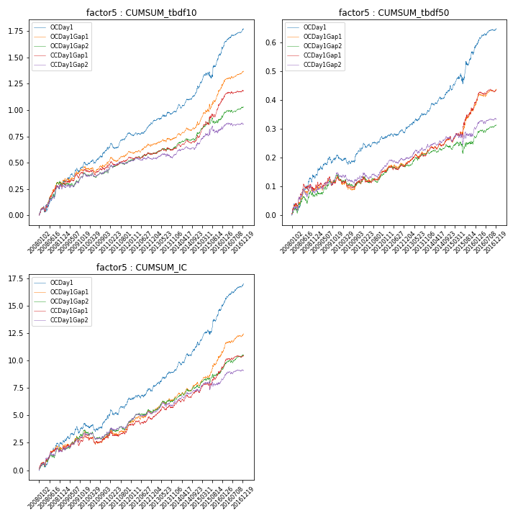

**因子换手率:** 36.82%

**截面指标_OCDay1:**

|  |  |  |  |  |  |  |  |  |
| --- | --- | --- | --- | --- | --- | --- | --- | --- |
| year | annret_tbdf10 | sharpe_tbdf10 | maxdd_tbdf10 | annret_tbdf50 | sharpe_tbdf50 | maxdd_tbdf50 | mean_IC | tstat_IC |
| 2008 | 0.29 | 3.78 | -0.06 | 0.13 | 3.77 | -0.02 | 0.01 | 3.62 |
| 2009 | 0.21 | 3.73 | -0.04 | 0.08 | 2.64 | -0.02 | 0.01 | 2.9 |
| 2010 | 0.14 | 2.56 | -0.04 | 0.03 | 1.02 | -0.03 | 0.0 | 1.12 |
| 2011 | 0.14 | 2.88 | -0.05 | 0.04 | 1.66 | -0.02 | 0.01 | 2.62 |
| 2012 | 0.11 | 2.62 | -0.02 | 0.03 | 1.62 | -0.01 | 0.0 | 1.87 |
| 2013 | 0.11 | 2.3 | -0.02 | 0.07 | 3.22 | -0.01 | 0.01 | 3.35 |
| 2014 | 0.22 | 4.16 | -0.04 | 0.08 | 3.73 | -0.01 | 0.01 | 4.34 |
| 2015 | 0.32 | 3.02 | -0.06 | 0.12 | 2.43 | -0.04 | 0.01 | 3.85 |
| 2016 | 0.24 | 4.86 | -0.02 | 0.08 | 3.98 | -0.01 | 0.01 | 4.78 |

**截面指标_CCDay1Gap1:**

|  |  |  |  |  |  |  |  |  |
| --- | --- | --- | --- | --- | --- | --- | --- | --- |
| year | annret_tbdf10 | sharpe_tbdf10 | maxdd_tbdf10 | annret_tbdf50 | sharpe_tbdf50 | maxdd_tbdf50 | mean_IC | tstat_IC |
| 2008 | 0.27 | 3.28 | -0.04 | 0.09 | 2.45 | -0.02 | 0.01 | 2.6 |
| 2009 | 0.17 | 2.65 | -0.04 | 0.04 | 1.5 | -0.03 | 0.01 | 2.52 |
| 2010 | 0.03 | 0.58 | -0.06 | -0.01 | -0.53 | -0.04 | -0.0 | -0.11 |
| 2011 | 0.08 | 1.71 | -0.04 | 0.03 | 1.47 | -0.02 | 0.0 | 1.83 |
| 2012 | 0.04 | 0.9 | -0.02 | 0.02 | 1.25 | -0.01 | 0.0 | 1.18 |
| 2013 | 0.05 | 1.16 | -0.03 | 0.05 | 2.37 | -0.02 | 0.01 | 2.75 |
| 2014 | 0.1 | 2.04 | -0.04 | 0.04 | 2.17 | -0.01 | 0.0 | 2.63 |
| 2015 | 0.33 | 3.58 | -0.03 | 0.11 | 2.41 | -0.02 | 0.01 | 2.22 |
| 2016 | 0.11 | 2.35 | -0.02 | 0.06 | 3.1 | -0.01 | 0.01 | 3.03 |

**风格暴露:**

|  |  |  |  |  |
| --- | --- | --- | --- | --- |
|  | long | short | corr_OCDay1 | corr_CCDay1Gap1 |
| liquidity10 | -0.03 | 0.01 | 0.03 | -0.0 |
| liquidity20 | -0.03 | 0.01 | 0.04 | -0.0 |
| liquidity5 | -0.02 | 0.01 | 0.03 | -0.03 |
| logmktcap | -0.01 | 0.02 | 0.02 | 0.07 |
| momentum15 | -0.01 | 0.02 | 0.02 | -0.02 |
| momentum30 | -0.05 | 0.05 | 0.09 | 0.04 |
| momentum5 | -0.01 | 0.01 | 0.06 | -0.04 |
| retvolatility30 | -0.01 | 0.0 | 0.08 | 0.03 |