Factors Report 20080102-20161230

**1. factor10**

**截面指标累计曲线:**

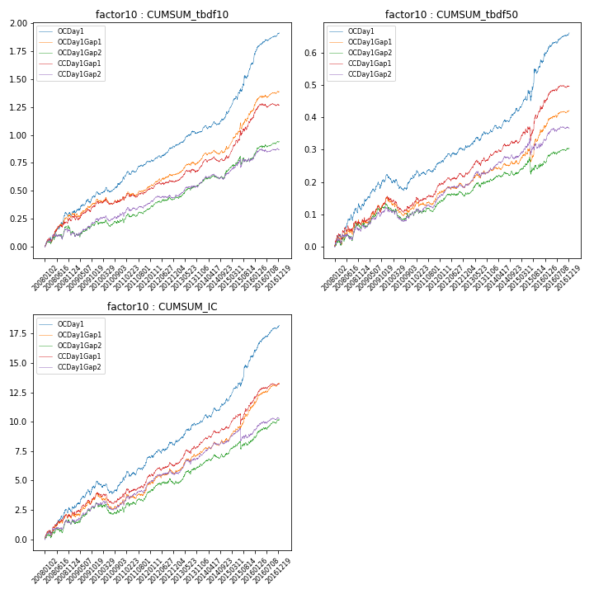

**因子换手率:** 27.46%

**截面指标_OCDay1:**

|  |  |  |  |  |  |  |  |  |
| --- | --- | --- | --- | --- | --- | --- | --- | --- |
| year | annret_tbdf10 | sharpe_tbdf10 | maxdd_tbdf10 | annret_tbdf50 | sharpe_tbdf50 | maxdd_tbdf50 | mean_IC | tstat_IC |
| 2008 | 0.28 | 3.76 | -0.04 | 0.11 | 3.19 | -0.02 | 0.01 | 3.32 |
| 2009 | 0.22 | 3.44 | -0.04 | 0.11 | 3.76 | -0.02 | 0.01 | 3.97 |
| 2010 | 0.13 | 2.31 | -0.04 | -0.0 | -0.15 | -0.05 | 0.0 | 0.45 |
| 2011 | 0.14 | 3.09 | -0.03 | 0.04 | 2.0 | -0.02 | 0.01 | 3.12 |
| 2012 | 0.14 | 3.5 | -0.02 | 0.05 | 2.56 | -0.01 | 0.0 | 2.22 |
| 2013 | 0.13 | 2.83 | -0.02 | 0.06 | 2.69 | -0.01 | 0.01 | 3.63 |
| 2014 | 0.17 | 3.19 | -0.03 | 0.06 | 3.21 | -0.01 | 0.01 | 3.38 |
| 2015 | 0.45 | 4.84 | -0.03 | 0.15 | 3.05 | -0.03 | 0.02 | 4.53 |
| 2016 | 0.27 | 5.16 | -0.01 | 0.09 | 4.03 | -0.01 | 0.01 | 5.13 |

**截面指标_CCDay1Gap1:**

|  |  |  |  |  |  |  |  |  |
| --- | --- | --- | --- | --- | --- | --- | --- | --- |
| year | annret_tbdf10 | sharpe_tbdf10 | maxdd_tbdf10 | annret_tbdf50 | sharpe_tbdf50 | maxdd_tbdf50 | mean_IC | tstat_IC |
| 2008 | 0.23 | 3.04 | -0.03 | 0.07 | 1.83 | -0.02 | 0.01 | 2.72 |
| 2009 | 0.18 | 2.65 | -0.05 | 0.09 | 3.13 | -0.02 | 0.01 | 3.48 |
| 2010 | 0.04 | 0.68 | -0.05 | -0.02 | -0.88 | -0.05 | -0.0 | -0.31 |
| 2011 | 0.07 | 1.5 | -0.04 | 0.06 | 2.72 | -0.02 | 0.01 | 2.88 |
| 2012 | 0.07 | 1.6 | -0.03 | 0.03 | 1.5 | -0.01 | 0.0 | 1.77 |
| 2013 | 0.14 | 2.72 | -0.03 | 0.07 | 2.91 | -0.02 | 0.01 | 3.65 |
| 2014 | 0.08 | 1.61 | -0.05 | 0.04 | 2.11 | -0.01 | 0.01 | 2.9 |
| 2015 | 0.36 | 3.86 | -0.04 | 0.11 | 2.26 | -0.04 | 0.01 | 2.32 |
| 2016 | 0.11 | 2.27 | -0.03 | 0.06 | 2.98 | -0.01 | 0.01 | 3.18 |

**风格暴露:**

|  |  |  |  |  |
| --- | --- | --- | --- | --- |
|  | long | short | corr_OCDay1 | corr_CCDay1Gap1 |
| liquidity10 | -0.01 | -0.0 | 0.07 | -0.01 |
| liquidity20 | -0.0 | -0.01 | 0.07 | -0.01 |
| liquidity5 | -0.01 | -0.0 | 0.07 | -0.02 |
| logmktcap | -0.01 | 0.02 | 0.04 | 0.1 |
| momentum15 | -0.01 | 0.02 | 0.04 | -0.06 |
| momentum30 | -0.04 | 0.04 | 0.11 | 0.02 |
| momentum5 | 0.0 | 0.01 | 0.09 | -0.05 |
| retvolatility30 | 0.01 | -0.03 | 0.09 | 0.01 |