Factors Report 20080102-20161230

**1. factor14**

**截面指标累计曲线:**

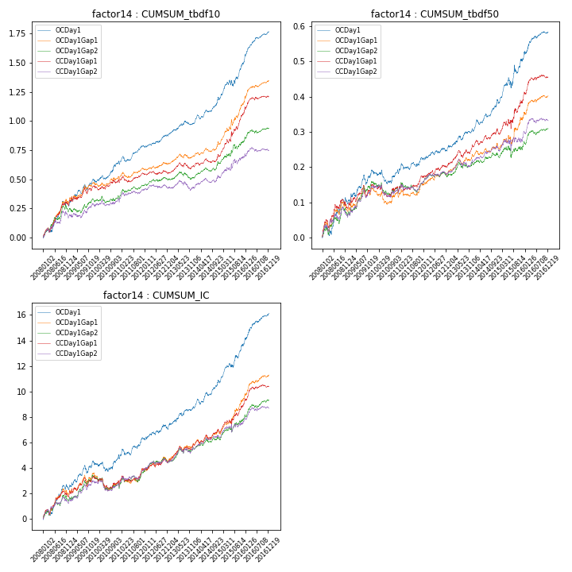

**因子换手率:** 35.98%

**截面指标_OCDay1:**

|  |  |  |  |  |  |  |  |  |
| --- | --- | --- | --- | --- | --- | --- | --- | --- |
| year | annret_tbdf10 | sharpe_tbdf10 | maxdd_tbdf10 | annret_tbdf50 | sharpe_tbdf50 | maxdd_tbdf50 | mean_IC | tstat_IC |
| 2008 | 0.27 | 3.6 | -0.04 | 0.1 | 2.75 | -0.03 | 0.01 | 3.49 |
| 2009 | 0.23 | 3.83 | -0.05 | 0.09 | 2.97 | -0.03 | 0.01 | 3.17 |
| 2010 | 0.15 | 2.68 | -0.03 | 0.0 | 0.1 | -0.04 | 0.0 | 0.8 |
| 2011 | 0.14 | 2.8 | -0.05 | 0.04 | 1.68 | -0.02 | 0.01 | 2.33 |
| 2012 | 0.1 | 2.4 | -0.02 | 0.03 | 1.7 | -0.01 | 0.0 | 1.88 |
| 2013 | 0.1 | 2.23 | -0.03 | 0.05 | 2.51 | -0.01 | 0.01 | 2.84 |
| 2014 | 0.21 | 3.81 | -0.04 | 0.08 | 3.86 | -0.01 | 0.01 | 3.65 |
| 2015 | 0.31 | 3.56 | -0.05 | 0.12 | 2.57 | -0.03 | 0.01 | 4.01 |
| 2016 | 0.27 | 5.3 | -0.02 | 0.08 | 3.53 | -0.01 | 0.01 | 4.79 |

**截面指标_CCDay1Gap1:**

|  |  |  |  |  |  |  |  |  |
| --- | --- | --- | --- | --- | --- | --- | --- | --- |
| year | annret_tbdf10 | sharpe_tbdf10 | maxdd_tbdf10 | annret_tbdf50 | sharpe_tbdf50 | maxdd_tbdf50 | mean_IC | tstat_IC |
| 2008 | 0.27 | 3.61 | -0.03 | 0.08 | 2.29 | -0.03 | 0.01 | 2.64 |
| 2009 | 0.17 | 2.47 | -0.05 | 0.07 | 2.24 | -0.03 | 0.01 | 2.57 |
| 2010 | 0.05 | 0.9 | -0.04 | -0.01 | -0.35 | -0.04 | -0.0 | -0.72 |
| 2011 | 0.06 | 1.22 | -0.05 | 0.03 | 1.49 | -0.02 | 0.0 | 1.78 |
| 2012 | 0.01 | 0.14 | -0.03 | 0.03 | 1.65 | -0.01 | 0.0 | 1.17 |
| 2013 | 0.06 | 1.33 | -0.06 | 0.05 | 2.51 | -0.02 | 0.01 | 2.67 |
| 2014 | 0.08 | 1.71 | -0.03 | 0.04 | 2.04 | -0.01 | 0.0 | 2.46 |
| 2015 | 0.37 | 4.04 | -0.04 | 0.09 | 1.95 | -0.03 | 0.01 | 2.85 |
| 2016 | 0.14 | 2.73 | -0.02 | 0.06 | 3.04 | -0.01 | 0.01 | 2.99 |

**风格暴露:**

|  |  |  |  |  |
| --- | --- | --- | --- | --- |
|  | long | short | corr_OCDay1 | corr_CCDay1Gap1 |
| liquidity10 | -0.01 | -0.0 | 0.02 | -0.03 |
| liquidity20 | -0.01 | -0.0 | 0.03 | -0.02 |
| liquidity5 | -0.01 | -0.0 | 0.02 | -0.03 |
| logmktcap | -0.01 | 0.02 | 0.03 | 0.11 |
| momentum15 | -0.02 | 0.02 | 0.01 | -0.03 |
| momentum30 | -0.04 | 0.05 | 0.07 | 0.03 |
| momentum5 | -0.01 | 0.02 | 0.06 | 0.0 |
| retvolatility30 | 0.0 | -0.02 | 0.07 | 0.01 |