Factors Report 20080102-20161230

**1. factor16**

**截面指标累计曲线:**

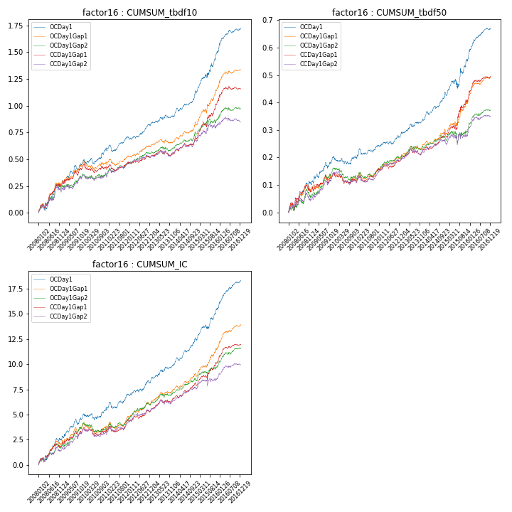

**因子换手率:** 36.15%

**截面指标_OCDay1:**

|  |  |  |  |  |  |  |  |  |
| --- | --- | --- | --- | --- | --- | --- | --- | --- |
| year | annret_tbdf10 | sharpe_tbdf10 | maxdd_tbdf10 | annret_tbdf50 | sharpe_tbdf50 | maxdd_tbdf50 | mean_IC | tstat_IC |
| 2008 | 0.26 | 3.5 | -0.07 | 0.1 | 3.02 | -0.02 | 0.01 | 3.75 |
| 2009 | 0.24 | 3.62 | -0.05 | 0.1 | 3.39 | -0.02 | 0.01 | 3.92 |
| 2010 | 0.11 | 1.73 | -0.05 | 0.0 | 0.07 | -0.03 | 0.0 | 0.89 |
| 2011 | 0.1 | 2.16 | -0.06 | 0.04 | 1.89 | -0.02 | 0.01 | 2.29 |
| 2012 | 0.13 | 3.14 | -0.02 | 0.04 | 2.3 | -0.01 | 0.01 | 2.87 |
| 2013 | 0.07 | 1.72 | -0.03 | 0.05 | 2.73 | -0.01 | 0.01 | 2.93 |
| 2014 | 0.22 | 4.13 | -0.03 | 0.09 | 4.37 | -0.01 | 0.01 | 4.87 |
| 2015 | 0.38 | 4.22 | -0.04 | 0.13 | 2.6 | -0.03 | 0.01 | 4.06 |
| 2016 | 0.22 | 4.14 | -0.03 | 0.11 | 5.26 | -0.01 | 0.01 | 5.52 |

**截面指标_CCDay1Gap1:**

|  |  |  |  |  |  |  |  |  |
| --- | --- | --- | --- | --- | --- | --- | --- | --- |
| year | annret_tbdf10 | sharpe_tbdf10 | maxdd_tbdf10 | annret_tbdf50 | sharpe_tbdf50 | maxdd_tbdf50 | mean_IC | tstat_IC |
| 2008 | 0.25 | 3.28 | -0.04 | 0.07 | 2.12 | -0.03 | 0.01 | 2.7 |
| 2009 | 0.21 | 3.25 | -0.04 | 0.07 | 2.26 | -0.03 | 0.01 | 3.2 |
| 2010 | -0.03 | -0.49 | -0.08 | -0.03 | -1.09 | -0.04 | -0.0 | -0.55 |
| 2011 | 0.05 | 0.94 | -0.06 | 0.04 | 1.95 | -0.02 | 0.0 | 1.85 |
| 2012 | 0.05 | 1.27 | -0.02 | 0.04 | 2.0 | -0.01 | 0.0 | 1.99 |
| 2013 | 0.03 | 0.66 | -0.06 | 0.03 | 1.7 | -0.02 | 0.0 | 2.29 |
| 2014 | 0.14 | 2.64 | -0.03 | 0.05 | 2.73 | -0.01 | 0.01 | 3.24 |
| 2015 | 0.35 | 4.32 | -0.05 | 0.13 | 2.96 | -0.02 | 0.01 | 2.95 |
| 2016 | 0.11 | 2.11 | -0.03 | 0.08 | 3.9 | -0.01 | 0.01 | 3.57 |

**风格暴露:**

|  |  |  |  |  |
| --- | --- | --- | --- | --- |
|  | long | short | corr_OCDay1 | corr_CCDay1Gap1 |
| liquidity10 | -0.03 | 0.01 | 0.06 | -0.0 |
| liquidity20 | -0.03 | 0.02 | 0.06 | -0.01 |
| liquidity5 | -0.03 | 0.01 | 0.06 | -0.04 |
| logmktcap | -0.01 | 0.02 | -0.02 | 0.08 |
| momentum15 | -0.01 | 0.02 | 0.04 | -0.04 |
| momentum30 | -0.06 | 0.06 | 0.1 | 0.03 |
| momentum5 | -0.0 | 0.01 | 0.07 | -0.05 |
| retvolatility30 | -0.02 | 0.01 | 0.11 | 0.04 |