Factors Report 20080102-20161230

**1. factor18**

**截面指标累计曲线:**

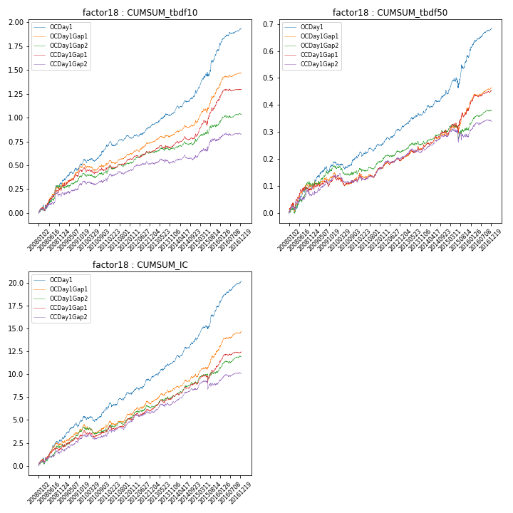

**因子换手率:** 35.17%

**截面指标_OCDay1:**

|  |  |  |  |  |  |  |  |  |
| --- | --- | --- | --- | --- | --- | --- | --- | --- |
| year | annret_tbdf10 | sharpe_tbdf10 | maxdd_tbdf10 | annret_tbdf50 | sharpe_tbdf50 | maxdd_tbdf50 | mean_IC | tstat_IC |
| 2008 | 0.3 | 3.98 | -0.06 | 0.09 | 2.63 | -0.03 | 0.01 | 4.04 |
| 2009 | 0.26 | 4.19 | -0.03 | 0.1 | 3.47 | -0.02 | 0.01 | 4.28 |
| 2010 | 0.14 | 2.49 | -0.04 | 0.02 | 0.85 | -0.03 | 0.0 | 1.52 |
| 2011 | 0.1 | 2.01 | -0.05 | 0.04 | 2.1 | -0.02 | 0.01 | 2.77 |
| 2012 | 0.12 | 2.74 | -0.02 | 0.07 | 3.59 | -0.01 | 0.01 | 3.12 |
| 2013 | 0.14 | 2.93 | -0.02 | 0.06 | 2.99 | -0.01 | 0.01 | 3.59 |
| 2014 | 0.21 | 4.01 | -0.03 | 0.07 | 3.18 | -0.01 | 0.01 | 4.6 |
| 2015 | 0.44 | 4.36 | -0.04 | 0.14 | 2.69 | -0.04 | 0.01 | 4.36 |
| 2016 | 0.23 | 4.49 | -0.02 | 0.1 | 4.78 | -0.01 | 0.01 | 5.39 |

**截面指标_CCDay1Gap1:**

|  |  |  |  |  |  |  |  |  |
| --- | --- | --- | --- | --- | --- | --- | --- | --- |
| year | annret_tbdf10 | sharpe_tbdf10 | maxdd_tbdf10 | annret_tbdf50 | sharpe_tbdf50 | maxdd_tbdf50 | mean_IC | tstat_IC |
| 2008 | 0.24 | 3.08 | -0.03 | 0.08 | 2.27 | -0.02 | 0.01 | 2.77 |
| 2009 | 0.24 | 3.66 | -0.03 | 0.05 | 1.81 | -0.02 | 0.01 | 3.49 |
| 2010 | -0.01 | -0.1 | -0.07 | -0.01 | -0.53 | -0.04 | -0.0 | -0.0 |
| 2011 | 0.09 | 2.07 | -0.04 | 0.05 | 2.09 | -0.02 | 0.01 | 2.51 |
| 2012 | 0.07 | 1.73 | -0.02 | 0.03 | 1.81 | -0.01 | 0.0 | 1.81 |
| 2013 | 0.08 | 1.58 | -0.04 | 0.05 | 2.41 | -0.02 | 0.01 | 3.03 |
| 2014 | 0.1 | 1.93 | -0.04 | 0.05 | 2.34 | -0.01 | 0.01 | 3.03 |
| 2015 | 0.37 | 4.25 | -0.05 | 0.09 | 1.98 | -0.04 | 0.01 | 2.13 |
| 2016 | 0.12 | 2.38 | -0.02 | 0.07 | 3.49 | -0.01 | 0.01 | 3.19 |

**风格暴露:**

|  |  |  |  |  |
| --- | --- | --- | --- | --- |
|  | long | short | corr_OCDay1 | corr_CCDay1Gap1 |
| liquidity10 | -0.02 | 0.01 | 0.06 | -0.0 |
| liquidity20 | -0.02 | 0.01 | 0.07 | 0.0 |
| liquidity5 | -0.02 | 0.01 | 0.06 | -0.02 |
| logmktcap | -0.01 | 0.02 | -0.01 | 0.08 |
| momentum15 | -0.01 | 0.02 | 0.01 | -0.05 |
| momentum30 | -0.06 | 0.06 | 0.1 | 0.05 |
| momentum5 | 0.0 | 0.0 | 0.04 | -0.06 |
| retvolatility30 | -0.0 | -0.01 | 0.11 | 0.05 |