Factors Report 20080102-20161230

**1. factor57**

**截面指标累计曲线:**

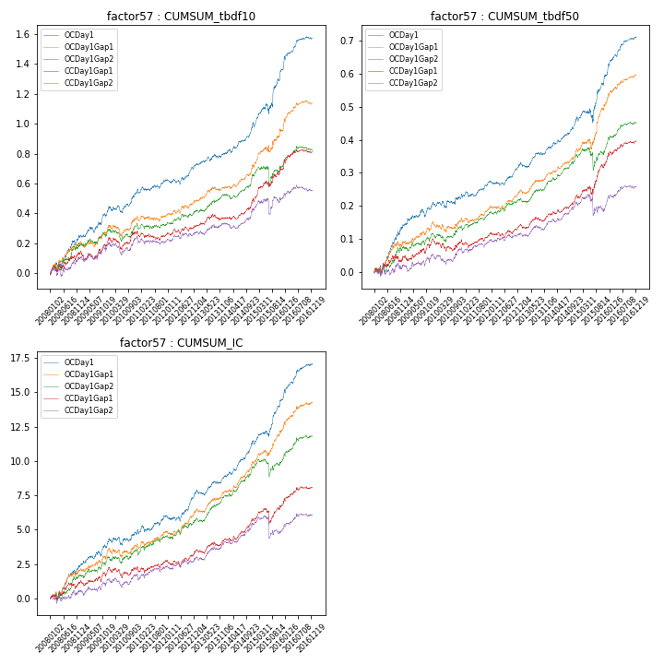

**因子换手率:** 26.49%

**截面指标_OCDay1:**

|  |  |  |  |  |  |  |  |  |
| --- | --- | --- | --- | --- | --- | --- | --- | --- |
| year | annret_tbdf10 | sharpe_tbdf10 | maxdd_tbdf10 | annret_tbdf50 | sharpe_tbdf50 | maxdd_tbdf50 | mean_IC | tstat_IC |
| 2008 | 0.24 | 3.3 | -0.04 | 0.14 | 3.94 | -0.02 | 0.01 | 3.42 |
| 2009 | 0.2 | 3.37 | -0.04 | 0.07 | 2.49 | -0.02 | 0.01 | 3.23 |
| 2010 | 0.12 | 2.06 | -0.05 | 0.03 | 0.93 | -0.02 | 0.0 | 1.01 |
| 2011 | 0.06 | 1.34 | -0.03 | 0.04 | 1.89 | -0.02 | 0.0 | 1.72 |
| 2012 | 0.11 | 2.39 | -0.04 | 0.05 | 2.8 | -0.01 | 0.01 | 3.12 |
| 2013 | 0.07 | 1.65 | -0.03 | 0.05 | 2.86 | -0.01 | 0.0 | 2.51 |
| 2014 | 0.18 | 3.55 | -0.03 | 0.08 | 3.73 | -0.01 | 0.01 | 4.38 |
| 2015 | 0.38 | 3.51 | -0.07 | 0.14 | 2.84 | -0.04 | 0.01 | 4.27 |
| 2016 | 0.21 | 4.24 | -0.02 | 0.11 | 4.87 | -0.01 | 0.01 | 4.51 |

**截面指标_CCDay1Gap1:**

|  |  |  |  |  |  |  |  |  |
| --- | --- | --- | --- | --- | --- | --- | --- | --- |
| year | annret_tbdf10 | sharpe_tbdf10 | maxdd_tbdf10 | annret_tbdf50 | sharpe_tbdf50 | maxdd_tbdf50 | mean_IC | tstat_IC |
| 2008 | 0.13 | 1.67 | -0.04 | 0.05 | 1.24 | -0.02 | 0.0 | 1.77 |
| 2009 | 0.11 | 1.7 | -0.06 | 0.05 | 1.86 | -0.02 | 0.0 | 1.84 |
| 2010 | 0.04 | 0.68 | -0.08 | -0.01 | -0.24 | -0.04 | -0.0 | -0.07 |
| 2011 | -0.02 | -0.37 | -0.06 | 0.03 | 1.28 | -0.02 | 0.0 | 1.0 |
| 2012 | 0.05 | 1.17 | -0.04 | 0.02 | 1.18 | -0.02 | 0.0 | 1.38 |
| 2013 | 0.05 | 1.14 | -0.04 | 0.03 | 1.64 | -0.01 | 0.0 | 1.68 |
| 2014 | 0.11 | 2.33 | -0.02 | 0.05 | 2.49 | -0.01 | 0.01 | 2.99 |
| 2015 | 0.21 | 2.48 | -0.04 | 0.11 | 2.67 | -0.03 | 0.0 | 1.14 |
| 2016 | 0.12 | 2.45 | -0.03 | 0.06 | 2.52 | -0.01 | 0.01 | 2.46 |

**风格暴露:**

|  |  |  |  |  |
| --- | --- | --- | --- | --- |
|  | long | short | corr_OCDay1 | corr_CCDay1Gap1 |
| liquidity10 | -0.09 | 0.08 | 0.12 | 0.03 |
| liquidity20 | -0.08 | 0.07 | 0.12 | 0.03 |
| liquidity5 | -0.08 | 0.07 | 0.12 | 0.04 |
| logmktcap | -0.04 | 0.05 | 0.02 | 0.14 |
| momentum15 | -0.05 | 0.06 | 0.08 | 0.03 |
| momentum30 | -0.1 | 0.1 | 0.15 | 0.12 |
| momentum5 | -0.0 | 0.01 | 0.09 | -0.02 |
| retvolatility30 | -0.08 | 0.06 | 0.17 | 0.08 |