Factors Report 20080102-20161230

**1. factor66**

**截面指标累计曲线:**

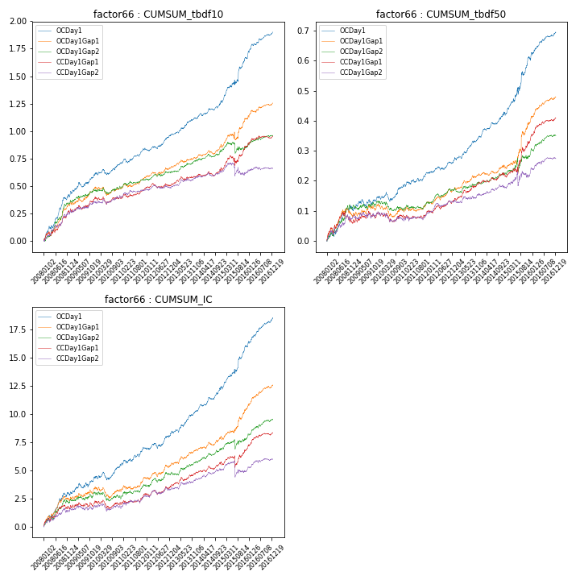

**因子换手率:** 35.01%

**截面指标_OCDay1:**

|  |  |  |  |  |  |  |  |  |
| --- | --- | --- | --- | --- | --- | --- | --- | --- |
| year | annret_tbdf10 | sharpe_tbdf10 | maxdd_tbdf10 | annret_tbdf50 | sharpe_tbdf50 | maxdd_tbdf50 | mean_IC | tstat_IC |
| 2008 | 0.4 | 5.54 | -0.02 | 0.1 | 3.1 | -0.02 | 0.01 | 4.24 |
| 2009 | 0.21 | 3.43 | -0.04 | 0.04 | 1.51 | -0.03 | 0.01 | 2.56 |
| 2010 | 0.1 | 1.84 | -0.05 | 0.04 | 1.75 | -0.03 | 0.0 | 1.88 |
| 2011 | 0.12 | 2.83 | -0.04 | 0.04 | 1.99 | -0.01 | 0.01 | 2.64 |
| 2012 | 0.13 | 3.03 | -0.02 | 0.05 | 2.51 | -0.01 | 0.01 | 2.42 |
| 2013 | 0.15 | 3.42 | -0.01 | 0.08 | 3.96 | -0.01 | 0.01 | 3.88 |
| 2014 | 0.15 | 3.02 | -0.02 | 0.08 | 3.64 | -0.01 | 0.01 | 3.97 |
| 2015 | 0.4 | 3.9 | -0.04 | 0.18 | 3.82 | -0.02 | 0.01 | 4.28 |
| 2016 | 0.24 | 4.77 | -0.02 | 0.09 | 3.81 | -0.01 | 0.01 | 5.0 |

**截面指标_CCDay1Gap1:**

|  |  |  |  |  |  |  |  |  |
| --- | --- | --- | --- | --- | --- | --- | --- | --- |
| year | annret_tbdf10 | sharpe_tbdf10 | maxdd_tbdf10 | annret_tbdf50 | sharpe_tbdf50 | maxdd_tbdf50 | mean_IC | tstat_IC |
| 2008 | 0.26 | 3.57 | -0.04 | 0.06 | 1.65 | -0.04 | 0.01 | 2.7 |
| 2009 | 0.14 | 2.27 | -0.04 | 0.04 | 1.24 | -0.02 | 0.0 | 1.13 |
| 2010 | -0.0 | -0.01 | -0.07 | -0.01 | -0.56 | -0.03 | -0.0 | -0.31 |
| 2011 | 0.09 | 2.04 | -0.03 | 0.02 | 0.97 | -0.02 | 0.0 | 1.64 |
| 2012 | 0.02 | 0.54 | -0.04 | 0.03 | 1.87 | -0.01 | 0.0 | 1.23 |
| 2013 | 0.08 | 1.7 | -0.03 | 0.06 | 2.87 | -0.01 | 0.01 | 2.5 |
| 2014 | 0.06 | 1.37 | -0.04 | 0.02 | 1.21 | -0.01 | 0.0 | 1.81 |
| 2015 | 0.21 | 2.28 | -0.09 | 0.12 | 2.57 | -0.02 | 0.01 | 1.3 |
| 2016 | 0.09 | 2.06 | -0.02 | 0.07 | 3.72 | -0.01 | 0.01 | 3.35 |

**风格暴露:**

|  |  |  |  |  |
| --- | --- | --- | --- | --- |
|  | long | short | corr_OCDay1 | corr_CCDay1Gap1 |
| liquidity10 | -0.03 | 0.02 | 0.03 | -0.06 |
| liquidity20 | -0.03 | 0.02 | 0.04 | -0.05 |
| liquidity5 | -0.03 | 0.02 | 0.05 | -0.05 |
| logmktcap | -0.02 | 0.03 | 0.06 | 0.16 |
| momentum15 | -0.01 | 0.01 | 0.08 | -0.03 |
| momentum30 | -0.05 | 0.06 | 0.14 | 0.05 |
| momentum5 | -0.01 | 0.01 | 0.14 | -0.02 |
| retvolatility30 | -0.01 | -0.01 | 0.05 | -0.02 |