Factors Report 20080102-20161230

**1. factor67**

**截面指标累计曲线:**

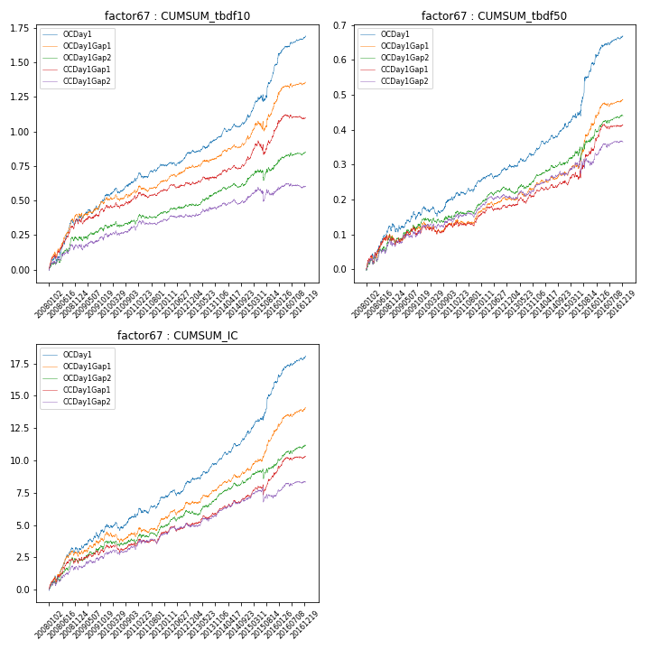

**因子换手率:** 27.92%

**截面指标_OCDay1:**

|  |  |  |  |  |  |  |  |  |
| --- | --- | --- | --- | --- | --- | --- | --- | --- |
| year | annret_tbdf10 | sharpe_tbdf10 | maxdd_tbdf10 | annret_tbdf50 | sharpe_tbdf50 | maxdd_tbdf50 | mean_IC | tstat_IC |
| 2008 | 0.35 | 4.84 | -0.04 | 0.11 | 3.24 | -0.02 | 0.01 | 4.27 |
| 2009 | 0.2 | 3.28 | -0.03 | 0.07 | 2.48 | -0.02 | 0.01 | 3.27 |
| 2010 | 0.11 | 2.2 | -0.04 | 0.03 | 1.24 | -0.03 | 0.0 | 1.38 |
| 2011 | 0.1 | 2.24 | -0.04 | 0.05 | 2.24 | -0.01 | 0.01 | 2.26 |
| 2012 | 0.1 | 2.46 | -0.03 | 0.04 | 2.38 | -0.01 | 0.01 | 2.6 |
| 2013 | 0.11 | 2.53 | -0.02 | 0.05 | 2.64 | -0.01 | 0.01 | 3.52 |
| 2014 | 0.14 | 3.0 | -0.03 | 0.07 | 3.22 | -0.01 | 0.01 | 3.98 |
| 2015 | 0.38 | 4.09 | -0.05 | 0.18 | 3.57 | -0.01 | 0.02 | 4.56 |
| 2016 | 0.21 | 4.27 | -0.02 | 0.08 | 3.65 | -0.01 | 0.01 | 3.97 |

**截面指标_CCDay1Gap1:**

|  |  |  |  |  |  |  |  |  |
| --- | --- | --- | --- | --- | --- | --- | --- | --- |
| year | annret_tbdf10 | sharpe_tbdf10 | maxdd_tbdf10 | annret_tbdf50 | sharpe_tbdf50 | maxdd_tbdf50 | mean_IC | tstat_IC |
| 2008 | 0.34 | 5.05 | -0.03 | 0.07 | 2.13 | -0.02 | 0.01 | 3.33 |
| 2009 | 0.13 | 2.03 | -0.04 | 0.05 | 1.73 | -0.02 | 0.01 | 2.22 |
| 2010 | 0.07 | 1.34 | -0.04 | 0.0 | 0.11 | -0.03 | 0.0 | 0.3 |
| 2011 | 0.05 | 1.06 | -0.04 | 0.03 | 1.36 | -0.02 | 0.0 | 1.51 |
| 2012 | 0.04 | 1.08 | -0.03 | 0.03 | 1.44 | -0.01 | 0.0 | 1.22 |
| 2013 | 0.07 | 1.52 | -0.02 | 0.04 | 2.18 | -0.02 | 0.01 | 2.63 |
| 2014 | 0.11 | 2.42 | -0.03 | 0.02 | 1.24 | -0.01 | 0.0 | 2.37 |
| 2015 | 0.23 | 2.65 | -0.1 | 0.1 | 2.32 | -0.02 | 0.01 | 2.24 |
| 2016 | 0.07 | 1.44 | -0.03 | 0.07 | 2.87 | -0.01 | 0.0 | 2.62 |

**风格暴露:**

|  |  |  |  |  |
| --- | --- | --- | --- | --- |
|  | long | short | corr_OCDay1 | corr_CCDay1Gap1 |
| liquidity10 | -0.03 | 0.01 | 0.06 | -0.03 |
| liquidity20 | -0.03 | 0.02 | 0.07 | -0.02 |
| liquidity5 | -0.02 | 0.01 | 0.06 | -0.02 |
| logmktcap | -0.02 | 0.03 | -0.01 | 0.13 |
| momentum15 | -0.0 | 0.01 | 0.04 | -0.01 |
| momentum30 | -0.04 | 0.04 | 0.11 | 0.05 |
| momentum5 | -0.0 | 0.01 | 0.08 | -0.01 |
| retvolatility30 | -0.02 | 0.01 | 0.1 | 0.01 |