Factors Report 20080102-20161230

**1. factor6**

**截面指标累计曲线:**

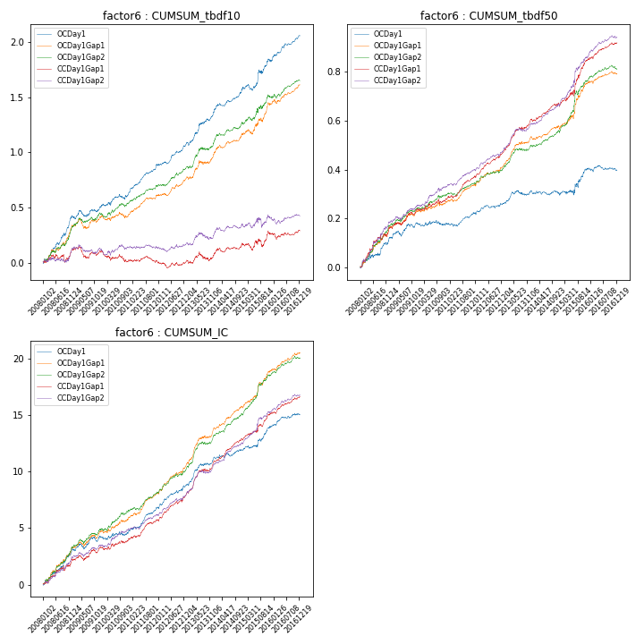

**因子换手率:** 36.7%

**截面指标_OCDay1:**

|  |  |  |  |  |  |  |  |  |
| --- | --- | --- | --- | --- | --- | --- | --- | --- |
| year | annret_tbdf10 | sharpe_tbdf10 | maxdd_tbdf10 | annret_tbdf50 | sharpe_tbdf50 | maxdd_tbdf50 | mean_IC | tstat_IC |
| 2008 | 0.42 | 5.88 | -0.03 | 0.12 | 3.15 | -0.01 | 0.01 | 5.17 |
| 2009 | 0.08 | 1.28 | -0.06 | 0.06 | 2.19 | -0.02 | 0.0 | 1.96 |
| 2010 | 0.14 | 2.19 | -0.05 | 0.0 | 0.13 | -0.02 | 0.0 | 1.05 |
| 2011 | 0.25 | 5.96 | -0.01 | 0.04 | 2.18 | -0.01 | 0.01 | 4.47 |
| 2012 | 0.18 | 4.1 | -0.02 | 0.04 | 1.95 | -0.01 | 0.01 | 4.02 |
| 2013 | 0.3 | 4.31 | -0.03 | 0.05 | 2.12 | -0.02 | 0.01 | 4.35 |
| 2014 | 0.23 | 4.44 | -0.03 | -0.02 | -0.85 | -0.02 | 0.0 | 1.53 |
| 2015 | 0.23 | 2.29 | -0.06 | 0.11 | 2.14 | -0.02 | 0.01 | 3.16 |
| 2016 | 0.23 | 4.75 | -0.02 | -0.01 | -0.47 | -0.02 | 0.0 | 2.44 |

**截面指标_CCDay1Gap1:**

|  |  |  |  |  |  |  |  |  |
| --- | --- | --- | --- | --- | --- | --- | --- | --- |
| year | annret_tbdf10 | sharpe_tbdf10 | maxdd_tbdf10 | annret_tbdf50 | sharpe_tbdf50 | maxdd_tbdf50 | mean_IC | tstat_IC |
| 2008 | 0.12 | 1.41 | -0.07 | 0.16 | 3.72 | -0.02 | 0.01 | 3.25 |
| 2009 | -0.02 | -0.39 | -0.11 | 0.08 | 2.76 | -0.01 | 0.0 | 1.97 |
| 2010 | -0.07 | -1.16 | -0.1 | 0.04 | 1.54 | -0.02 | 0.0 | 1.47 |
| 2011 | -0.02 | -0.47 | -0.06 | 0.1 | 4.9 | -0.01 | 0.01 | 4.04 |
| 2012 | 0.0 | 0.07 | -0.05 | 0.1 | 4.7 | -0.01 | 0.01 | 4.73 |
| 2013 | 0.06 | 0.89 | -0.08 | 0.14 | 5.66 | -0.01 | 0.01 | 5.47 |
| 2014 | 0.09 | 1.87 | -0.04 | 0.06 | 2.74 | -0.02 | 0.01 | 4.94 |
| 2015 | 0.09 | 0.96 | -0.07 | 0.19 | 4.15 | -0.02 | 0.01 | 3.78 |
| 2016 | 0.03 | 0.59 | -0.06 | 0.06 | 3.19 | -0.01 | 0.01 | 3.74 |

**风格暴露:**

|  |  |  |  |  |
| --- | --- | --- | --- | --- |
|  | long | short | corr_OCDay1 | corr_CCDay1Gap1 |
| liquidity10 | 0.13 | -0.12 | -0.09 | -0.12 |
| liquidity20 | 0.1 | -0.09 | -0.06 | -0.09 |
| liquidity5 | 0.14 | -0.13 | -0.11 | -0.1 |
| logmktcap | -0.03 | 0.03 | 0.03 | 0.05 |
| momentum15 | 0.11 | -0.11 | -0.1 | -0.12 |
| momentum30 | 0.08 | -0.07 | -0.01 | -0.05 |
| momentum5 | 0.07 | -0.06 | -0.02 | -0.04 |
| retvolatility30 | 0.05 | -0.04 | -0.0 | -0.0 |