Factors Report 20080102-20161230

**1. factor12**

**截面指标累计曲线:**

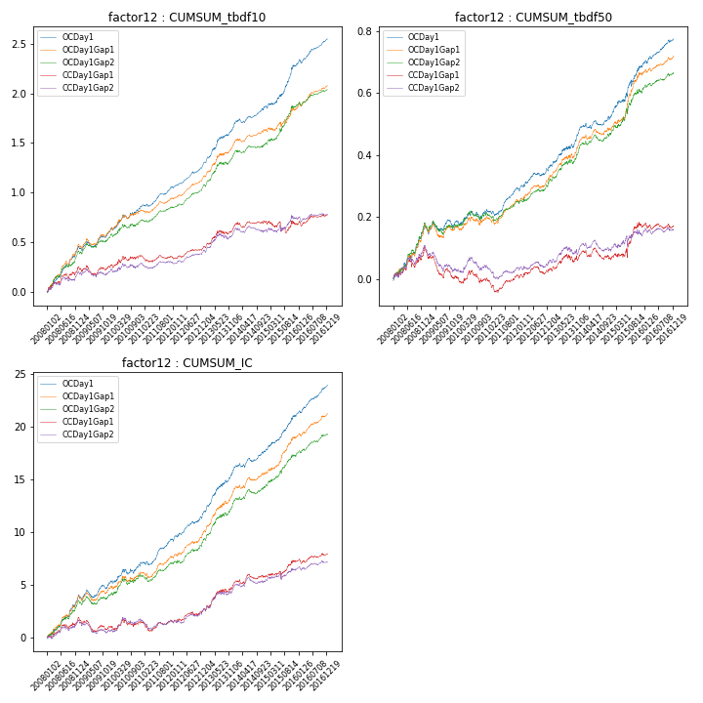

**因子换手率:** 29.16%

**截面指标_OCDay1:**

|  |  |  |  |  |  |  |  |  |
| --- | --- | --- | --- | --- | --- | --- | --- | --- |
| year | annret_tbdf10 | sharpe_tbdf10 | maxdd_tbdf10 | annret_tbdf50 | sharpe_tbdf50 | maxdd_tbdf50 | mean_IC | tstat_IC |
| 2008 | 0.45 | 5.99 | -0.03 | 0.17 | 4.92 | -0.01 | 0.02 | 5.58 |
| 2009 | 0.15 | 2.62 | -0.06 | 0.01 | 0.38 | -0.03 | 0.0 | 1.85 |
| 2010 | 0.26 | 3.45 | -0.04 | 0.04 | 1.27 | -0.03 | 0.01 | 2.55 |
| 2011 | 0.2 | 4.69 | -0.02 | 0.07 | 3.23 | -0.02 | 0.01 | 4.18 |
| 2012 | 0.22 | 5.96 | -0.02 | 0.07 | 3.07 | -0.01 | 0.01 | 4.28 |
| 2013 | 0.39 | 5.48 | -0.02 | 0.12 | 3.99 | -0.01 | 0.02 | 5.74 |
| 2014 | 0.2 | 4.2 | -0.04 | 0.04 | 1.77 | -0.02 | 0.01 | 3.15 |
| 2015 | 0.42 | 4.73 | -0.03 | 0.16 | 3.69 | -0.02 | 0.01 | 5.14 |
| 2016 | 0.27 | 5.85 | -0.04 | 0.09 | 4.23 | -0.01 | 0.01 | 6.11 |

**截面指标_CCDay1Gap1:**

|  |  |  |  |  |  |  |  |  |
| --- | --- | --- | --- | --- | --- | --- | --- | --- |
| year | annret_tbdf10 | sharpe_tbdf10 | maxdd_tbdf10 | annret_tbdf50 | sharpe_tbdf50 | maxdd_tbdf50 | mean_IC | tstat_IC |
| 2008 | 0.25 | 3.1 | -0.05 | 0.1 | 2.65 | -0.03 | 0.01 | 2.84 |
| 2009 | -0.0 | -0.01 | -0.09 | -0.1 | -3.31 | -0.1 | -0.0 | -1.62 |
| 2010 | 0.13 | 1.59 | -0.05 | -0.0 | -0.1 | -0.04 | 0.0 | 0.81 |
| 2011 | -0.02 | -0.46 | -0.07 | 0.01 | 0.35 | -0.05 | 0.0 | 0.01 |
| 2012 | 0.09 | 2.31 | -0.02 | 0.02 | 0.82 | -0.02 | 0.0 | 1.92 |
| 2013 | 0.21 | 2.79 | -0.04 | 0.05 | 1.45 | -0.03 | 0.01 | 3.39 |
| 2014 | 0.06 | 1.21 | -0.05 | -0.01 | -0.5 | -0.04 | 0.0 | 1.35 |
| 2015 | -0.02 | -0.17 | -0.12 | 0.11 | 2.21 | -0.03 | 0.01 | 1.91 |
| 2016 | 0.09 | 1.86 | -0.05 | 0.0 | 0.04 | -0.02 | 0.0 | 1.62 |

**风格暴露:**

|  |  |  |  |  |
| --- | --- | --- | --- | --- |
|  | long | short | corr_OCDay1 | corr_CCDay1Gap1 |
| liquidity10 | -0.08 | 0.09 | 0.12 | 0.09 |
| liquidity20 | -0.07 | 0.08 | 0.09 | 0.08 |
| liquidity5 | -0.08 | 0.08 | 0.12 | 0.11 |
| logmktcap | 0.04 | -0.04 | 0.11 | 0.09 |
| momentum15 | -0.1 | 0.11 | 0.17 | 0.18 |
| momentum30 | -0.07 | 0.08 | 0.2 | 0.22 |
| momentum5 | -0.08 | 0.09 | 0.16 | 0.12 |
| retvolatility30 | -0.06 | 0.07 | 0.13 | 0.09 |