Factors Report 20080102-20161230

**1. factor13**

**截面指标累计曲线:**

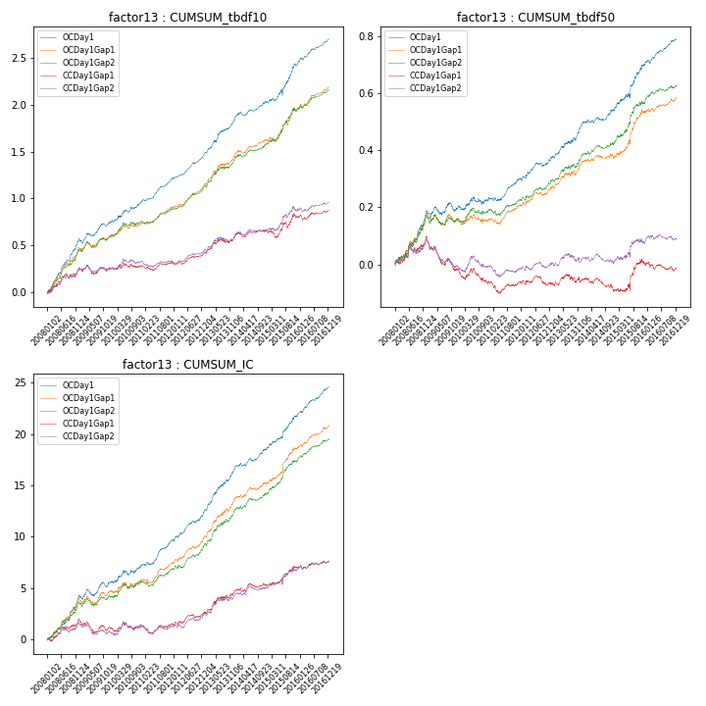

**因子换手率:** 34.98%

**截面指标_OCDay1:**

|  |  |  |  |  |  |  |  |  |
| --- | --- | --- | --- | --- | --- | --- | --- | --- |
| year | annret_tbdf10 | sharpe_tbdf10 | maxdd_tbdf10 | annret_tbdf50 | sharpe_tbdf50 | maxdd_tbdf50 | mean_IC | tstat_IC |
| 2008 | 0.56 | 7.72 | -0.02 | 0.19 | 4.89 | -0.01 | 0.02 | 5.77 |
| 2009 | 0.18 | 3.0 | -0.05 | 0.01 | 0.37 | -0.03 | 0.01 | 2.05 |
| 2010 | 0.24 | 3.32 | -0.03 | 0.04 | 1.2 | -0.03 | 0.01 | 2.46 |
| 2011 | 0.24 | 5.82 | -0.02 | 0.07 | 3.21 | -0.01 | 0.01 | 4.68 |
| 2012 | 0.25 | 6.8 | -0.02 | 0.08 | 3.06 | -0.01 | 0.01 | 4.84 |
| 2013 | 0.38 | 5.46 | -0.02 | 0.12 | 3.87 | -0.01 | 0.02 | 5.95 |
| 2014 | 0.19 | 3.76 | -0.04 | 0.04 | 2.13 | -0.01 | 0.01 | 3.61 |
| 2015 | 0.4 | 3.88 | -0.06 | 0.17 | 3.64 | -0.02 | 0.01 | 4.71 |
| 2016 | 0.27 | 5.85 | -0.02 | 0.09 | 4.16 | -0.01 | 0.01 | 6.03 |

**截面指标_CCDay1Gap1:**

|  |  |  |  |  |  |  |  |  |
| --- | --- | --- | --- | --- | --- | --- | --- | --- |
| year | annret_tbdf10 | sharpe_tbdf10 | maxdd_tbdf10 | annret_tbdf50 | sharpe_tbdf50 | maxdd_tbdf50 | mean_IC | tstat_IC |
| 2008 | 0.26 | 3.22 | -0.05 | 0.1 | 2.5 | -0.03 | 0.01 | 3.0 |
| 2009 | -0.01 | -0.14 | -0.09 | -0.12 | -3.99 | -0.11 | -0.0 | -1.58 |
| 2010 | 0.04 | 0.51 | -0.05 | -0.04 | -1.29 | -0.05 | 0.0 | 0.38 |
| 2011 | 0.02 | 0.47 | -0.06 | -0.0 | -0.02 | -0.04 | 0.0 | 0.26 |
| 2012 | 0.11 | 2.82 | -0.02 | -0.01 | -0.31 | -0.03 | 0.0 | 2.08 |
| 2013 | 0.18 | 2.39 | -0.04 | 0.01 | 0.43 | -0.03 | 0.01 | 2.92 |
| 2014 | 0.06 | 1.21 | -0.06 | -0.04 | -1.56 | -0.05 | 0.0 | 1.25 |
| 2015 | 0.16 | 1.68 | -0.08 | 0.1 | 1.89 | -0.03 | 0.01 | 2.46 |
| 2016 | 0.06 | 1.22 | -0.05 | -0.02 | -0.79 | -0.03 | 0.0 | 1.36 |

**风格暴露:**

|  |  |  |  |  |
| --- | --- | --- | --- | --- |
|  | long | short | corr_OCDay1 | corr_CCDay1Gap1 |
| liquidity10 | -0.08 | 0.09 | 0.11 | 0.08 |
| liquidity20 | -0.07 | 0.08 | 0.09 | 0.07 |
| liquidity5 | -0.08 | 0.09 | 0.12 | 0.11 |
| logmktcap | 0.05 | -0.05 | 0.06 | 0.07 |
| momentum15 | -0.11 | 0.11 | 0.17 | 0.13 |
| momentum30 | -0.07 | 0.08 | 0.2 | 0.17 |
| momentum5 | -0.12 | 0.13 | 0.2 | 0.13 |
| retvolatility30 | -0.05 | 0.06 | 0.14 | 0.1 |