Factors Report 20080102-20161230

**1. factor27**

**截面指标累计曲线:**

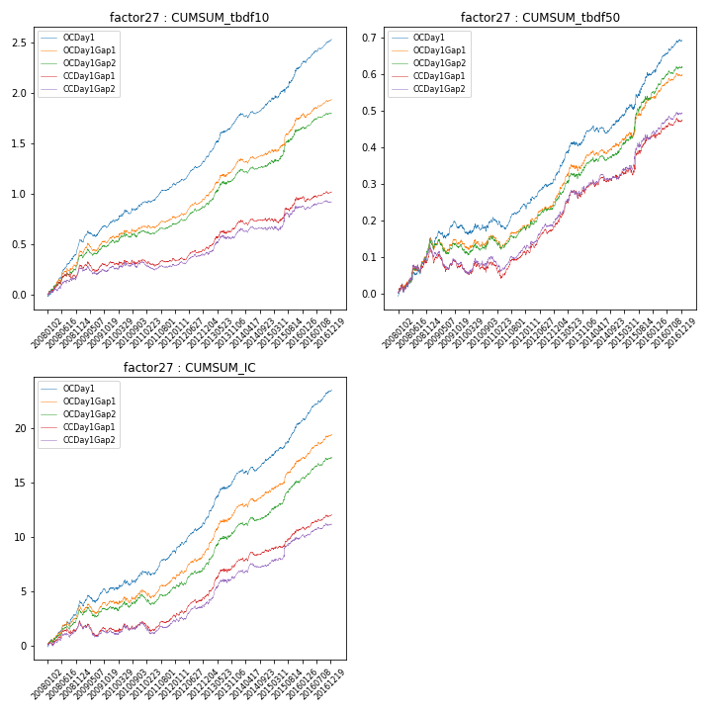

**因子换手率:** 27.77%

**截面指标_OCDay1:**

|  |  |  |  |  |  |  |  |  |
| --- | --- | --- | --- | --- | --- | --- | --- | --- |
| year | annret_tbdf10 | sharpe_tbdf10 | maxdd_tbdf10 | annret_tbdf50 | sharpe_tbdf50 | maxdd_tbdf50 | mean_IC | tstat_IC |
| 2008 | 0.53 | 7.64 | -0.02 | 0.15 | 4.15 | -0.02 | 0.02 | 5.87 |
| 2009 | 0.18 | 3.02 | -0.06 | 0.04 | 1.21 | -0.03 | 0.01 | 1.98 |
| 2010 | 0.21 | 2.97 | -0.04 | 0.02 | 0.75 | -0.03 | 0.01 | 2.14 |
| 2011 | 0.19 | 4.44 | -0.02 | 0.04 | 1.69 | -0.03 | 0.01 | 3.4 |
| 2012 | 0.24 | 5.57 | -0.02 | 0.08 | 3.55 | -0.01 | 0.01 | 4.74 |
| 2013 | 0.4 | 5.96 | -0.02 | 0.12 | 4.04 | -0.01 | 0.02 | 5.72 |
| 2014 | 0.17 | 3.47 | -0.04 | 0.03 | 1.25 | -0.02 | 0.01 | 2.61 |
| 2015 | 0.35 | 4.07 | -0.04 | 0.13 | 3.29 | -0.01 | 0.01 | 4.91 |
| 2016 | 0.27 | 6.38 | -0.02 | 0.09 | 4.56 | -0.01 | 0.01 | 6.42 |

**截面指标_CCDay1Gap1:**

|  |  |  |  |  |  |  |  |  |
| --- | --- | --- | --- | --- | --- | --- | --- | --- |
| year | annret_tbdf10 | sharpe_tbdf10 | maxdd_tbdf10 | annret_tbdf50 | sharpe_tbdf50 | maxdd_tbdf50 | mean_IC | tstat_IC |
| 2008 | 0.29 | 3.19 | -0.06 | 0.13 | 3.23 | -0.02 | 0.01 | 3.19 |
| 2009 | 0.03 | 0.53 | -0.1 | -0.05 | -1.62 | -0.06 | -0.0 | -1.23 |
| 2010 | 0.04 | 0.54 | -0.04 | 0.01 | 0.24 | -0.03 | 0.0 | 0.97 |
| 2011 | -0.01 | -0.2 | -0.07 | 0.03 | 1.36 | -0.04 | 0.0 | 1.0 |
| 2012 | 0.11 | 2.71 | -0.03 | 0.07 | 3.2 | -0.01 | 0.01 | 3.08 |
| 2013 | 0.24 | 3.3 | -0.03 | 0.1 | 3.15 | -0.02 | 0.01 | 4.36 |
| 2014 | 0.06 | 1.19 | -0.05 | 0.03 | 1.23 | -0.02 | 0.0 | 2.15 |
| 2015 | 0.21 | 2.25 | -0.05 | 0.11 | 2.79 | -0.02 | 0.01 | 3.28 |
| 2016 | 0.06 | 1.25 | -0.05 | 0.04 | 2.1 | -0.01 | 0.01 | 2.98 |

**风格暴露:**

|  |  |  |  |  |
| --- | --- | --- | --- | --- |
|  | long | short | corr_OCDay1 | corr_CCDay1Gap1 |
| liquidity10 | 0.05 | -0.05 | 0.02 | -0.0 |
| liquidity20 | 0.04 | -0.03 | 0.03 | 0.0 |
| liquidity5 | 0.06 | -0.05 | 0.02 | 0.0 |
| logmktcap | 0.0 | 0.0 | 0.06 | 0.07 |
| momentum15 | 0.05 | -0.04 | 0.03 | 0.03 |
| momentum30 | 0.03 | -0.03 | 0.09 | 0.07 |
| momentum5 | -0.01 | 0.02 | 0.06 | -0.0 |
| retvolatility30 | 0.02 | -0.01 | 0.11 | 0.07 |