Factors Report 20080102-20161230

**1. factor38**

**截面指标累计曲线:**

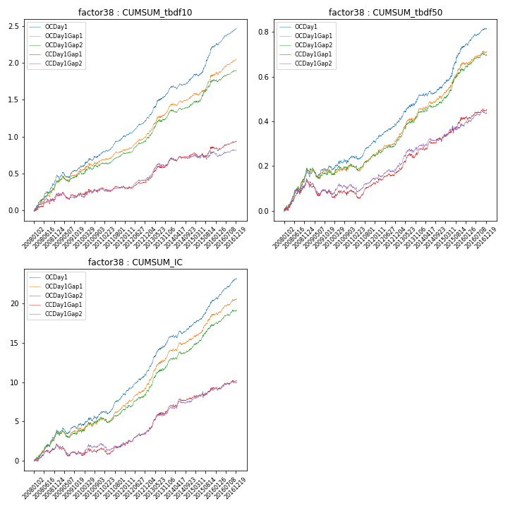

**因子换手率:** 27.86%

**截面指标_OCDay1:**

|  |  |  |  |  |  |  |  |  |
| --- | --- | --- | --- | --- | --- | --- | --- | --- |
| year | annret_tbdf10 | sharpe_tbdf10 | maxdd_tbdf10 | annret_tbdf50 | sharpe_tbdf50 | maxdd_tbdf50 | mean_IC | tstat_IC |
| 2008 | 0.48 | 6.53 | -0.02 | 0.18 | 5.24 | -0.01 | 0.02 | 5.67 |
| 2009 | 0.09 | 1.54 | -0.07 | 0.02 | 0.58 | -0.03 | 0.0 | 1.09 |
| 2010 | 0.22 | 3.0 | -0.03 | 0.05 | 1.64 | -0.02 | 0.01 | 2.3 |
| 2011 | 0.23 | 5.51 | -0.02 | 0.07 | 3.09 | -0.02 | 0.01 | 4.09 |
| 2012 | 0.23 | 5.59 | -0.01 | 0.08 | 3.7 | -0.01 | 0.01 | 4.76 |
| 2013 | 0.39 | 5.58 | -0.02 | 0.13 | 4.27 | -0.01 | 0.02 | 6.03 |
| 2014 | 0.17 | 3.37 | -0.05 | 0.03 | 1.5 | -0.01 | 0.01 | 2.78 |
| 2015 | 0.43 | 5.36 | -0.03 | 0.19 | 4.65 | -0.01 | 0.01 | 5.06 |
| 2016 | 0.25 | 5.81 | -0.02 | 0.08 | 3.93 | -0.01 | 0.01 | 5.64 |

**截面指标_CCDay1Gap1:**

|  |  |  |  |  |  |  |  |  |
| --- | --- | --- | --- | --- | --- | --- | --- | --- |
| year | annret_tbdf10 | sharpe_tbdf10 | maxdd_tbdf10 | annret_tbdf50 | sharpe_tbdf50 | maxdd_tbdf50 | mean_IC | tstat_IC |
| 2008 | 0.21 | 2.85 | -0.05 | 0.14 | 3.46 | -0.02 | 0.01 | 3.17 |
| 2009 | 0.01 | 0.08 | -0.09 | -0.06 | -1.87 | -0.07 | -0.0 | -1.99 |
| 2010 | 0.09 | 1.2 | -0.05 | 0.01 | 0.26 | -0.03 | 0.0 | 0.97 |
| 2011 | -0.0 | -0.02 | -0.04 | 0.04 | 1.5 | -0.04 | 0.0 | 0.87 |
| 2012 | 0.1 | 2.44 | -0.02 | 0.05 | 2.07 | -0.01 | 0.01 | 3.01 |
| 2013 | 0.26 | 3.51 | -0.03 | 0.1 | 3.33 | -0.02 | 0.01 | 4.36 |
| 2014 | 0.1 | 1.91 | -0.04 | 0.04 | 1.78 | -0.02 | 0.0 | 2.13 |
| 2015 | 0.1 | 1.25 | -0.06 | 0.1 | 2.75 | -0.02 | 0.01 | 2.1 |
| 2016 | 0.08 | 1.71 | -0.05 | 0.03 | 1.59 | -0.02 | 0.0 | 2.05 |

**风格暴露:**

|  |  |  |  |  |
| --- | --- | --- | --- | --- |
|  | long | short | corr_OCDay1 | corr_CCDay1Gap1 |
| liquidity10 | 0.04 | -0.03 | 0.03 | 0.0 |
| liquidity20 | 0.03 | -0.02 | 0.03 | 0.01 |
| liquidity5 | 0.04 | -0.03 | 0.03 | 0.03 |
| logmktcap | -0.0 | 0.0 | 0.09 | 0.07 |
| momentum15 | 0.01 | -0.01 | 0.08 | 0.06 |
| momentum30 | 0.02 | -0.01 | 0.14 | 0.1 |
| momentum5 | -0.02 | 0.03 | 0.1 | 0.03 |
| retvolatility30 | 0.01 | -0.0 | 0.07 | 0.07 |