Factors Report 20080102-20161230

**1. factor44**

**截面指标累计曲线:**

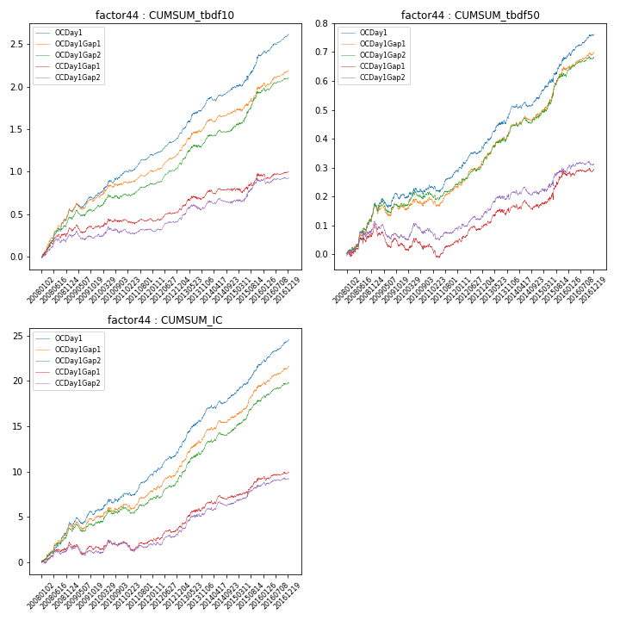

**因子换手率:** 28.7%

**截面指标_OCDay1:**

|  |  |  |  |  |  |  |  |  |
| --- | --- | --- | --- | --- | --- | --- | --- | --- |
| year | annret_tbdf10 | sharpe_tbdf10 | maxdd_tbdf10 | annret_tbdf50 | sharpe_tbdf50 | maxdd_tbdf50 | mean_IC | tstat_IC |
| 2008 | 0.56 | 7.14 | -0.02 | 0.17 | 4.88 | -0.01 | 0.02 | 5.87 |
| 2009 | 0.16 | 2.73 | -0.05 | 0.03 | 0.94 | -0.03 | 0.01 | 2.07 |
| 2010 | 0.28 | 3.88 | -0.03 | 0.04 | 1.15 | -0.02 | 0.01 | 2.57 |
| 2011 | 0.2 | 4.72 | -0.02 | 0.05 | 2.4 | -0.02 | 0.01 | 3.93 |
| 2012 | 0.23 | 5.75 | -0.02 | 0.09 | 3.78 | -0.01 | 0.01 | 4.74 |
| 2013 | 0.39 | 5.38 | -0.02 | 0.13 | 4.22 | -0.01 | 0.02 | 5.83 |
| 2014 | 0.19 | 3.74 | -0.05 | 0.03 | 1.41 | -0.02 | 0.01 | 3.15 |
| 2015 | 0.38 | 3.72 | -0.05 | 0.14 | 3.64 | -0.01 | 0.01 | 5.15 |
| 2016 | 0.24 | 5.56 | -0.03 | 0.08 | 3.93 | -0.01 | 0.01 | 5.58 |

**截面指标_CCDay1Gap1:**

|  |  |  |  |  |  |  |  |  |
| --- | --- | --- | --- | --- | --- | --- | --- | --- |
| year | annret_tbdf10 | sharpe_tbdf10 | maxdd_tbdf10 | annret_tbdf50 | sharpe_tbdf50 | maxdd_tbdf50 | mean_IC | tstat_IC |
| 2008 | 0.34 | 4.19 | -0.05 | 0.1 | 2.69 | -0.02 | 0.01 | 3.17 |
| 2009 | 0.01 | 0.19 | -0.1 | -0.07 | -2.34 | -0.08 | -0.0 | -0.98 |
| 2010 | 0.1 | 1.29 | -0.04 | 0.0 | 0.01 | -0.04 | 0.0 | 0.93 |
| 2011 | -0.01 | -0.11 | -0.06 | 0.01 | 0.5 | -0.05 | 0.0 | 0.26 |
| 2012 | 0.11 | 2.68 | -0.02 | 0.06 | 2.34 | -0.01 | 0.01 | 2.53 |
| 2013 | 0.19 | 2.54 | -0.05 | 0.06 | 1.93 | -0.02 | 0.01 | 3.52 |
| 2014 | 0.06 | 1.11 | -0.05 | 0.0 | 0.11 | -0.03 | 0.0 | 1.58 |
| 2015 | 0.17 | 1.74 | -0.06 | 0.11 | 2.54 | -0.02 | 0.01 | 3.02 |
| 2016 | 0.03 | 0.66 | -0.06 | 0.02 | 0.71 | -0.02 | 0.0 | 1.53 |

**风格暴露:**

|  |  |  |  |  |
| --- | --- | --- | --- | --- |
|  | long | short | corr_OCDay1 | corr_CCDay1Gap1 |
| liquidity10 | -0.01 | 0.02 | 0.04 | 0.02 |
| liquidity20 | -0.01 | 0.02 | 0.03 | 0.02 |
| liquidity5 | -0.01 | 0.02 | 0.04 | 0.05 |
| logmktcap | 0.02 | -0.02 | 0.12 | 0.09 |
| momentum15 | -0.03 | 0.04 | 0.12 | 0.09 |
| momentum30 | -0.02 | 0.03 | 0.17 | 0.15 |
| momentum5 | -0.05 | 0.06 | 0.12 | 0.07 |
| retvolatility30 | -0.01 | 0.02 | 0.09 | 0.08 |