Factors Report 20080102-20161230

**1. factor45**

**截面指标累计曲线:**

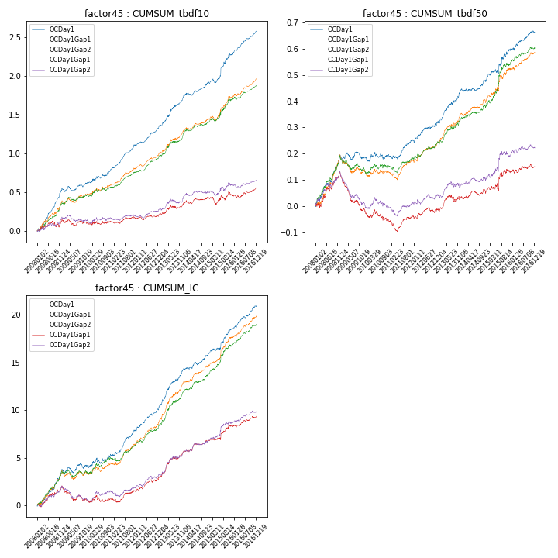

**因子换手率:** 39.58%

**截面指标_OCDay1:**

|  |  |  |  |  |  |  |  |  |
| --- | --- | --- | --- | --- | --- | --- | --- | --- |
| year | annret_tbdf10 | sharpe_tbdf10 | maxdd_tbdf10 | annret_tbdf50 | sharpe_tbdf50 | maxdd_tbdf50 | mean_IC | tstat_IC |
| 2008 | 0.55 | 7.47 | -0.02 | 0.19 | 5.05 | -0.01 | 0.02 | 5.57 |
| 2009 | 0.06 | 1.01 | -0.06 | -0.01 | -0.4 | -0.03 | 0.0 | 0.58 |
| 2010 | 0.19 | 2.59 | -0.03 | 0.01 | 0.48 | -0.03 | 0.01 | 1.75 |
| 2011 | 0.32 | 7.2 | -0.01 | 0.06 | 2.48 | -0.02 | 0.01 | 4.86 |
| 2012 | 0.25 | 5.82 | -0.01 | 0.07 | 2.91 | -0.01 | 0.01 | 4.7 |
| 2013 | 0.38 | 5.36 | -0.02 | 0.13 | 4.24 | -0.01 | 0.02 | 5.67 |
| 2014 | 0.2 | 3.88 | -0.03 | 0.03 | 1.41 | -0.01 | 0.01 | 3.03 |
| 2015 | 0.36 | 3.63 | -0.05 | 0.12 | 2.48 | -0.02 | 0.01 | 3.87 |
| 2016 | 0.31 | 6.55 | -0.01 | 0.07 | 3.06 | -0.01 | 0.01 | 5.27 |

**截面指标_CCDay1Gap1:**

|  |  |  |  |  |  |  |  |  |
| --- | --- | --- | --- | --- | --- | --- | --- | --- |
| year | annret_tbdf10 | sharpe_tbdf10 | maxdd_tbdf10 | annret_tbdf50 | sharpe_tbdf50 | maxdd_tbdf50 | mean_IC | tstat_IC |
| 2008 | 0.15 | 1.69 | -0.08 | 0.13 | 3.18 | -0.02 | 0.01 | 3.19 |
| 2009 | -0.04 | -0.76 | -0.08 | -0.15 | -5.11 | -0.14 | -0.01 | -2.75 |
| 2010 | 0.02 | 0.33 | -0.04 | -0.04 | -1.26 | -0.05 | 0.0 | 0.33 |
| 2011 | 0.03 | 0.77 | -0.03 | 0.02 | 0.65 | -0.05 | 0.0 | 1.52 |
| 2012 | 0.05 | 1.28 | -0.04 | 0.02 | 1.02 | -0.02 | 0.01 | 2.93 |
| 2013 | 0.14 | 1.89 | -0.05 | 0.05 | 1.61 | -0.03 | 0.01 | 3.98 |
| 2014 | 0.08 | 1.44 | -0.04 | 0.02 | 0.86 | -0.02 | 0.0 | 2.35 |
| 2015 | 0.04 | 0.39 | -0.09 | 0.08 | 1.66 | -0.03 | 0.01 | 2.49 |
| 2016 | 0.09 | 2.0 | -0.04 | 0.02 | 0.65 | -0.02 | 0.0 | 2.28 |

**风格暴露:**

|  |  |  |  |  |
| --- | --- | --- | --- | --- |
|  | long | short | corr_OCDay1 | corr_CCDay1Gap1 |
| liquidity10 | -0.0 | 0.01 | 0.04 | 0.01 |
| liquidity20 | -0.0 | 0.01 | 0.04 | 0.01 |
| liquidity5 | 0.0 | 0.01 | 0.05 | 0.04 |
| logmktcap | 0.02 | -0.02 | 0.04 | 0.07 |
| momentum15 | -0.01 | 0.02 | 0.09 | 0.05 |
| momentum30 | -0.01 | 0.02 | 0.14 | 0.1 |
| momentum5 | -0.05 | 0.06 | 0.13 | 0.07 |
| retvolatility30 | -0.01 | 0.02 | 0.1 | 0.06 |