Factors Report 20080102-20161230

**1. factor43**

**截面指标累计曲线:**

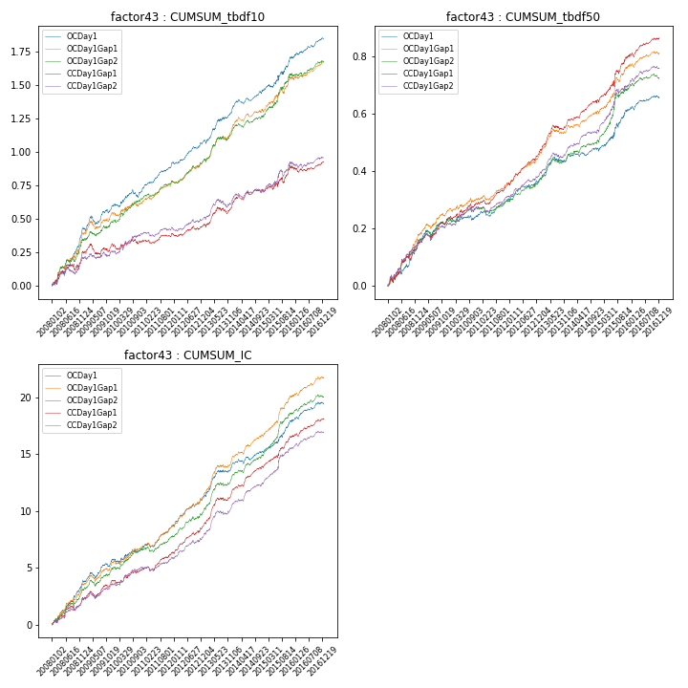

**因子换手率:** 26.16%

**截面指标_OCDay1:**

|  |  |  |  |  |  |  |  |  |
| --- | --- | --- | --- | --- | --- | --- | --- | --- |
| year | annret_tbdf10 | sharpe_tbdf10 | maxdd_tbdf10 | annret_tbdf50 | sharpe_tbdf50 | maxdd_tbdf50 | mean_IC | tstat_IC |
| 2008 | 0.43 | 6.57 | -0.02 | 0.15 | 4.33 | -0.01 | 0.02 | 6.12 |
| 2009 | 0.17 | 2.93 | -0.06 | 0.08 | 3.06 | -0.02 | 0.01 | 3.22 |
| 2010 | 0.14 | 2.48 | -0.06 | 0.02 | 0.74 | -0.02 | 0.01 | 2.03 |
| 2011 | 0.2 | 5.15 | -0.01 | 0.05 | 3.02 | -0.02 | 0.01 | 4.08 |
| 2012 | 0.15 | 3.8 | -0.02 | 0.06 | 3.15 | -0.01 | 0.01 | 4.54 |
| 2013 | 0.26 | 4.62 | -0.03 | 0.09 | 3.96 | -0.02 | 0.01 | 5.06 |
| 2014 | 0.13 | 3.27 | -0.03 | 0.01 | 0.63 | -0.02 | 0.0 | 2.1 |
| 2015 | 0.25 | 3.26 | -0.04 | 0.15 | 3.76 | -0.02 | 0.01 | 4.32 |
| 2016 | 0.14 | 3.88 | -0.02 | 0.04 | 2.32 | -0.01 | 0.01 | 3.4 |

**截面指标_CCDay1Gap1:**

|  |  |  |  |  |  |  |  |  |
| --- | --- | --- | --- | --- | --- | --- | --- | --- |
| year | annret_tbdf10 | sharpe_tbdf10 | maxdd_tbdf10 | annret_tbdf50 | sharpe_tbdf50 | maxdd_tbdf50 | mean_IC | tstat_IC |
| 2008 | 0.25 | 3.18 | -0.04 | 0.15 | 3.46 | -0.03 | 0.01 | 3.04 |
| 2009 | 0.06 | 0.96 | -0.08 | 0.09 | 3.17 | -0.02 | 0.01 | 2.82 |
| 2010 | 0.03 | 0.58 | -0.04 | 0.06 | 2.09 | -0.02 | 0.0 | 1.98 |
| 2011 | 0.05 | 1.25 | -0.03 | 0.07 | 3.6 | -0.01 | 0.01 | 3.17 |
| 2012 | 0.06 | 1.66 | -0.03 | 0.1 | 5.23 | -0.01 | 0.01 | 4.62 |
| 2013 | 0.18 | 3.06 | -0.05 | 0.12 | 4.9 | -0.02 | 0.01 | 5.52 |
| 2014 | 0.09 | 2.07 | -0.04 | 0.07 | 3.22 | -0.01 | 0.01 | 4.5 |
| 2015 | 0.18 | 2.13 | -0.04 | 0.16 | 3.77 | -0.02 | 0.01 | 4.92 |
| 2016 | 0.04 | 1.05 | -0.04 | 0.06 | 2.93 | -0.01 | 0.01 | 3.66 |

**风格暴露:**

|  |  |  |  |  |
| --- | --- | --- | --- | --- |
|  | long | short | corr_OCDay1 | corr_CCDay1Gap1 |
| liquidity10 | 0.09 | -0.08 | -0.07 | -0.08 |
| liquidity20 | 0.08 | -0.07 | -0.05 | -0.07 |
| liquidity5 | 0.09 | -0.08 | -0.08 | -0.06 |
| logmktcap | -0.02 | 0.02 | 0.05 | 0.06 |
| momentum15 | 0.08 | -0.07 | -0.07 | -0.03 |
| momentum30 | 0.06 | -0.05 | 0.01 | 0.02 |
| momentum5 | 0.03 | -0.02 | 0.01 | -0.03 |
| retvolatility30 | 0.04 | -0.03 | 0.03 | 0.0 |