Factors Report 20080102-20161230

**1. factor42**

**截面指标累计曲线:**

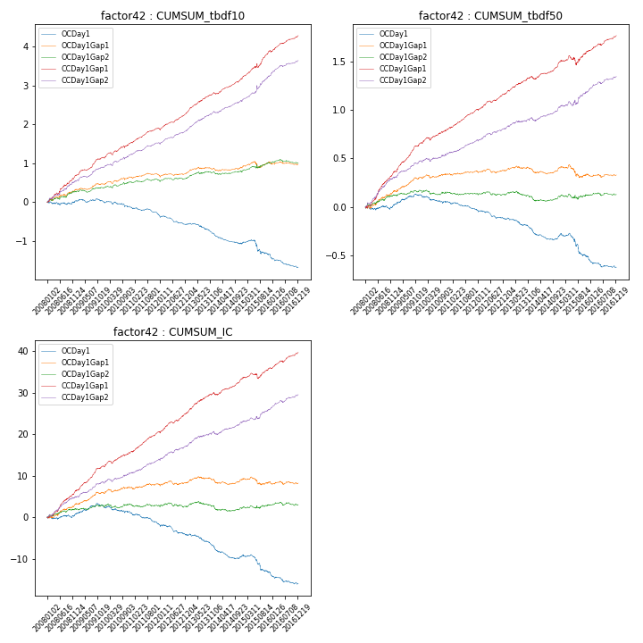

**因子换手率:** 57.02%

**截面指标_OCDay1:**

|  |  |  |  |  |  |  |  |  |
| --- | --- | --- | --- | --- | --- | --- | --- | --- |
| year | annret_tbdf10 | sharpe_tbdf10 | maxdd_tbdf10 | annret_tbdf50 | sharpe_tbdf50 | maxdd_tbdf50 | mean_IC | tstat_IC |
| 2008 | 0.03 | 0.32 | -0.09 | 0.02 | 0.37 | -0.04 | 0.0 | 0.75 |
| 2009 | -0.01 | -0.12 | -0.07 | 0.1 | 2.33 | -0.02 | 0.01 | 2.07 |
| 2010 | -0.15 | -1.74 | -0.15 | -0.07 | -1.66 | -0.08 | -0.01 | -1.7 |
| 2011 | -0.2 | -3.13 | -0.18 | -0.08 | -2.6 | -0.08 | -0.01 | -3.31 |
| 2012 | -0.24 | -3.64 | -0.22 | -0.09 | -2.79 | -0.09 | -0.01 | -2.8 |
| 2013 | -0.26 | -3.23 | -0.24 | -0.12 | -3.11 | -0.12 | -0.01 | -3.13 |
| 2014 | -0.24 | -3.3 | -0.23 | -0.05 | -1.36 | -0.1 | -0.01 | -2.7 |
| 2015 | -0.28 | -1.84 | -0.33 | -0.23 | -2.92 | -0.22 | -0.02 | -2.84 |
| 2016 | -0.33 | -3.87 | -0.29 | -0.11 | -2.64 | -0.11 | -0.01 | -2.98 |

**截面指标_CCDay1Gap1:**

|  |  |  |  |  |  |  |  |  |
| --- | --- | --- | --- | --- | --- | --- | --- | --- |
| year | annret_tbdf10 | sharpe_tbdf10 | maxdd_tbdf10 | annret_tbdf50 | sharpe_tbdf50 | maxdd_tbdf50 | mean_IC | tstat_IC |
| 2008 | 0.68 | 5.64 | -0.04 | 0.36 | 6.49 | -0.02 | 0.03 | 6.51 |
| 2009 | 0.48 | 5.97 | -0.02 | 0.3 | 7.18 | -0.01 | 0.02 | 7.05 |
| 2010 | 0.39 | 4.19 | -0.06 | 0.15 | 3.59 | -0.03 | 0.01 | 3.97 |
| 2011 | 0.36 | 5.67 | -0.02 | 0.19 | 6.15 | -0.01 | 0.02 | 6.25 |
| 2012 | 0.41 | 5.91 | -0.04 | 0.16 | 4.62 | -0.02 | 0.02 | 5.29 |
| 2013 | 0.53 | 6.55 | -0.02 | 0.18 | 4.33 | -0.01 | 0.02 | 5.27 |
| 2014 | 0.39 | 5.26 | -0.03 | 0.17 | 4.69 | -0.02 | 0.01 | 4.68 |
| 2015 | 0.71 | 5.26 | -0.1 | 0.1 | 1.36 | -0.09 | 0.01 | 2.22 |
| 2016 | 0.39 | 5.12 | -0.04 | 0.16 | 4.64 | -0.01 | 0.02 | 4.94 |

**风格暴露:**

|  |  |  |  |  |
| --- | --- | --- | --- | --- |
|  | long | short | corr_OCDay1 | corr_CCDay1Gap1 |
| liquidity10 | 0.63 | -0.62 | -0.53 | -0.51 |
| liquidity20 | 0.51 | -0.5 | -0.48 | -0.46 |
| liquidity5 | 0.77 | -0.76 | -0.58 | -0.53 |
| logmktcap | -0.38 | 0.39 | 0.33 | 0.36 |
| momentum15 | 0.59 | -0.58 | -0.46 | -0.46 |
| momentum30 | 0.43 | -0.42 | -0.41 | -0.35 |
| momentum5 | 0.65 | -0.64 | -0.46 | -0.47 |
| retvolatility30 | 0.41 | -0.41 | -0.42 | -0.38 |