Factors Report 20080102-20161230

**1. factor4**

**截面指标累计曲线:**

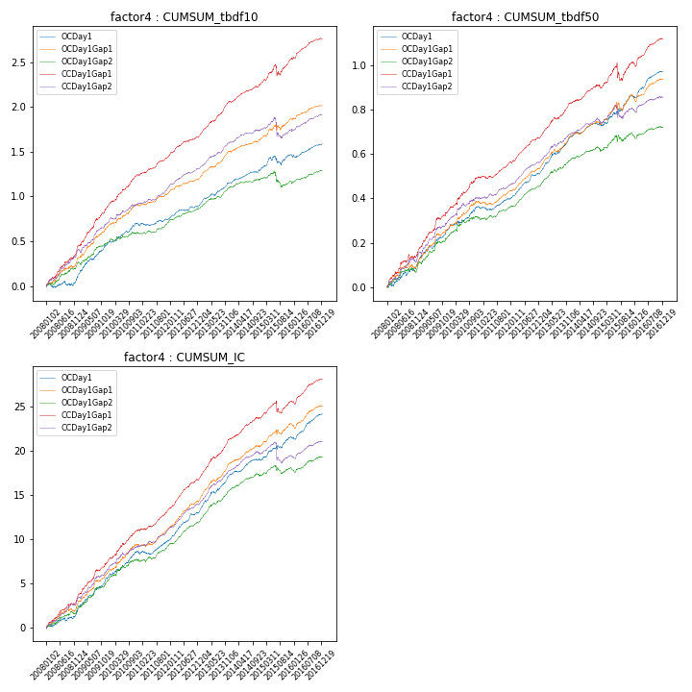

**因子换手率:** 36.41%

**截面指标_OCDay1:**

|  |  |  |  |  |  |  |  |  |
| --- | --- | --- | --- | --- | --- | --- | --- | --- |
| year | annret_tbdf10 | sharpe_tbdf10 | maxdd_tbdf10 | annret_tbdf50 | sharpe_tbdf50 | maxdd_tbdf50 | mean_IC | tstat_IC |
| 2008 | 0.1 | 1.39 | -0.05 | 0.11 | 3.3 | -0.02 | 0.01 | 2.89 |
| 2009 | 0.38 | 5.78 | -0.01 | 0.15 | 4.91 | -0.01 | 0.02 | 5.57 |
| 2010 | 0.2 | 3.72 | -0.02 | 0.1 | 3.22 | -0.01 | 0.01 | 3.95 |
| 2011 | 0.08 | 1.81 | -0.02 | 0.04 | 2.05 | -0.02 | 0.01 | 2.59 |
| 2012 | 0.15 | 3.75 | -0.02 | 0.12 | 6.73 | -0.01 | 0.01 | 6.42 |
| 2013 | 0.25 | 5.69 | -0.02 | 0.16 | 6.68 | -0.01 | 0.02 | 7.12 |
| 2014 | 0.15 | 3.84 | -0.02 | 0.05 | 2.28 | -0.01 | 0.01 | 3.35 |
| 2015 | 0.17 | 2.01 | -0.1 | 0.14 | 3.63 | -0.02 | 0.01 | 3.91 |
| 2016 | 0.12 | 2.77 | -0.03 | 0.11 | 5.32 | -0.01 | 0.01 | 5.39 |

**截面指标_CCDay1Gap1:**

|  |  |  |  |  |  |  |  |  |
| --- | --- | --- | --- | --- | --- | --- | --- | --- |
| year | annret_tbdf10 | sharpe_tbdf10 | maxdd_tbdf10 | annret_tbdf50 | sharpe_tbdf50 | maxdd_tbdf50 | mean_IC | tstat_IC |
| 2008 | 0.43 | 5.76 | -0.02 | 0.16 | 3.98 | -0.02 | 0.01 | 5.49 |
| 2009 | 0.46 | 6.46 | -0.02 | 0.19 | 5.94 | -0.01 | 0.02 | 6.33 |
| 2010 | 0.36 | 6.4 | -0.01 | 0.15 | 4.6 | -0.01 | 0.01 | 5.41 |
| 2011 | 0.22 | 5.48 | -0.01 | 0.06 | 3.58 | -0.01 | 0.01 | 4.98 |
| 2012 | 0.22 | 5.36 | -0.01 | 0.12 | 6.41 | -0.01 | 0.01 | 7.45 |
| 2013 | 0.39 | 8.48 | -0.01 | 0.16 | 6.41 | -0.01 | 0.02 | 8.11 |
| 2014 | 0.2 | 4.86 | -0.01 | 0.07 | 3.0 | -0.02 | 0.01 | 5.01 |
| 2015 | 0.29 | 2.88 | -0.12 | 0.11 | 1.98 | -0.08 | 0.01 | 2.0 |
| 2016 | 0.22 | 5.01 | -0.02 | 0.11 | 4.55 | -0.02 | 0.01 | 5.29 |

**风格暴露:**

|  |  |  |  |  |
| --- | --- | --- | --- | --- |
|  | long | short | corr_OCDay1 | corr_CCDay1Gap1 |
| liquidity10 | -0.01 | 0.02 | 0.04 | 0.1 |
| liquidity20 | -0.01 | 0.02 | 0.03 | 0.09 |
| liquidity5 | -0.02 | 0.03 | 0.05 | 0.15 |
| logmktcap | 0.04 | -0.03 | -0.09 | -0.1 |
| momentum15 | -0.02 | 0.02 | 0.12 | 0.13 |
| momentum30 | -0.01 | 0.02 | 0.09 | 0.11 |
| momentum5 | -0.08 | 0.08 | 0.15 | 0.18 |
| retvolatility30 | -0.02 | 0.03 | 0.03 | 0.1 |