Factors Report 20080102-20161230

**1. factor15**

**截面指标累计曲线:**

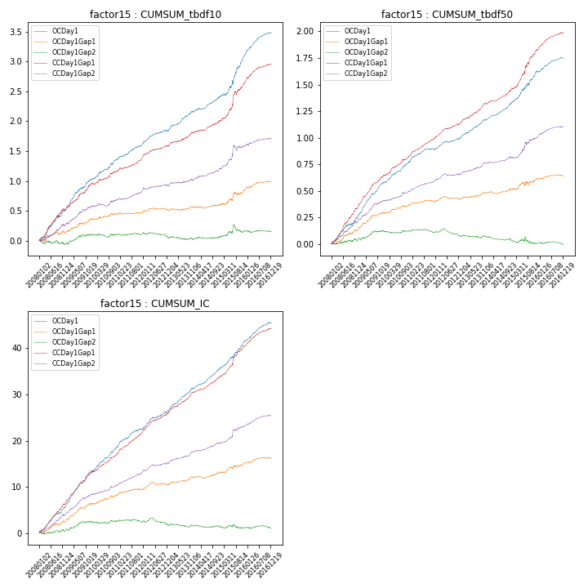

**因子换手率:** 36.07%

**截面指标_OCDay1:**

|  |  |  |  |  |  |  |  |  |
| --- | --- | --- | --- | --- | --- | --- | --- | --- |
| year | annret_tbdf10 | sharpe_tbdf10 | maxdd_tbdf10 | annret_tbdf50 | sharpe_tbdf50 | maxdd_tbdf50 | mean_IC | tstat_IC |
| 2008 | 0.49 | 6.49 | -0.02 | 0.25 | 6.38 | -0.01 | 0.02 | 7.48 |
| 2009 | 0.54 | 7.93 | -0.02 | 0.34 | 10.88 | -0.01 | 0.03 | 11.28 |
| 2010 | 0.33 | 4.85 | -0.02 | 0.19 | 6.48 | -0.01 | 0.02 | 7.17 |
| 2011 | 0.26 | 5.28 | -0.02 | 0.12 | 4.51 | -0.01 | 0.02 | 5.69 |
| 2012 | 0.24 | 4.81 | -0.02 | 0.11 | 4.68 | -0.02 | 0.02 | 6.17 |
| 2013 | 0.33 | 5.92 | -0.02 | 0.18 | 6.25 | -0.01 | 0.02 | 7.41 |
| 2014 | 0.25 | 4.75 | -0.02 | 0.16 | 6.93 | -0.01 | 0.02 | 7.69 |
| 2015 | 0.7 | 5.55 | -0.06 | 0.29 | 5.56 | -0.02 | 0.02 | 7.29 |
| 2016 | 0.37 | 6.91 | -0.02 | 0.13 | 5.33 | -0.01 | 0.02 | 7.03 |

**截面指标_CCDay1Gap1:**

|  |  |  |  |  |  |  |  |  |
| --- | --- | --- | --- | --- | --- | --- | --- | --- |
| year | annret_tbdf10 | sharpe_tbdf10 | maxdd_tbdf10 | annret_tbdf50 | sharpe_tbdf50 | maxdd_tbdf50 | mean_IC | tstat_IC |
| 2008 | 0.51 | 6.04 | -0.03 | 0.34 | 8.43 | -0.01 | 0.03 | 8.79 |
| 2009 | 0.44 | 6.34 | -0.03 | 0.3 | 9.98 | -0.01 | 0.03 | 10.47 |
| 2010 | 0.21 | 3.23 | -0.03 | 0.18 | 5.81 | -0.01 | 0.02 | 5.92 |
| 2011 | 0.23 | 4.9 | -0.02 | 0.17 | 7.29 | -0.01 | 0.02 | 8.01 |
| 2012 | 0.19 | 4.18 | -0.02 | 0.15 | 5.91 | -0.01 | 0.02 | 6.83 |
| 2013 | 0.24 | 4.31 | -0.02 | 0.19 | 6.8 | -0.01 | 0.02 | 7.2 |
| 2014 | 0.19 | 3.74 | -0.02 | 0.14 | 5.68 | -0.01 | 0.01 | 6.64 |
| 2015 | 0.65 | 5.81 | -0.06 | 0.36 | 5.68 | -0.02 | 0.03 | 6.01 |
| 2016 | 0.3 | 5.54 | -0.02 | 0.16 | 7.16 | -0.01 | 0.02 | 7.8 |

**风格暴露:**

|  |  |  |  |  |
| --- | --- | --- | --- | --- |
|  | long | short | corr_OCDay1 | corr_CCDay1Gap1 |
| liquidity10 | 0.01 | -0.01 | 0.11 | 0.09 |
| liquidity20 | -0.0 | 0.01 | 0.12 | 0.1 |
| liquidity5 | 0.05 | -0.04 | 0.08 | 0.04 |
| logmktcap | -0.03 | 0.04 | -0.11 | -0.04 |
| momentum15 | 0.12 | -0.11 | -0.15 | -0.11 |
| momentum30 | 0.08 | -0.07 | -0.17 | -0.1 |
| momentum5 | 0.23 | -0.23 | -0.24 | -0.27 |
| retvolatility30 | -0.01 | 0.01 | 0.12 | 0.1 |